Remote Sensing (C)
Nebraska Science Olympiad
Regional Competition
Henry Doorly Zoo
Saturday, February 27th 2010

96 points total

Please answer all questions with complete sentences with the exception of problems 2, 4, 9, 14 & 16.

- Radar imagery is a common tool used by scientists, foresters, and other relevant policymakers involved in monitoring deforestation. Why would images from radar be more useful in monitoring short-term changes in deforestation over traditional satellite sensors using reflectance in the visible and infrared wavebands (i.e. LandSat, MODIS)? (6pts)

- Radar can penetrate clouds (3pts), thus allowing it to be used more frequently that traditional satellite sensors (3pts).

- The Normalized Difference Vegetation Index (NDVI) is used as a measure of identifying vegetation. Table 1 is a numeric grid containing values determined by NDVI. Circle four major land cover types on the image, identify what major cover types (i.e. vegetation, soil, etc.) are in each group, and indicate the approximate NDVI value for that land cover type. (HINT: groups may be nested inside another group.) (6pts)

Table 1: NDVI values: Values in table are close to land cover types identified in Holben, 1986
0.712 | 0.723 | 0.813 | 0.726 | 0.626 | 0.771 | 0.783
0.752 | 0.794 | 0.783 | 0.679 | 0.006 | 0.637 | 0.723
0.717 | 0.753 | 0.681 | 0.003 | 0.002 | 0.643 | 0.779
0.756 | 0.724 | 0.005 | 0.001 | 0.005 | 0.064 | 0.670
0.743 | 0.797 | 0.681 | 0.002 | 0.005 | 0.653 | 0.789
0.783 | 0.800 | 0.750 | 0.630 | 0.681 | 0.891 | 0.861
0.025 | 0.040 | -0.210 | -0.168 | 0.621 | 0.902 | 0.637
0.020 | 0.030 | -0.351 | -0.161 | 0.798 | 0.736 | 0.716
0.035 | -0.230 | -0.191 | -0.132 | 0.676 | 0.637 | 0.816
0.043 | 0.035 | 0.792 | 0.952 | 0.686 | 0.763 | 0.762
(2pts for circling, 2pts for Land cover type, 2pts for NDVI)

Land Cover Type 1: __Vegetation (green)______________ Approximate NDVI: __>0.6 __

Land Cover Type 2: ___Clouds (no highlight) ___________ Approximate NDVI: __0.001-0.005__
Land Cover Type 3: ___Soil (brown)______ _______ Approximate NDVI: ___0.02-0.043______
Land Cover Type 4: ___Water (blue)__________ _____ Approximate NDVI: __(<0)_______
- Using Figure 1, describe the overall change in forest cover in Massachusetts from 1830-1985. What is the likely cause for this change? (6 pts)

Figure 1: Land Use Change in the state of Massachusetts from a) 1830 to b) 1985 (taken from Foster et al., 1998)
a)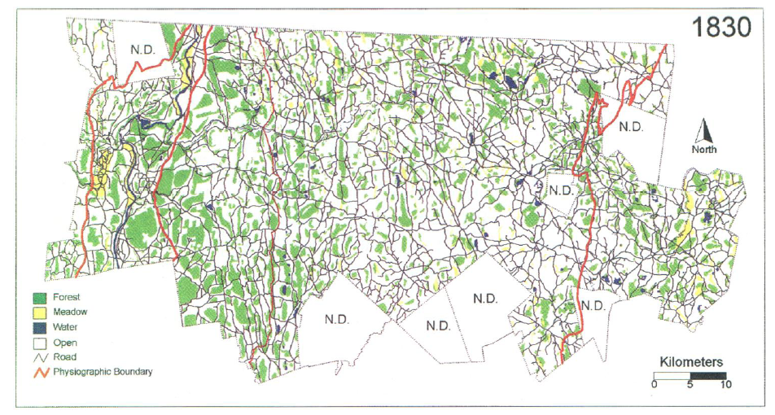
b)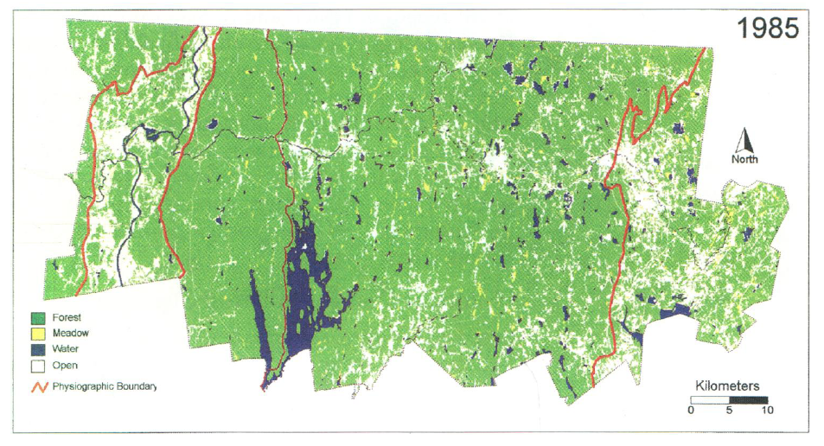

- Increase in forest (3pts) as agriculture decreased (3pts). While there is increased urbanization, this figure does not label urban locations.

- The green chlorophyll index (CIgreen) (Gitelson and Merzlyak, 1994) was developed to assist in quantifying chlorophyll concentrations in maple and chestnut trees and is represented by the following equation:
CIgreen = (Near Infrared Band /Green Band) - 1
Calculate CIgreen for the following pixel from Landsat 7. Please show your work, circle your answer, and use the correct number of significant figures. (NOTE: Part of this question will be used as a tie breaker.) (6pts)
Band Number | Wavelength Interval (μm) | Reflectance
1 | 0.45-0.52 | 0.025
2 | 0.52-0.60 | 0.043
3 | 0.63-0.69 | 0.024
4 | 0.76-0.90 | 0.719
5 | 1.55-1.75 | 0.725
7 | 2.08-2.35 | 0.716

- CIgreen = (0.719/0.043)-1 = 16.7-1 (3pts) = 15.7 (3pts) (only three significant figures. Significant figures will be used as tie breaker #1).

- Name five sources of greenhouse gases. At least one example must be from a non-anthropogenic source. (6pts)

- Anthropogenic: Halocarbons from manufacturing/refrigerant (chlorofluorocarbons), burning fossil fuels, clearing forests, livestock/human wastes, burning biomass (wood, etc.), use of fertilizers (1pts each up to 4)
Natural: Volcanic eruptions (outgassing), forest fires, evaporation (1st worth 2pts after which each only worth 1 pt for a total of 6pts from both groups)

- Using Figure 2, a map of forest cover change in a region of India, please summarize the overall land management in terms of maintaining the amount of forest from 1996 to 2002. Can forest managers increase the density of forest located in the green areas from the 2002 densities? (6pts)

Figure 2: (taken from Roy, 2003) Map of forest change. Values are in percent forest cover 1) >80% 2) 61-80%, 3) 41-60%, 4) 21-40%, 5) <20%, 6) No Forest. Colors correspond to a change from forest coverage ‘x’ to ‘y’. Four examples are displayed within the figure.
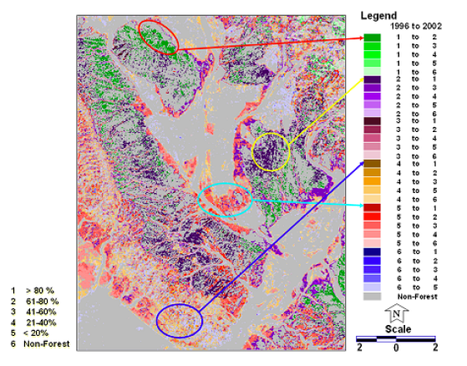

- While there are regions of deforestation, on a whole, forest density has been increasing during this time period. (3pts) Yes the forest managers can increase the density of the forest in the green area from the 2002 levels (3pts)

- Describe the patterns in Figure 3 and provide an explanation/source for this pattern. (6pts)

Figure 3: Global carbon levels in July 2008 produced from Atmospheric Infrared Sounder (AIRS)
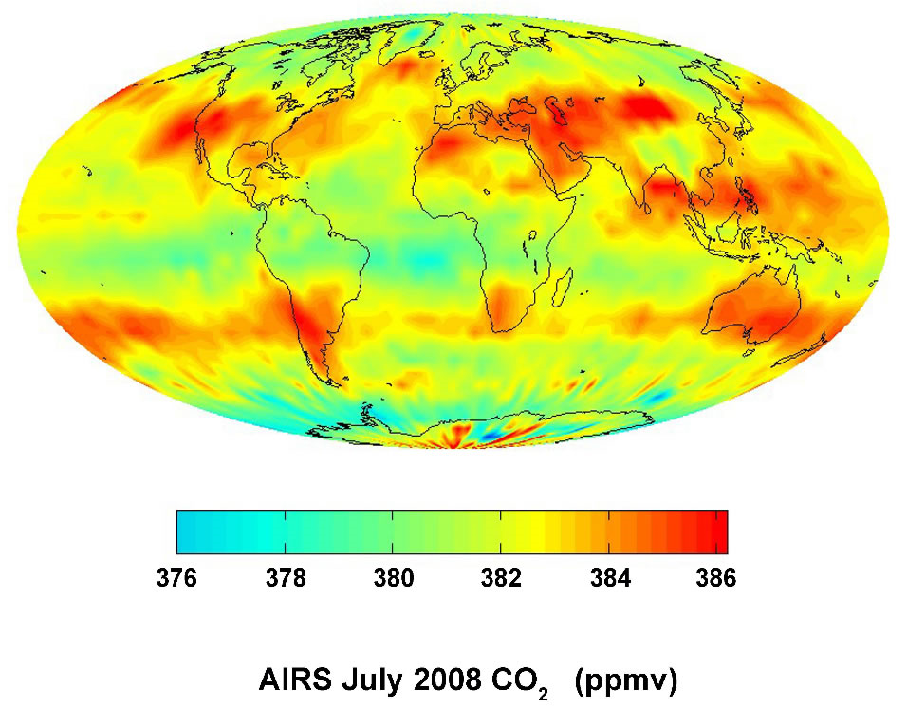

- Banding along the jet stream as CO₂ becomes captured (3pts). Greater amounts in the Northern hemisphere are due to higher rates of industrial pollution (3pts.

- Describe the differences in the two images in Figure 4 using scientific terminology. How can remote sensing scientists produce these images from a satellite-based sensor such as LandSat? Why might remote sensing scientists want to create both types of images? (8pts)

Figure 4: LandSat images taken of Chesapeake Bay, USA on August 23rd, 2004. Both images were taken concurrently.
a) 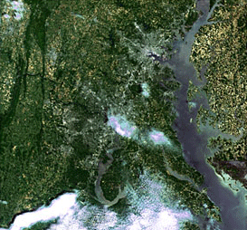 b)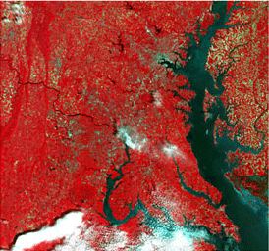

- a) is a true color image (2pts), while b) is a false color image (2pts). These images are created by using 3 different bands to represent the ‘Red’, ‘Green’, and ‘Blue’ bands in a digital image. A true color image is one where the three bands selected are the same wavelength range that RGB bands are located within (2pts). These images provide scientists valuable information in regions of the electromagnetic spectrum humans cannot ‘see’ (2pts).

- The mean annual radian energy and heat balance of the earth was estimated by Houghton et al. (1996) and summarized in Figure 5. Assuming the atmospheric window does not change, if an increase in greenhouse gases causes approximately 94.29% of the remaining surface radiation (surface radiation- atmospheric window) to be returned as back radiation, what is the total radiation absorbed by the surface of the earth in W/m²? Show your work, circle your answer, and use the correct number of significant figures. (8pts)

Figure 5: Mean annual radian energy and heat balance of the earth (Houghton et al., 1996).
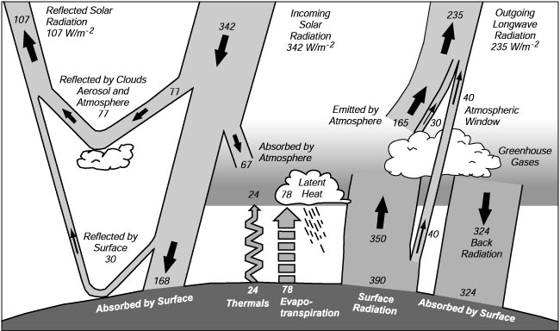
- Back Radiation = Surface radiation not bypassed through atmosphere*94.29% = 350*0.9429 (2pts)= 330 (2pts)
Total Absorbed by surface = Absorption from incoming + Back Radiation = 168+330 (2pts)= 498 W/m² (2pts)

- Figure 6 displays the amount of energy from the top of the atmosphere to the earth’s surface. Explain why there is a difference between these two lines. Using this figure, give an explanation as to why humans might have developed eyesight in the ‘visible’ range of the electromagnetic spectrum. (6pts)

Figure 6: Solar radiation curve expressed in energy reaching the atmosphere and surface of the earth.
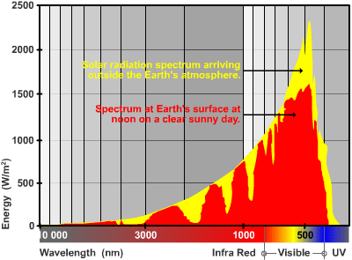
- Absorption, scattering, and reflection (attenuation)by the atmosphere reduces the amount of energy reaching the surface (3pts). Most energy coming to earth is in the visible spectrum. Thus, eyes that are sensitive to this region will provide humans the best source of light to sense the world around them (3pts).

- Describe how remote sensing can be used to monitor human interactions with forest biomes. Provide at least 3 examples. (6pts)

- This question is pretty open-ended. Accept any valid reasoning including but not limited to monitoring forest deforestation, invasive species infestation, tracking forest fires, managing forests for timber, determining carbon sequestration, etc. (2pts for each example).

- Lidar is a relatively new remote sensing platform that uses lasers to determine elevation. Provide at least one advantage and disadvantage Lidar has compared to traditional reflectance-based sensors (i.e. LandSat, MODIS). How might scientists interpret information from canopy height and ground elevation acquired from the Lidar data transect presented in Figure 7? (6pts)

Figure 7: Sample Lidar data acquired from Dubayah and Drake (2000).
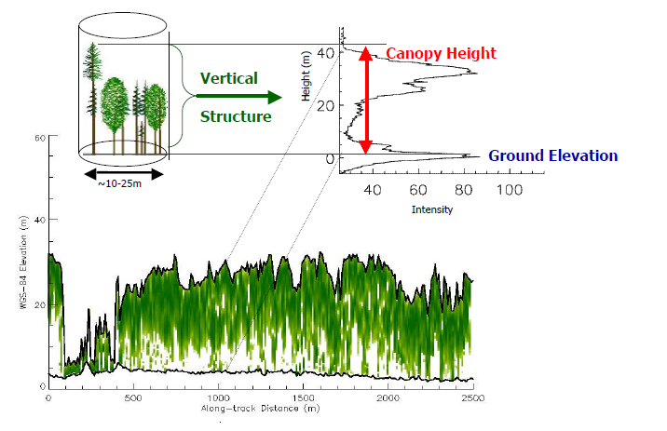

- Advantages: provides very accurate elevation data with one pass, active sensor means data can be collected at any time of day, estimate fire fuel densities, determine forest structural age(2pts)
Disadvantage: information limited to elevation, thus applicability to gather biophysical and physiological information is limited, not as effective in high density environments, canopy height typically shorter than photogrammetry and field measurements. (2pts)
Figure 7 shows a clearing/shrub vegetation around ~100-500 m but otherwise the canopy is relatively stable/age of forest is similar (1pt). Slope is relatively flat though it is acceptable to say that slope decrease slightly from 500-2500 m (1pt)

- When measuring productivity of plant systems, many scientists determine the total amount of photosynthetically active radiation (PAR). In what region of the electromagnetic spectrum is PAR located? You may use wavelengths or descriptors; however, if you use descriptors, you must include all regions. In the northern hemisphere, what month will have the greatest incoming PAR values, assuming cloud-free conditions? (6pts)

- 400-700nm, red, green, blue (3pts). June (3pts)

- The enhanced vegetation index (EVI) is another index used to estimate vegetation and is represented by the following equation:

EVI = 2.5 * (NIR – RED)_____
(NIR + C1 * RED – C2 * Blue + L)

When applied to MODIS images, the following coefficients are used: L=1.0, C1=6.0, C2= 0.5. Find EVI for the following MODIS pixel. Be sure to show your work, circle your answer, and use the correct number of significant figures. (6pts)

Band | Reflectance
Blue | 0.02
Green | 0.04
Red | 0.02
NIR | 0.61
- EVI = 2.5*(0.61-0.02)/(0.61+6.0*0.02-0.5*0.02+1.0) = 2.5*0.59/(0.61+0.12-0.01+1.0) (2pts) =
2.5*0.59/1.72 = 0.86 (2 pts) (additional 1 pt each significant figures and showing work with more than 1 step

- Typically, how do forests contribute to the carbon cycle? (4pts)

- Forest act as carbon sinks (net uptake of carbon) (4pts)

- Assuming 100% consumption in the fire, if a 1 ha stand of oak trees with a dry biomass of 20.32 mg/ha and an average age of 53 years is cut down and burned, what is the net release of carbon dioxide into the atmosphere for the life of the stand of trees? Be sure to show your work, circle your answer, and use the correct number of significant figures. (4 pts)

- Growth biomass = 20.32 mg/ha, Consumption by fire = 20.32 mg/ha (2pts)
1 ha(20.32 mg/ha -20.32mg/ha) = 0.0 mg CO₂ (2pts)

