Multiple Choice

- Everything an organism does and needs in its environment is known as its:
  - feeding level
  - niche
  - habitat
  - adaptation

- If a community in a particular place is left alone, in time it will consist of a group of species that are not replaced by new arrivals. This stable collection of organisms is known as a:
  - climax population
  - climax community
  - climax ecosystem
  - climax succession

- The greatest variety of plants and animal species is found in a:
  - desert
  - estuary
  - rain forest
  - taiga

- If a city decreases in land area, but its population stays the same, the population density:
  - increases
  - decreases
  - stays the same
  - levels off

- A lichen is which type of symbiosis?
  - parasitism
  - commensalism
  - mutualism
  - predation

- Which of the following levels of study in ecology includes all the others listed?
  - population
  - organism
  - ecosystem
  - community

- The carrying capacity of a population is:
  - the number of individuals in a population
  - the number of individuals that can be supported by available resources
  - constant for all populations
  - fixed for humans only

- Primary succession:
  - begins with bare rock
  - begins with soil
  - takes tens of years
  - takes hundreds of years
  - a and d
  - b and c

- What is the percentage decrease at all trophic levels in a food pyramid?
  - 1%
  - 10%
  - 50%
  - 90%

- Which process does not release carbon dioxide back into the environment?
  - combustion
  - respiration
  - photosynthesis
  - decomposition

- A characteristic that improves an organism’s ability to survive is a(n):
  - adaptation
  - inherited variation
  - reproduction
  - breeding

- What are the main conditions that determine the plant life of a biome?
  - rainfall and temperature
  - sunlight and temperature
  - altitude and temperature
  - rainfall and sunlight

- Close interaction between organisms of different species over an extended period of time, in which one individual benefits while the other individual neither benefits nor is harmed by the relationship, is known as:
  - predation
  - competition
  - commensalism
  - mutualism
  - parasitism

- An ecosystem contains
  - only the biotic components of the environment
  - only the abiotic components of the environment
  - only the energy flow components of an environment
  - both the living organisms and the abiotic components of the environment
  - only the food relationships found in an environment

- Which kind of organisms would be most likely to perform photosynthesis?
  - omnivore
  - herbivore
  - detritivore
  - autotroph
  - carnivore

- Which may be a secondary or tertiary consumer?
  - decomposer
  - herbivore
  - detritivore
  - autotroph
  - carnivore

- Which is not true about a complex food web?
  - it remains stable
  - populations tend to remain the same size
  - energy levels remain about the same for all trophic levels
  - inputs are constant and outputs are minimum except for heat
  - most of the energy entering the system maintains the whole community
- Which statement is true about the water (hydrologic) cycle?
  - because this is a true cycle, it is impossible to run out of fresh water for human use
  - some water evaporates from land and from plants
  - all water molecules that evaporate from the ocean precipitate on land and move by gravity through groundwater to the ocean again
  - once water sinks into the ground, it is safe from human exploitation or pollution until it has rejoined the ocean

- The diagram which shows how energy moves through an ecosystem is known as:
  - habitat
  - food chain
  - food net
  - food web

- Process by which atmospheric nitrogen gas is changed to forms that plants can use
  - biogeochemical fixation
  - hydrologic fixation
  - nitrogen fixation
  - carbon fixation
  - phosphorous fixation

- Photosynthesis and respiration belong to which cycle?
  - nitrogen cycle
  - carbon cycle
  - phosphorous cycle
  - hydrologic cycle

- Ecology is best defined as the study of:
  - populations
  - the rate of population changes
  - population increases and decreases
  - how populations are restricted by environmental resistance
  - organisms as they interact with other organisms and their physical environment

- Ecology is derived from the Greek root words for “the study of the ______”
  - populations
  - weather
  - change
  - the environment
  - house or home

- The location where an organism lives is best described as the organisms
  - life zone
  - niche
  - ecosystem
  - community
  - habitat

- The pattern for dispersal of individuals with in an area is the
  - population density
  - population distribution
  - carrying capacity
  - intrinsic rate of reproduction
  - limiting factors

- The factors that determine if an organism can live in an area is/are
  - population density
  - population distribution
  - carry capacity
  - intrinsic rate of reproduction
  - limiting factors

- The maximum rate of natural increase of a population that can occur under ideal conditions is the
  - population growth
  - biotic potential
  - environmental resistance
  - carrying capacity
  - steady state

- Which of the following is a characteristic of an R-selected species?
  - low reproductive rate
  - extensive postnatal care
  - relatively constant population size
  - J-shaped growth curve
  - members include humans

- In a series of trophic levels, the organisms farthest from the producer usually
  - have the most biomass
  - receive the most energy
  - are the largest in number
  - receive the least energy

- A food chain for a prairie could be as follows: grass, rabbit, snake, and hawk. The snake represents which of the following?
  - autotroph
  - secondary consumer
  - tertiary consumer
  - herbivore
  - primary consumer

- In the Sonoran Desert, the lesser long-nosed bat pollinates the saguaro cactus as it feeds from the nectar from the flowers, this is a classic example of
  - commensalism
  - mutualism
  - parasitism
  - predation

- At nighttime, desert temperature
  - stay scorching hot
  - cool down to a warm and balmy temperature
  - often cool down to freezing temperatures
  - vary significantly from desert to desert

- What is desertification?
  - a serious world problem when deserts disappear due to increasing rainfall
  - a rapid increase in the number of desert species over a period of 5-10 years
  - a rapid decrease in the number of desert species over a period of 5-10 years
  - a serious world problem when deserts encroach on arable land

- What characteristics of grasses allow them to thrive in the grassland biome?
  - they grow from the bottom rather than the top, thus being able to rebound after a fire
  - they require thick layers of healthy soil to grow
  - they require constant rainfall
  - all of the above

- In their natural state, which of the following factors contribute to the maintenance of the grasslands:
  - climate, topography, and grazing
  - climate, topography, and fire
  - topography, fire, and grazing
  - climate, fire, and grazing

Please identify the type of interaction between the following organisms:

- A chimpanzee fights with a langor monkey for fruit.

- A leach sucks you blood as you swim in a rural pond.

- A termite has bacteria in its gut that digest the cellulose the termite eats in exchange for a share of the energy from the digestion.

- A rat lives in the garbage disposal facility where it eats the trash that humans produce, but the humans are unaffected.

- A bee pollinates a flower in exchange for the nectar that it makes into honey.

Match the given biome to the plant life that it can support.

41. Tundra | a. evergreen trees
42. Taiga | b. cacti
43. Temperate Deciduous Forest | c. shrubs
44. Tropical Rain Forest | d. grasses
45. Chaparral | e. broadleaf trees
46. Desert | f. orchids
47. Grassland | g. lichen

Short Answer

48. Label the energy available at each trophic level for figure 1:

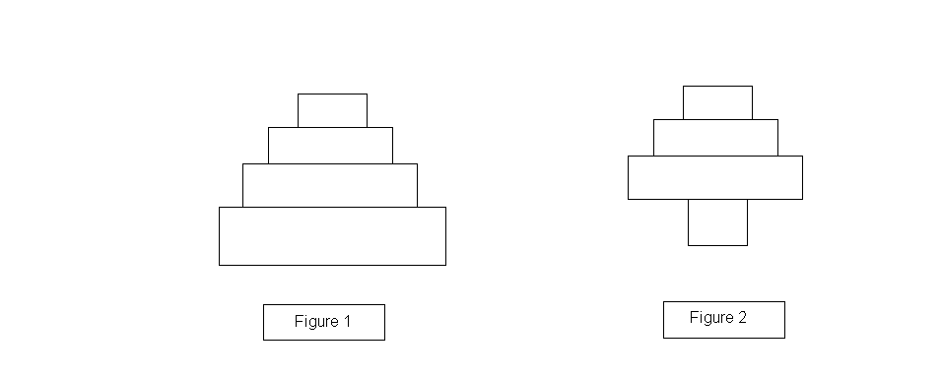
49. What type of pyramid might figure 2 be?

50. In a grassland biome, what food chain might this pyramid represent?

51. Label the diagram on the answer sheet:

52. What is the name of the following cycle, and in what step of this cycle is necessary for plants to receive the nutrients from this cycle?
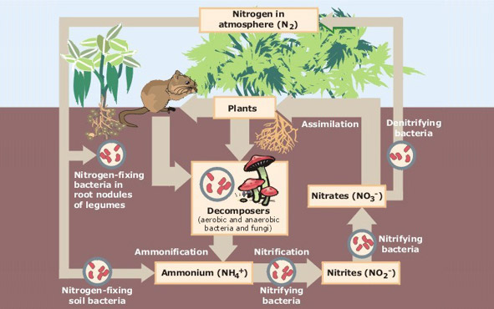

Label which biomes the following pairs of temperature and precipitation graphs belong to.

53. 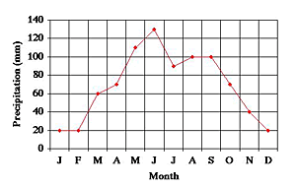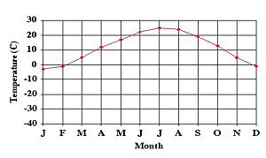

54.
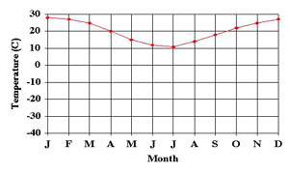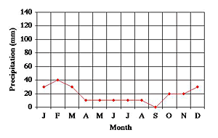

55. Define and list abiotic factors in an ecosystem.

56. What is the most common limiting factor in a desert environment?

57. Name the four North American Deserts.

Tiebreakers: these will be used to determine who wins in the case of a tie.

58. List three or more adaptations in desert organisms and their functions.

59. List three or more adaptations in grassland organisms and their functions.

60. List three common greenhouse gases, and explain the difference between global warming and the greenhouse effect.

Team Name and Number _________Answer Key__________________________________________________
Student Names _____________________________________________________________________________

Multiple Choice: mark your answer in the table below, make sure the answer is readable. (1 point each)

1. __B___ | 2. __B__ | 3. __C__ | 4. __A__ | 5. __C__
6. __C__ | 7. __B__ | 8. __E__ | 9. __D__ | 10. __C__
11. __A__ | 12. __A__ | 13. __C__ | 14. __D__ | 15. __D__
16. __E__ | 17. __C__ | 18. __C__ | 19. __B__ | 20. __C__
21. __B__ | 22. __E__ | 23. __E__ | 24. __E__ | 25. __B__
26. __E__ | 27. __B__ | 28. __D__ | 29. __D__ | 30. __B__
31. __B__ | 32. __C__ | 33. __D__ | 34. __A__ | 35. __D__

Identify the interaction shown. (2 points each)

36. __________competition____________ | 37. __________parasitism___________
38. __________mutualism_____________ | 39. __________commensalism__________
40. _____________mutualism____________

Matching (1 point each)

41. __G__ | 42. __A__
43. __E__ | 44. __F__
45. __C__ | 46. __B__
47. __D__

Short Answer
48. (4 points total)
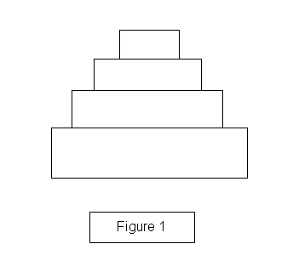

- pyramid of numbers (2 points)

- bottom – grass, any herbivore, omnivore or carnivore, carnivore, decomposer (4 points, 1 each level)
51. (1 point per blank)
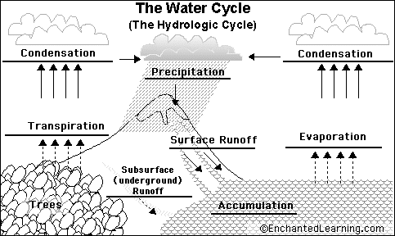

52. Nitrogen cycle Nitrogen fixation (2 points

53. grassland (1 point)

54. Desert (1 point)

55. abiotic factors – any nonliving components of an ecosystem: soil, minerals and other chemicals, pH, weather, climate, water, light, moisture, most limiting factors (4 points, at least 3 factors)

56. Water (1 point)
57. Chihuahuan Desert, Great Basin Desert, Mojave Desert, Sonoran Desert
58. large surface area for cooling – ex. rabbit ears; waxy surface to contain water; large water retaining trunks, stocks, humps, or holding areas to have a water supply in case of drought; needles as opposed to leaves to conserve water; spines and poisons for protection; nocturnal to conserve water and energy, so as not to overheat; CAM photosynthesis to conserve water (6 points, Any three or other appropriate answer)
59. Some animals, such as bison, have broad, flat-topped teeth and digestive systems especially adapted to feed on grasses. Many prairie animals have front legs and paws that allow them to burrow into the ground, where they are protected from predators. Many prairie animals are adapted for nocturnal life; that is, they are active at night, which helps conceal their presence from predators. The color of many prairie animals blends in with the plant life, which also helps them hide from predators. The colorful blossoms attract insects to pollinate them. Extensive root systems for some shrubs can get water from far down in the Earth. Different species' roots get most of their water and nutrients from different levels in the soil. Three examples of animal adaptation are first giraffes because their necks are adapted to feed from the tall trees instead of feeding from the smaller trees where all the other animals feed. (6 points, any three or other appropriate answer)
60. Carbon dioxide, Methane, water vapor, nitrous oxide, ozone, CFCs; greenhouse effect = The process in which greenhouse gases in the atmosphere trap heat from the sun and keep Earth warm. The greenhouse effect is necessary for life on Earth, but too many gases in the atmosphere could make our planet's temperatures rise too high. global warming = an increase in the average temperature of the earth's atmosphere (especially a sustained increase that causes climatic changes). (5 points, 3 for gases, 2 for difference between the two)

