S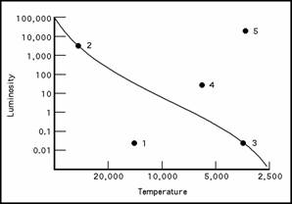
SUN Star c
Sirius B
Star e
a
BETELGEUSE Star a
VEGA Star d
13 (Group)
14
Group
Alpha Centauri B
Star b
12
Group
15 Group
HR Diagram for Part 2, Section A Questions 1-15
13 Group
HR
hR

