ENVIRONMENTAL CHEMISTRY
INVITATIONAL EXAM

PATRICK O’NEILL, DEC 2009
peoneill@indiana.edu

SCHOOL NAME: TEAM NO.:
STUDENT NAMES:

Atomic # | Symbol | Element | Atomic Mass
1 | H | Hydrogen | 1.0
6 | C | Carbon | 12.0
7 | N | Nitrogen | 14.0
8 | O | Oxygen | 16.0
11 | Na | Sodium | 23.0
12 | Mg | Magnesium | 24.3
16 | S | Sulfur | 32.1
17 | Cl | Chlorine | 35.5
20 | Ca | Calcium | 40.1
29 | Cu | Copper | 63.5
Relative Isotope Abundance of Common Elements:
Element | Isotope | Relative  Abundance | Isotope | Relative  Abundance | Isotope | Relative  Abundance
Carbon | ¹²C | 100 | ¹³C | 1.11
Hydrogen | ¹H | 100 | ²H | .016
Nitrogen | ¹⁴N | 100 | ¹⁵N | .38
Oxygen | ¹⁶O | 100 | ¹⁷O | .04 | ¹⁸O | .20
Sulfur | ³²S | 100 | ³³S | .78 | ³⁴S | 4.40
Chlorine | ³⁵Cl | 100 |  |  | ³⁷Cl | 32.5
Bromine | ⁷⁹Br | 100 |  |  | ⁸¹Br | 98.0

I. GENERAL CHEMISTRY

1. C₂H₂ is the molecular formula for ethylyne (A.K.A. acetylene).
(a) How many atoms are in one molecule?
(b) Which atoms make up acetylene?
(c) How many atoms are in one mole of acetylene?
(d) How many molecules are in 5.3 moles of acetylene?

2. Mg(OH)₂ + (NH₄)₂SO₄ →MgSO₄ + H₂O + NH₃
a) Balance the above reaction with coefficients.
b) How many grams of Mg(OH)₂ do you need to use in the above reaction to produce 500g MgSO₄?

II. DILUTION AND SERIAL DILUTIONS

1. How would you make 25 mL of 20.% ethanol from a 95% ethanol stock?

2. A waste container containing 6.00kg of an organic pollutant leaks into a lake that has a surface area of 2km² and an average depth of 3m. Assuming the pollutant has diffused throughout the lake, is it more appropriate to us percentage, parts per thousand, parts per million, or parts per billion to discuss the concentration of this pollutant. ANSWER MUST BE JUSTIFIED BY CALCULATION/ESTIMATES.

3. If you were to dilute fish liver oil to 1.0 x 10⁻⁵, and then found that the concentration of a pollutant was 2.5 pg / L in that dilution, what was the concentration of that pollutant in undiluted fish liver oil?

4. If you have a stock solution of 3.0 M potassium chloride (KCl, a powder), how would you make up 200. ml of a 5.0 µM (micromolar) solution of KCl?

III. SOIL TESTING
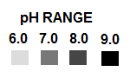
1. Give the value of the pH for a soil sample with this result. Is it acidic, basic, or neutral? Is this a probable cause for concern?

2. Give the value of the pH for a soil sample with this result. Is it acidic, basic, or neutral? Is this a probable cause for concern?

IV. PLANT NUTRIENTS

CIRLCE THE CORRECT ANSWER
1. Which of the following is a macronutrient?

A) Potassium B) Oxygen C) Silt D) Cheeseburgers

2. Which of the following is a micronutrient?

A) Nitrogen B) Clay C) Iron D) Cesium

3. Phosphorus is absorbed into plants in what form?

A) PH₃ B) P₄O₆ or P₄O₁₀ C) PCl₃ or PBr₃ D) H₂PO₄⁻ or HPO₄²⁻

4. Which macronutrient causes high pH when in excess, which then precipitates many micronutrients so that they become unavailable to plants?

A) Nitrogen B) Sulfur C) Calcium D) Phosphorus

5. A deficiency of which macronutrient causes reduced growth, shortened inter-nodes, marginal burn or scorch (brown leaf edges), necrotic (dead) spots in leaves, a reduction of lateral bud breaks, and a tendency to wilt readily?

A) Potassium B) Nitrogen C) Oxygen D) Phosphorous

6.) If deficient, toxic levels of urea accumulate, leading to the formation of necrotic lesions.
A) Iron B) Nickel C) Molybdenum D) Cesium
V. REMEDIATION TECHNIQUES
Use the following answer choices for this section:

A) In Situ Oxidation B) Stabilization C) Solidification

D) Pump and Treat E) SEAR

1) Risky if the geology of the area is too porous as it can wash contaminants into other areas or deeper parts of the soil.

2) Falling out of favorability due to the CO₂ emissions from the large amount of concrete it requires.

3) Can damage the soil by killing off the natural bacteria.

4) The injection of chemicals as hydrogen peroxide, ozone gas, potassium permanganate or persulfates is used.

5) Although both cost-effective and able to quickly address severe soil pollution problems, this form of remediation is not very effective when contaminant levels are low (but still unacceptably high).

VI. SOIL COMPOSITION

Use the following answer choices for this section:

A) Sand B) Silt C) Clay D) Loam

1) A combination of the other three main soil types.

2) The best for horticulture.

3) The most coarse soil type.

4) The most resistant to temperature changes (has the highest specific heat).

5) Drains the most readily after a heavy rain.

6) Heaving may occur as a result of freezing and thawing, pushing plants out of the soil.

7) Individual particles can only be seen with a light microscope.

8) Individual particles can only be seen with an electron microscope

9) Composed primarily of quartz and feldspar

VIII. MASS SPECTROSCOPY

1.) What is the molecular weight of CH₄?

2.) The molecular weight of a substance is an odd number. Which compound below could it be (circle)?
A) C₂H₆ B) CO₂ C) C₆H₁₂O₆ D) C₃H₇O₃N E) C₆H₆ F) H₂O
3.) Why would this molecule be easy to identify using mass spec?
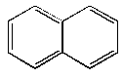
4.) What element is conspicuously present in the mass spectrogram below?
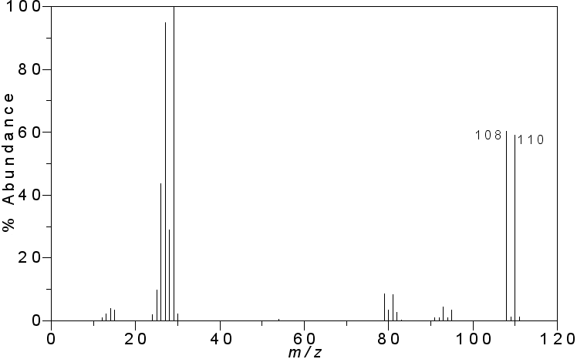
5. What are the three primary components of a mass spectrometer?

