Compute This!
Background info:
Q fever is a worldwide disease with acute and chronic stages caused by the bacteria Coxiella burneti. The Q fever was discovered in 1937, when Frank Macfarlane Burnet and Mavis Freeman isolated bacterium from a patient of Edward Holbrook Derrick. In this Compute This! Event, you will graph the frequency of symptoms in 55 symptomatic patients with confirmed cases of Q fever in Newport, Wales from August to September in the year 2002. This graph will include the information of the people who were sure of the symptoms and the number of people who were not sure of the symptoms. This should be in the format of a Line-Column graph. The x-axis should be labeled “symptoms” and the y-axis should be labeled “Number of Symptoms.” Make sure to include all of the symptoms listed and save a data table in the same file as the graph. The graph should be a new sheet in the file.
Q fever- Line bar graph
http://wwwnc.cdc.gov/eid/article/10/7/pdfs/03-0536.pdf

1) What animals are primary reservoirs of Q fever?
http://www.cdc.gov/qfever/
The animals that are primary reservoirs of Q fever are cattle, sheep, and goats.

2) What is the mental health of most people when exposed to the disease?
http://www.bt.cdc.gov/agent/qfever/clinicians/control.asp
Most people will experience normal emotional distress following exposure to the perceived or actual intentional release of a pathogen. A few will develop psychological illness depending on the circumstances of their exposure. Specific psychotherapeutic or psychopharmacologic treatments might be useful to treat post-traumatic stress disorders, anxiety disorders, or depression that might occur in some patients in the aftermath of exposure.
3) In the town of Stara Zagora (Southern region), testing period March-June 1997, how many people tested positive? Out of how many people?
http://wwwnc.cdc.gov/eid/article/5/3/99-0309-t1.htm
24 people out of 52 people tested positive during that testing period in the Southern region of Stara Zagora.

4) Is Q fever a notifiable disease? What is a notifiable disease?
http://www.cdc.gov/mmwr/preview/mmwrhtml/mm5853a1.htm
Yes. A notifiable disease is one for which regular, frequent, and timely information regarding individual cases is considered necessary for the prevention and control of the disease.

5) What is effective in shortening the course of acute illness in Q fever among Californian slaughterhouse workers?
http://www.cdc.gov/mmwr/preview/mmwrhtml/00000714.htm
Prompt treatment with tetracycline or chloramphenicol is effective in shortening the course of acute illness.
GRAPH
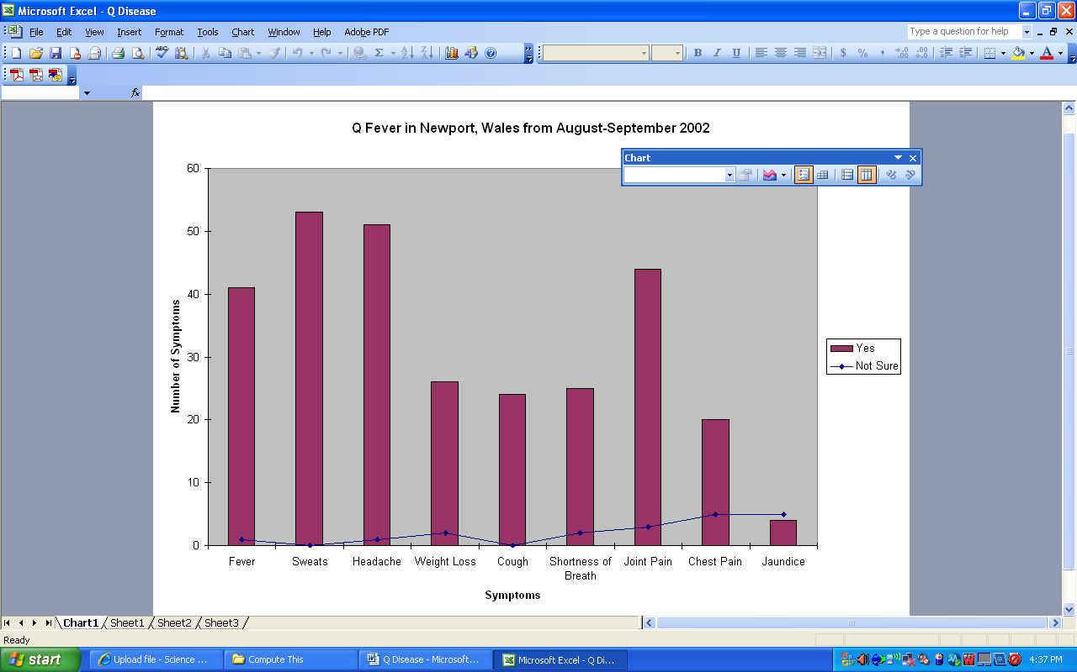
DATA TABLE


