STATION 1

1-5: The figure represents a growth curve of microbial culture. Provide the name of the stage that bests fits the following description. Some stages may be used more than once; others not at all.

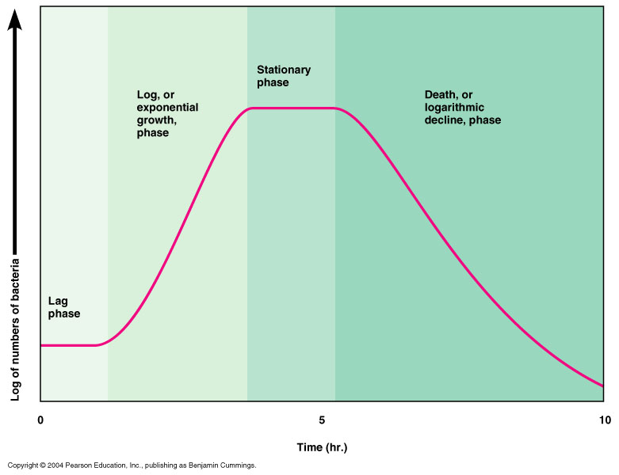

1. During this stage enzymes and molecules necessary for growth are produced

2. This stage seems to last about 4 hr.

3.During this stage the rate of cell growth is about equal to the rate of cell death.

4. This stage is characterized by rapid cell growth.

5. This stage seems to last less than one hour.
_____

6-8: The following figure represents a growth curve for an organism.
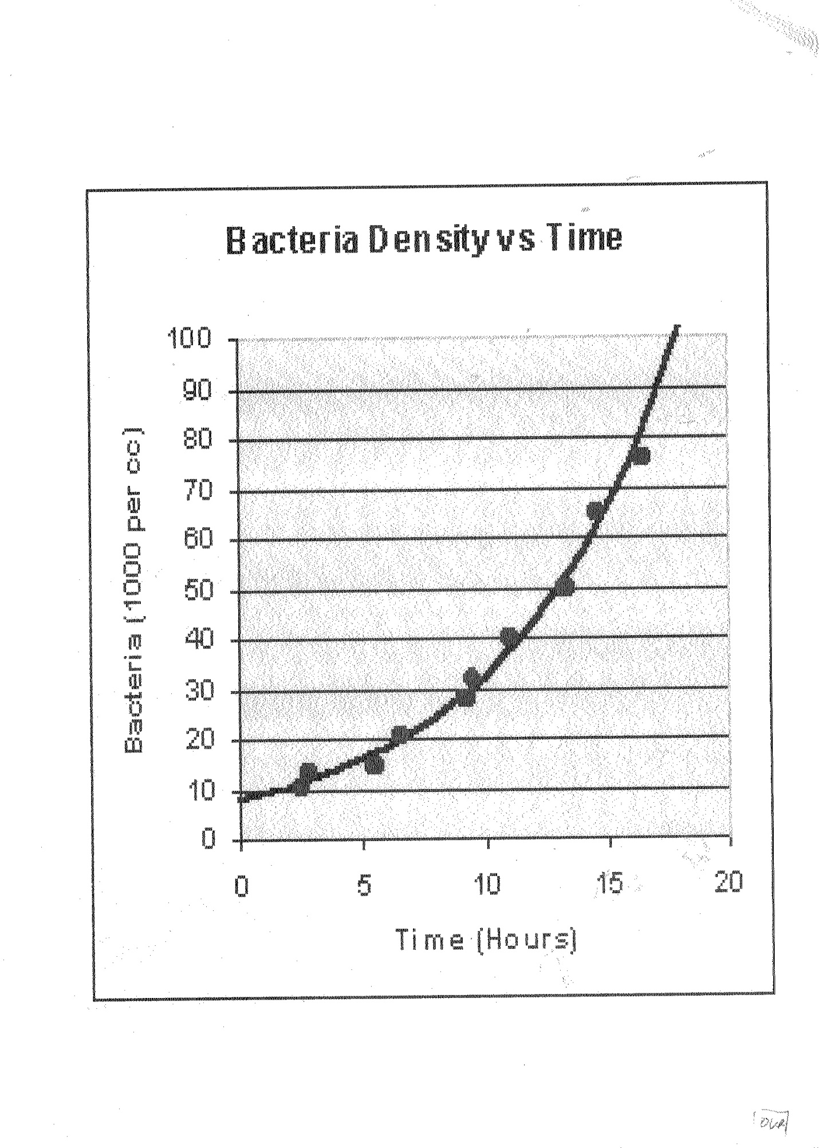

6. At what time did the culture achieve a concentration of about 50,000 cells/cc?

7. What is the approximate concentration after 8 hrs?

8. What is the approximate doubling time for the culture?

STATION 3

9-11: Complete the following table for a compound microscope.

OCCULAR LENS MAGNIFICATION | OBJECTIE LENS MAGNIFICATION | TOTAL MAGNIFICATION
10x | 4x | 9.
8x | 10. | 200x
11 | 10x | 150x

*12-15 Convert the following metric measurements to micrometers (μm). All answers must have a unit or they will be counted wrong.

12. 4.0 mm

13. 2.0 cm

14. 0.1 m

15. 100 nm

*16. If the diameter of the field of view is 3600um at 40x, what is the diameter of the field of view at 100x?

STATION 4

17-22: Using letters, indicate which type of microscope is best used for

17. Determining the shape of bacterial cells A. Dissecting microscope.
18. Observing various microbes in pond water B. Regular light microscope
19. Examining a tissue for viruses C. Transmission electron microscope
20. Examining mobile protozoans D. Scanning electron microscope
21. Examining the surface of pollen grains
22. Examining cells for the detailed structure of mitochondria

STATION 5

23-41: Microbial traits. Each of the answers, 23- should be the either A (for absent) , B (for present), or C (may or may not be present) For example, for number , if you think fungi contain flagella, then your answer on the number sheet should be B. Similarly, if you think that some but not all viruses contain an outer membrane, then you answer should be C.
Remember
A= Absent in all member of this group
B = Present in all members of the group
C =Present in some but nor all members of the group

Type of microbe | Nuclear membrane | chloroplast | Cell wall | DNA and RNA
Viruses | 23. | A | 24. | 25.
Bacteria | 26. | 27. | C | 28.
Fungi | 29. | 30. | 31. | 32.
Plant-like protists | 33. | B | 34. | 35.
Animal like protists | B | 36. | 37. | 38.
Prions | 39. | A | 40. | 41.

STATION 6

42-45: The following questions refer to microscopes A and B below . All answers should take the following format and should be written as capital letters

A. Only microscope A B. Only microscope B
C. Both microscope A and B D. Neither microscope A nor B.

A B
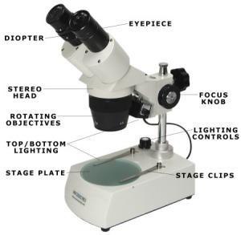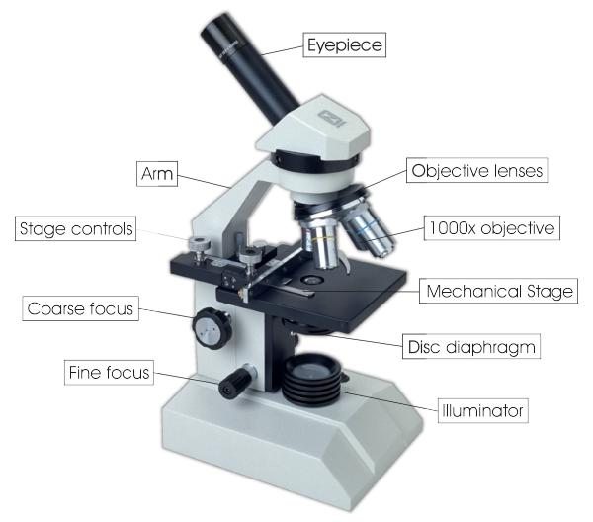
____ 42. Produces the larger magnification of the two scopes
____ 43. Is used to examine bacteria
____ 44.Provides detailed images of the cell surface
____ 45.Is used to observe cells moving

STATION 7

46-50: Match the following diseases with their usual mode of transmission. Each number will have only 1 answer. Some letters may be used more than once; others not at all.
46. malaria A. Ingestion of contaminated food
47. influenza B. Inhalation
48. AIDS C. Animal bites
49. rabies D. sexual fluids
50. common cold E. Answer not given

STATION 8
Questions (51-56) - pertain to the microscope image below
51. What is the function of part 7?
52. Which number will you use to make sure you have a very clear image?
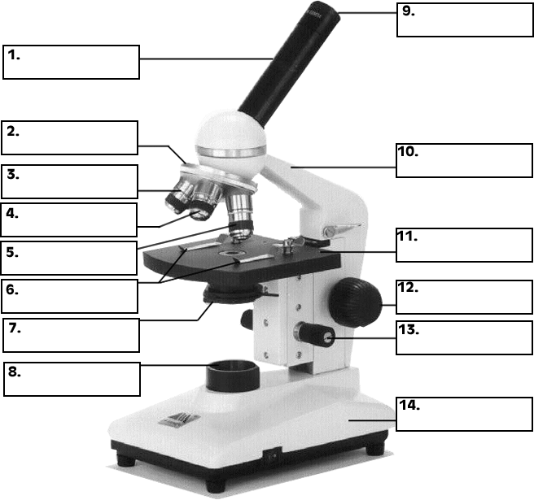
53. What is the name of part 9?

54. What is name of part 10?

55. What is name of part 11?

56. What is function of part 5?

STATION 9

57. You have found a single cell that is mobile, and when you examine it in the microscope you discover a small and a large nucleus. What is the most likely type of microbe that you have found?
A. virus B. fungus
C. protozoan D. bacterium
58. Which of the following groups of organisms represent the main decomposers in the soil?
A. bacteria and viruses C. fungi and viruses

B. bacteria and fungi D. algae and fungi

59. Which of the following statements about the composition of lichens is true?
A. They contain at least a fungus
B. They contain at least a virus
C. They contain at least a protozoan
D. The contain at least a bacterium

60. A plant is found that has fungi (mycorryhzae) associated with its roots. Which of the following statements best applies to this plant?
A. It will be more resistant to cold temperatures than a plant without the fungi.
B. It will be more resistant to herbicides that a plant without the fungi.
C. It will grow better and taller than a plant without the fungi.
D. It will die sooner than a plant without the fungi, for the fungi have damaged the xylem and phloem.
______

STATION 10

61. All of the following statements about the causative agent of AIDS are true except
A. It contains RNA instead of DNA
B. It infects cells of the immune system
C. It produces double stranded nucleic acids that replicate in the cytoplasm
D. It mutates while in the body of a victim.
62. Which group of microbes does not have a cell wall?
A. Fungi B. Archae C. Eubatreria D. Animal-like protists
63. You have found a single cell that is mobile, and when you examine it in the microscope you discover a small and a large nucleus. What is the most likely type of microbe that you have found?
A. virus
B. fungus
C protozoan
D. bacterium
64-66: Organism A is found to be resistant to high temperatures and acid conditions. Organism B is found to be capable of movement by a long way appendage.
64. What structure is probably the cause of the properties of organism A?
A. spore
B. cell wall
C. flagellum
D. answer not given
65. What structure is responsible for the property of organism B?
A. spore B. cell wall
C. flagellum D. answer not given
66. Organism B could belong to all of the following groups except
A. Fungi B. Bacteria C. Animal like protists D. Plant-like protists.
STATION 11
67 .What disease is caused by an organism that has many (>5) different life forms?
A. Estuary Associated Syndrome B. Ebola hemorrhagic fever
C. Toxic shock syndrome D. Strep throat
68. Which of the following diseases are the result of arthropod bites?
A. Botulism and mononucleosis B. Anthrax and tetanus
C.West Nile Fever and Rocky Mountain Spotted fever D. Herpes and Legionaire’s Disease
69-73: Match the human body system that is typically affected by the following diseases. Some answers may be used more than once; others not all. Each disease will have only 1 answer.
Disease Body System
69. Polio A. Circulatory
70. Syphillis B. Digestive
71.Tuberculosis C. Respiratory
72. Pertussis D. Bone/muscular
73. Athelete’s foot
_____

STATION 12
74-84: Match the disease with the usual type of causative agent. . Some answers may be used more than once; others not all. Each disease will have only 1 answer.
Disease Causative Agent
74. Chicken pox A. Fungus
75. Peptic ulcer B. Bacterium
76. Ringworm C. Prion
77. Paralytic shellfish poisoning D. Virus
78. Thrush E. Protozoan
79. Anthrax
80. Mad cow disease
81. NASA scientist have recently reported that they have isolated an organism from a lake in California. The lake has a 10% salt concentration (the oceans are about 3% salt) and a pH of 10. What is the most likely type of organism isolated?
A. Fungus B. Archeae C. Eubacteria D. Plant like protist(alga)
82. Which of the following groups of organisms represent the main decomposers in the soil?
A. bacteria and viruses C. fungi and viruses

B. bacteria and fungi D. algae and fungi
_____
83.You discover something green and fuzzy on some food that has been in the refrigerator for a long time. This organism is most likely a(n)
A. Archeae
B. bacterium
C. alga
D. fungus

84. A scientist discovers some cells underneath the surface of Antarctica. This organism is most likely a(n)
A. Archeae
B. virus
C. alga
D. fungus
STATION 13

85-90: Match the type of microbe with use/major characteristic. Some groups may be used more than one; others not at all. Each question will have only one letter as an answer

MAJOR USE TYPE OF MICROBE

85. Production of bread A. Eubacteria
86. Production of Yogurt B. Archae
87. Production of much of world oxygen C. Fungi
88. Production of soy sauce D. Animal like protists
89. Assisting plants in capturing nitrogen E. Plant like protists
90. Moving genes into plants F. Answer not given

91. Suppose a drug kills in 10 seconds about 99% of bacteria present. If the cell population is originally 10¹⁰, what will be the population 10 seconds after exposure to the drug?

92. All of the following statements about diatoms are true except that they
A. contain walls made of silica
B. produce > 20% of the world’s oxygen supply as a result of photosynthesis
C. are usually green in color
D. contain a bipartite cell wall that consists of two overlapping halves

93. Genetic variation among bacterial populations may result from all of the following processes except

A. transduction
B. mutation
C. Meiosis
D. Conjugation

94-95
94. Identify the following bacterial shapes:
94.
95
ANSWER KEY: http://voyagerscience.homestead.com/Microbe_Answer_Key.tif

