Name(s): ______________________________________________________ Team Number: __________

Dynamic Planet
2009 Science Olympiad Invitational at Mary Washington
Division C

- According to the following table, as the magnitude of earthquakes increases, the distance that tremors can be felt:
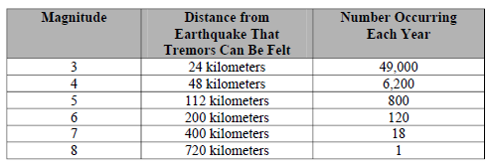

- Increases
- Decreases
- Increases and then decreases
- Remains the same

2. 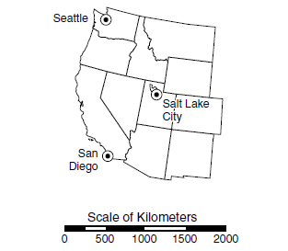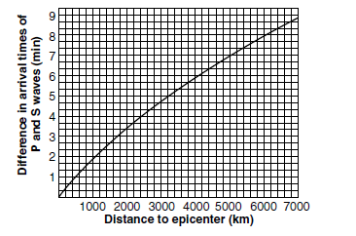
An Earthquake struck San Diego, California. The above map and table show that the approximate difference in arrival times between the P wave and S-wave at Seattle is____

  - 2 minutes
  - 3 minutes
  - 4 minutes
  - 5 minutes

3. According to the following illustration, at which locations would earthquakes be least likely to occur?

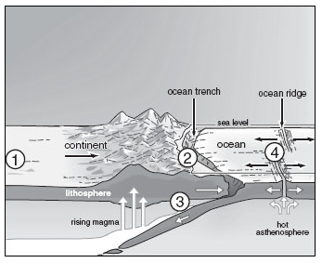

a. 1
b. 2
c. 3
d. 4

4. Which of the following energy sources is most likely to be abundant in California due to its position on a plate boundary?

a. wind
b. nuclear
c. solar
d. geothermal

5. Scientists have found fossils of tropical plants in Antarctica. How could tropical plants have grown in Antarctica?

a. at one time Earth’s entire surface was a tropical rain forest
b. at one time, Antarctica was located closer to the equator
c. the rotation of the Earth was increased, causing cooling of the atmosphere
d. catastrophic volcanic eruptions melted the ice and exposed the soil to sunlight

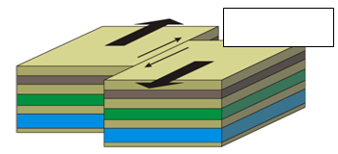
6 Answer the following question using the diagram to the right:

a. Block
b. Normal
c. Strike-Slip
d. Reverse
7. Which of the following provides evidence for plate tectonics?

a. atomospheric temperatures
b. ocean currents
c. Coriolis effect
d. sea-floor topography

8. The property of a magma that determines whether or not it has high viscosity:

a. density
b. silica content
c. color
d. iron content
e. water content

9. Most stratovolcanoes tend to erupt:

a. rhyolite
b. basalt
c. andesite
d. gabbro
e. obsidian

10. The property of a magma that determines whether or not it flows easily:

a. density
b. viscosity
c. color
d. iron content

11. Mount St. Helens, prior to its eruption in 1980 was an excellent example of:

a. a shield volcano
b. a dormant volcano
c. an extinct volcano
d. an active volcano
e. none of these

12. Molten rock which does not reach the surface is called:

a. volcanic ash
b. magma
c. basalt
d. lava

13. Two types of gases, other than steam, that are the most abundant in volcanic emissions are:

a. carbon dioxide and sulfur dioxide
b. carbon dioxide and nitrogen
c. hydrogen and helium
d. carbon monoxide and argon
14. Which is the most dangerous to humans:

a. nuee ardente or pyroclastic flow
b. pahoehoe
c. lava flows
d. pillow lava
e. volcanic bombs

15. Most calderas form by:

a. erosion of lava domes
b. forcefully injection
c. explosions
d. summit collapse
e. fissure eruptions

16. On the atomic scale, the property that governs magma viscosity, type of volcano formed, and eruptive
violence is:

a. average size of ions
b. average charge of ions
c. linkage of silica tetrahedral
d. ratio of large and small ions

17. Crater Lake in Oregon actually fills a

a. rift basin
b. caldera
c. sinkhole
d. deflation basin

18. Most tsunamis occur

a. in the Pacific
b. during hurricanes
c. in the Indian Ocean
d. in Hawaii

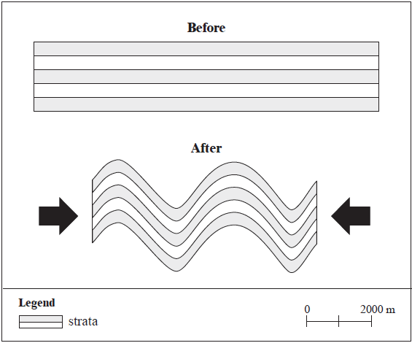

19. The change to the strata block in the diagram above is primarily the result of

  - tension
b erosion.
- divergence
- compression

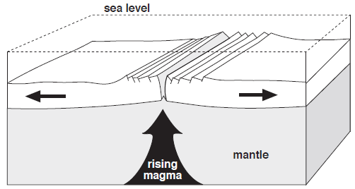

20. Features that result from the process illustrated in the diagram above are
a. batholiths and grykes.
b. coral reefs and trenches.
c. fold and block mountains.
d. ridges and transform faults.

21. Which rock type has been changed from its original form by heat and pressure?
a. igneous
b. metamorphic
c. sedimentary
d. intrusive

Use the following statement to answer questions 22 and 23:
The present formation was created when a volcano exploded and its sides collapsed.

22. The physical feature described in the statement above is a
a. caldera
b. laccolith
c. shield cone.
d. volcanic neck

23. Identify the sphere where the process described in the statement above originates.
a. biosphere
b. lithosphere
c. atmosphere
d. thermosphere

24. What makes an earthquake destructive?
a.The total number of aftershocks that occur.
b.The sudden release of energy and movement
c.The amount of time the seismic activity last.
d.The difference in the time between P wave and S wave arrival

25. Which of the following statements about P waves is FALSE
They squeeze and stretch rock material
They cause particles of rock to travel at right angles to the direction of the waves
They can travel through any material
They are also called primary waves.
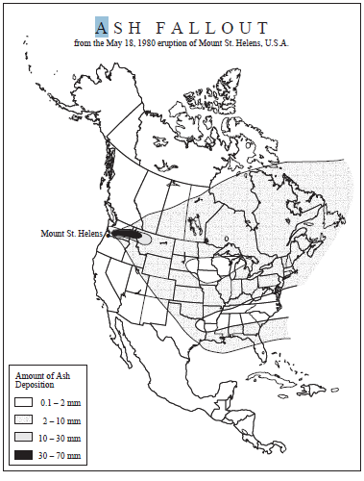
Short answer:

1a. Explain why most of the volcanic ash from the eruption of Mount St. Helens fell to the east of the volcano.

______________________________________________________________________________________________________________________________________________________________________________________________________________________________________________________________________________________________________________________________________________________________________________________________________________________________________________________________________________________________________________________________________________________________________________________________________________________________________________________

1b. State several problems associated with ash fallout caused by the 1980 eruption of Mount St. Helens.
______________________________________________________________________________________________________________________________________________________________________________________________________________________________________________________________________________________________________________________________________________________________________________________________________________________________________________________________________________________________________________________________________________________________________________________________________________________________________________________

1c. Describe two positive impacts of volcanic activity.
______________________________________________________________________________________________________________________________________________________________________________________________________________________________________________________________________________________________________________________________________________________________________________________________________________________________________________________________________________________________________________________________________________________________________________________________________________________________________________________

2. Predicting volcanic eruptions with any certainty is difficult. Volcanologists measure seismic activity, which may indicate magma moving up to the surface. They also analyze the gases that are emitted to find out if any change in gases indicates a pending eruption.

Some volcanic eruptions have been successfully predicted. Evacuations because of warning have saved thousands of lives. Other predictions have not been so successful. More than 20,000 people were killed after a volcano in Columbia erupted causing a mudslide. Authorities had told the residents that it was safe to stay.

Some volcanologists say that monitoring volcanic gas content is a better way to predict eruptions and that it is more reliable than monitoring seismic activity.

Knowing what you have learned about volcanoes, do agree that monitoring volcanic gas content may be a more reliable method of predicting eruptions?

Claim: monitoring gas emission content is a more reliable method of predicting volcanic eruptions. Do you agree or disagree? _____________________

Explain your reasoning: ______________________________________________________________________________________________________________________________________________________________________________________________________________________________________________________________________________________________________________________________________________________________________________________________________________________________________________________________________________________________________________________________________________________________________________________________________________________________________________________

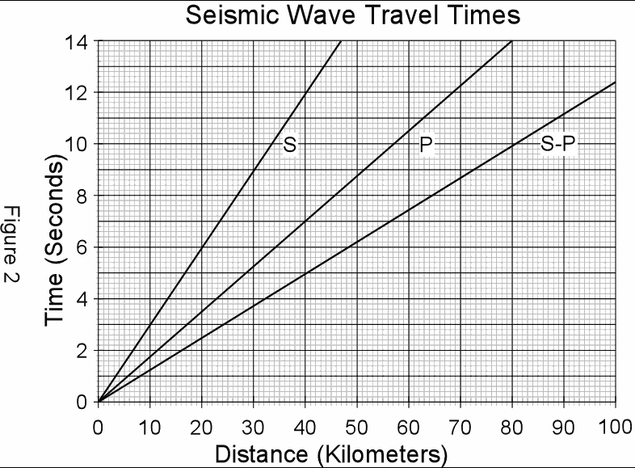

Use the above graph to answer the following questions

3a.How long does it take a S wave to travel 30 kilometers?

3b.A recording station reported that it took 6.20seconds for an initial wave to reach its station. How far away from the epicenter must the station be?

3c.There is a 9.6 second difference between the S & P wave travel time. How far away is the epicenter?

4. Use the following topographic maps of Mount Saint Helens to create two topographic profiles on the attached graph paper. Be sure to correctly label each graph as either Before Eruption or After Eruption. Make sure to identify all necessary information to have a complete, accurate graph.

