FSA school wide Science Olympiad 12/8/2007
Reach for the Stars – Multiple choice questions

1. During the first voyage around the world (1519), the Portuguese navigator Ferdinand Magellan and his crew "discovered" 2 irregularly-shaped objects, which were cloud-like in appearance, in the night-sky of the Southern Hemisphere. These later came to be known as the 2 "Magellanic Clouds", the larger and the smaller being called "Large Magellanic Cloud" (LMC) and "Small Magellanic Cloud" (SMC) respectively. What exactly are the Magellanic Clouds?
Name
A. Supernova remnants
B. Irregular dwarf galaxies orbiting the Milky Way
C. Planetary nebulae
D. They were just cirrus clouds in the Earth's atmosphere

2. If you look into a sky-chart, you'll probably come across several objects with funny-looking names consisting of the capital letter "M" followed by a number. For example, the Pleiades star-cluster in Taurus is labeled "M45", and "M13" is the labelling for the Hercules Globular Cluster. And so it goes on right from "M1" to "M110". But tell me, what exactly does the letter "M" represent in each of these cases?
A. Messier objects: astronomical objects catalogued by Charles Messier
B. They are all objects for which the first detailed study was carried out by the Mauna Kea Observatory in Hawaii

- Objects which lie within 5 degrees on either side of the ecliptic, and are hence occulted by the moon at some time or the other.

- All of them lie in the Milky Way band of the sky (the galactic equator)
3. On July 4, 1054, Chinese astronomers (and possibly Native Americans) recorded a supernova explosion taking place in the constellation Taurus- so bright that it was even visible to the naked eye during daytime! This supernova explosion, 6,500 light years away, resulted in the formation of a nebula, now more than 6 light years across, and expanding at the rate of 1000 kilometres per second! Also known as M1, what is this nebula commonly referred to as?
A. Crab Nebula C. Ring Nebula
B. Dumbbell Nebula D. Orion Nebula
4. Barnard's star is the closest star to us in the northern hemisphere of the sky.
Name
A. True
B. False

5. What type of star is Barnard's star?
A. Red giant
B. Red dwarf
C. White dwarf
D. Yellow dwarf

6. For the sake of convenience, astronomers have divided the sky into 88 constellations. In which of these constellations does the current Pole Star, Polaris, lie?
A. Tucana C. Orion
B. Ursa Minor D. Hercules

7. The great English poet William Shakespeare once wrote, "I am constant as the northern star." [Julius Caesar; Act III, Scene 1] The Pole Star, however, does not appear *exactly* fixed in the night-sky, rather, it is slightly off from the exact North direction. About how far, in degrees, is the Pole Star away from the Earth's axis of rotation?
A. 5 degrees C. 10 degrees
B. 1 degree D. 0.01 degrees

8. Where in the sky would the Pole Star appear to an observer situated on the North Pole? (For the sake of convenience, assume that the Pole Star *does* indeed lie exactly on the Earth's axis of rotation.)
A. At the zenith (exactly overhead)
B. It depends on the time of the year
C. At a fixed point on the horizon
D. Perpetually below the horizon and invisible

Name
9. We now have to begin to take into account yet another motion of the Earth, one which is not easily observable- the precession of the equinoxes. Think of the Earth as a spinning top: the axis of rotation of a top is never constant, the axis seems to move in a circular path (comparatively slowly), while the top keeps rotating at the same time.
Similar is the case of the Earth and its axis of rotation; the axis of rotation over a certain period, goes in the form of a circle known as the 'precession circle'. Approximately how much time does the Earth take to complete one precession?
A. 25,800 years
B. Of the order of 10^6 years
C. 3,600 years
D. [10 to the power log(365)] years

10. In about 14,000 AD, an extremely bright star in the constellation Lyra is going to become the Pole Star, and will by far be the brightest Pole Star of all. What is this star, also referred to as 'Alpha Lyrae', better known as?
A. Fomalhaut C. Canopus
B. Vega D. Achernar
11. Brown dwarfs are very faint and are therefore difficult to find in the night sky. Which of the options below is a method utilized to find them?
A. Imaging sections of sky and searching for faint, red sources
B. Concentrating on young star clusters
C. Focusing on known stars and looking for companions
D. All of these

12. What does the H-R Diagram plot?
A. spectral class and absolute magnitude
B. spectral class and temperature
C. absolute magnitude and luminosity
D. temperature and mass

Name

13. The H-R Diagram can also be used to find:
A. age C. density
B. distance D. extraterrestrial life

14. Where are the solar diameters of stars is plotted on the H-R Diagram?
A. Diagonal lines (top left to bottom right)
B. The x-axis
C. Solar diameters are not plotted on the H-R Diagram.
D. The y-axis

Match the picture with the term
Word Bank: irregular galaxy, spiral galaxy, elliptical galaxy, open cluster, globular cluster, barred spiral galaxy

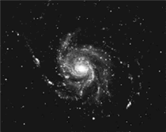 15. Spiral Galaxy
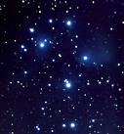 16. Open Cluster
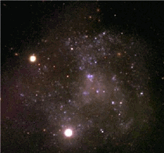 17. Irregular galaxy
Name

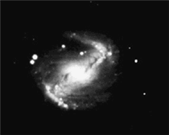 18. Barred Spiral Galaxy
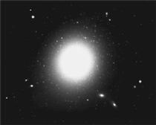 19. Elliptical Galaxy

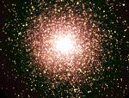 20. Globular Cluster

