**Science Olympiad**

**2012 Camas High School Invitational**

**Dynamic Planet**

**Key**

**Name the type of glacier shown in each picture:**

1. **This glacier can be classified as two types, name each one:**

**____Piedmont____ & _____Tidewater________**

1. **This series of photos shows a glacier over 30 years. What type of glacier is this? _____________Retreating_______________________**
2. **What type of glacier is this? __________Cirque_______________________**
3. **What type of glacier is this? _____________Hanging___________________**
4. **This is one of the only land masses that has these: _____Ice Sheets______**
5. **This is what type of glacier? ________Ice Shelf________________**
6. **This is what type if glacier? ______Valley____________**

**Name the glacier feature in each picture:**

1. **This is what glacier feature? __________Terminus__________**
2. **This is what glacier feature? _______Ice Cave_________**
3. **This climber is currently in what glacier feature? ___Crevasse______**
4. **This is what glacial feature? ______Ogives__________**
5. **This image illustrates the formation of what glacial feature? __Medial Moraine_________**
6. **The sides of this glacier show what glacial feature? _____Lateral Moraine________**
7. **This is what glacial landform? _______Erratic__________**
8. **This is what glacial landform? ______Arête________**
9. **Name the glacial feature as well as this famous mountain: ______Horn & Matterhorn_______**
10. **Name this glacial feature: ________Drumlin_____________**
11. **Name this glacial feature: __________Trough__________________**
12. **Name each of the glacial features on this diagram:**

**A: Hanging Valley**

**B: Arête**

**C: Horn**

**D: Tarn**

**E: Pater Noster Lakes**

**F: Cirques**

**G: Glacial Trough**

**Name this glacial feature: _______Tarn__________**

**Name this glacial feature: _________Kettle Lake__________**

**Name the glacial feature in the center of this picture: ______Kame_____**

**Answer each question directly on this test:**

1. **The degree of ellipticity of Earth’s orbit around the sun is called:**
2. **Precession**
3. **Eccentricity**
4. **Ellipticality**
5. **Tilt**
6. **If a glacier is moving quickly over a short period of time then it is a ______________________ glacier**
7. **Rock**
8. **Valley**
9. **Falling**
10. **Surging**
11. **What feature forms when two glaciers merge together?**
12. **Crevasse**
13. **Horns**
14. **Medial Moraine**
15. **Arêtes**
16. **Glaciers contain how much of the Earth’s freshwater?**
17. **30%**
18. **36%**
19. **25%**
20. **33%**

**Fill in the blank space with the correct answer**

1. **In the ____zone of accumulation____ snowfall is occurring all year round.**
2. **In the _____zone of ablation____ snowfall rarely occurs.**
3. **The _______Snow line__________________ separates the answer to question 19 and the answer to question 20.**
4. **All the material dropped by a glacier is called _____drift____**
5. **Glaciers erode the landscape by ___abrasion__ & __plucking__**
6. **The stages from snow to ice are:**

**Snow**

**____Granular ice______**

**____Firn______**

**Glacial Ice**

1. **The present epoch we are in now is __Holocene__ and the one before the present epoch is the ___Pleistocene___ epoch.**
2. **In the epoch that lasted from the beginning of the Quarternary Period to the end of the last glaciation there were 4 different major ice ages. Name them: __________Nebraskan___________, ________Kansan__________________, _________Illinoian_______________, & _________Wisconsin______________**
3. **Concerning the previous question, the oldest of these ice ages was the ________Nebraskan_______________ ice age and the latest one was the ________Wisconsin_____________ ice age.**
4. **The snow line at the equator is approximately __5,000__ meters**

**Match each of these glacial features to the type of glacier that forms it:**

1. **Arêtes: ___B___**
2. **Truncated Spurs: ___B___**
3. **Continental Glaciers**
4. **Valley Glaciers**
5. **Both Valley and Glaciers**
6. **Kettles: ___A___**
7. **Eskers: ___A___**
8. **Drumlins: __A____**
9. **Kames: ___A___**
10. **Cirques: ___B___**
11. **Horns: __B____**
12. **Hanging Valleys: ___B___**
13. **Glacial Trough: ___B___**

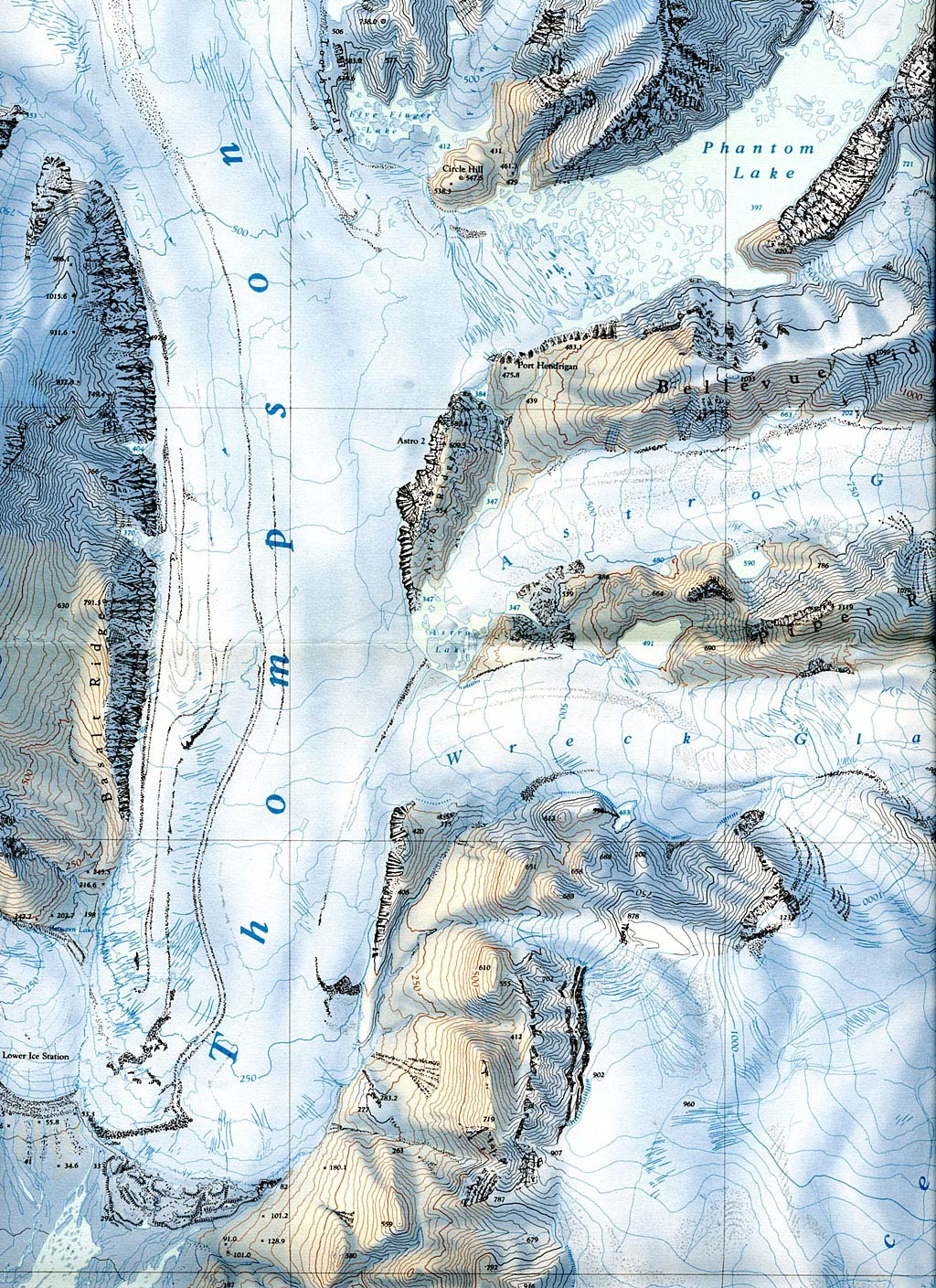

C

B

Topographic Map

A

**Answer the following questions:**

1. **Referring to the Topographic Map, what type of glacier is the Thompson glacier? ____________Valley Glacier__________________**
2. **On the topographic map there is a circle with a letter A next to it. What glacial feature is in this circle? ___________ Arêtes_________**
3. **On the topographic map there is a circle with a letter B next to it. What glacial feature is in this circle? _______Cirque__________**
4. **When the Wreck Glacier and the Thompson Glacier meet what will be formed in the middle? _________Medial Moraine_____________**
5. **What is the contour interval of this topographic map? ____25____ feet**
6. **On the topographic map there is a circle with a letter C next to it. What type of glacier is in this circle? _____Hanging Glacier (Ice Apron)_______**

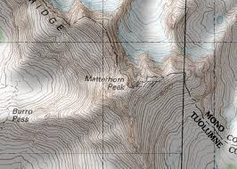

B

A

1. **Where is this famous mountain located? _________Border of Switzerland and Italy or Western Alps_________**
2. **On this topographic map there is a circle with a letter A next to it. What glacier feature is in this circle? _____Tarn_______**
3. **What is the glacier feature in circle B? ____Horn____**
4. **What is this diagram of? _______Lake Vostok________**

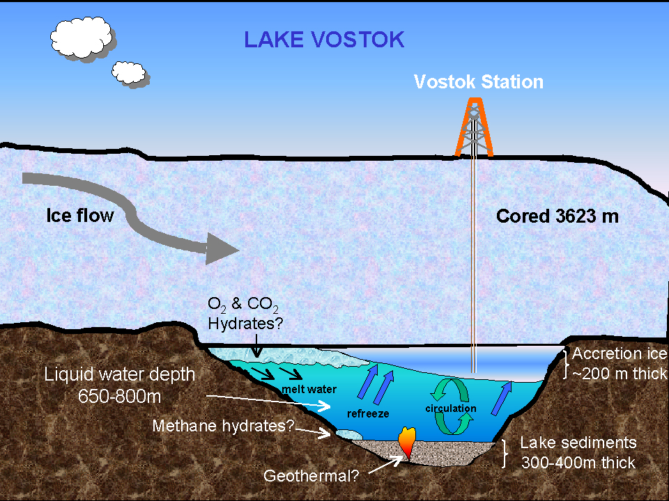

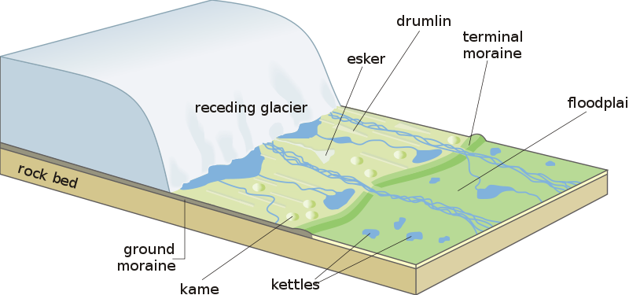

G

F

E

D

C

B

A

1. **Identify each of the glacial features in the above diagram.**

**A: Esker**

**B: Drumlin**

**C: Terminal Moraine**

**D: Floodplain  
E: Ground Moraine**

**F:** **Kame**

**G:** **Kettles**