2011 Science Olympiad
Anatomy and Physiology Exam
UW-Milwaukee Regionals

Note: This is a transcribed version of the actual exam, because I lack a decent scanner.

Station A: Use the diagram to answer the following questions (spelling must be correct).
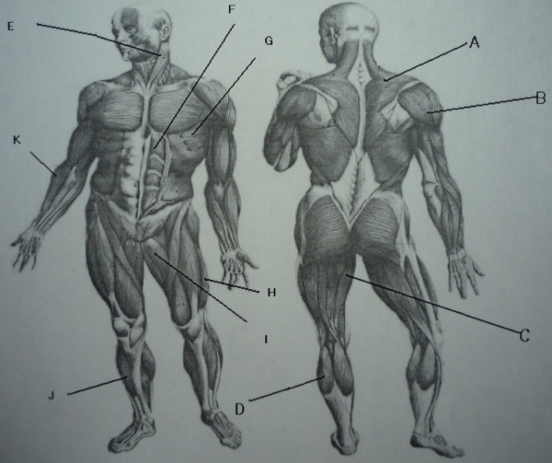

1. Name and give the function of the muscle labeled B.
2. Name and give the function of the muscle labeled I.
3. Name and give the function of the muscle labeled E.
4. Name and give the function of the muscle labeled F.
5. Name and give both the origin and insertion of the muscle labeled C.
6. Name and give both the origin and insertion of the muscle labeled K.
7. Name and give both the origin and insertion of the muscle labeled J.
8. Name and give both the origin and insertion of the muscle labeled D.
Station B: Use the following microscopic slides to fill in the chart.

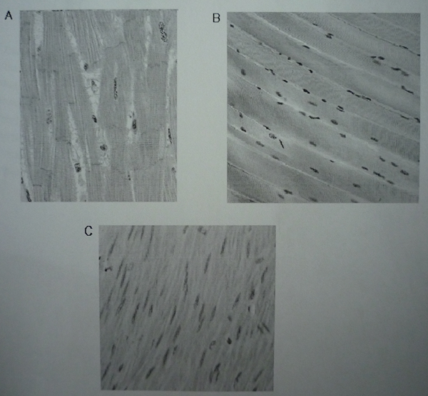

9.
Letter | A | B | C
Muscle Type
Location in the body
Function
Number of nuclei
Control
(Voluntary/Involuntary)
Striations present?

Station C: Use the Sliding Filament Model to answer the following questions.
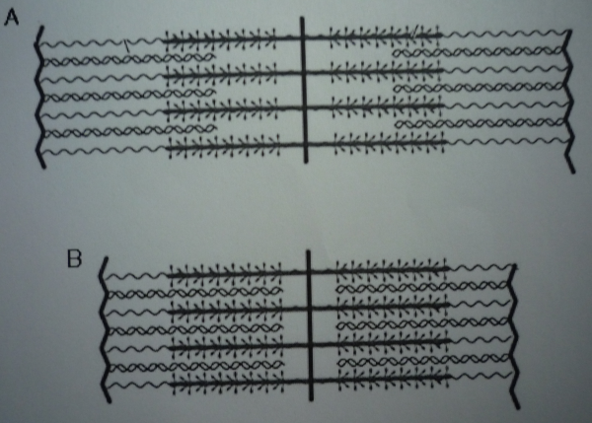
10. Which model, A or B, represents the contraction of a muscle fiber?

11. What happens to the Z disks when the muscle fiber contracts?

12. Where does calcium bind when introduced into the muscle fiber?

13. Describe how the thick and thin filaments are able to slide past one another during contraction.

14. What is the name of the condition when there is no more ATP left in the muscle fiber?

Station D: Explain the following diseases and list any treatments/prevention.
15. Poliomyelitis

16. Myasthenia gravis

17. Graves’ Disease

18. Emphysema

19. Pneumonia

Station E: Read the following case study and answer the following questions.
Lisa is a 7-year-old girl who has been in pretty good health until recently. In the past month she has been increasingly thirsty and gets up several times at night to urinate. At the dinner table she has been eating twice as much, yet she has lost a few pounds in the past month.
Lisa’s family took her to the hospital where blood and urine samples were taken. The results are as follows:
Blood glucose level: 545 mg/dl (normal range: 50-170 mg/dl)
Blood pH level: 7.23 (normal range: 7.35-7.45)
Urine: Tested positive for glucose and for acetone/acetoacetate (i.e. ketone bodies)
*normally urine is free of glucose and ketone bodies
20. Which condition does Lisa most likely suffer from?

21. Why are Lisa’s blood-glucose levels elevated?

22. Lisa has a fruity odor to her breath. Why is that?

23. Describe the mechanism of action of the hormone glucagon from its gland to its target.

Station F: Use the diagram to answer the following questions (spelling must be correct).
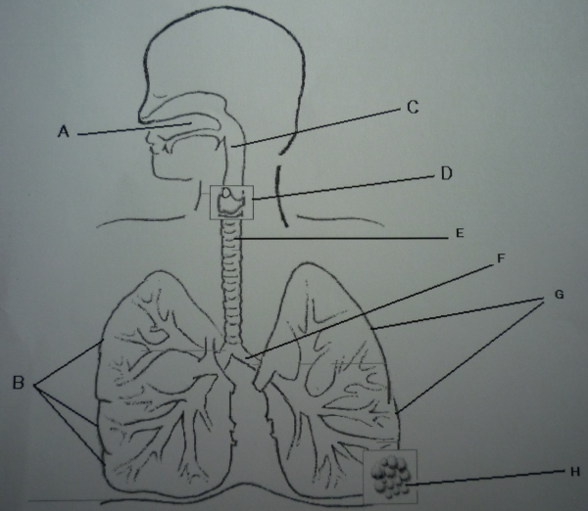

24. Name and give the function of the structure labeled B.
25. Name and give the function of the structure labeled D.
26. Name and give the function of the structure labeled H.
27. Name and give the function of the structure labeled F.
28. Name the three regions and types of epithelium tissue of structure C.
29. How would negative pressure affect the trachea if there were no rings of hyaline cartilage?
30. Describe how true vocal cords are able to produce different pitches.
Station G: Use the oxygen-dissociation curve to answer the following questions.

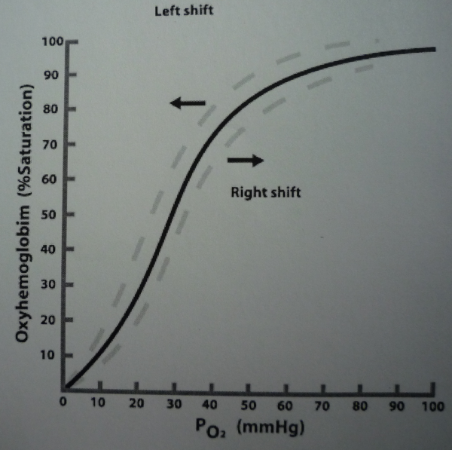

31. Which direction will the curve shift when elevation increases?

32. Which direction will the curve shift when temperature increases?

33. What does a left shift mean for the affinity of hemoglobin for oxygen?

34. What factors would increase the amount of oxygen unloading into tissues?

Answer Key

1. Deltoid: shoulder abduction, flexion/extension
2. Adductor Longus: adduction of thigh, flexion
3. Sternocleidomastoid: tilts head to its own side and rotates face towards opposite side.
4. Rectus Abdominus: flexion of trunk
5. Gracillis: Origin: Ischiopubic ramus; Insertion: Tibia
6. Brachioradialis: Origin: Humerus; Insertion: Radius (radial styloid process)
7. Tibialis Anterior: Origin: Tibia; Insertion: Medial cuneiform and first metatarsal bone of foot
8. Gastrocnemius: Origin: Lateral and medial condyles of femur; Insertion: Tendo calcaneus (Achilles)
9.
Letter | A | B | C
Muscle Type | Cardiac | Skeletal | Smooth
Location | Heart | Attached to bone | Hollow organs, glands, blood vessels
Function | Heart contraction to propel blood | Move body | Compression of tubes and ducts
# of nuclei | Multiple | Single | Single
Control | Involuntary | Voluntary | Involuntary
Striations? | Yes | Yes | No

10. B
11. They get closer together.
12. Troponin
13. Grade based on quality and detail of answer. Myosin heads explained.
14. Rigor
15. Viral infection of the nerves that control skeletal muscle movement. Prevention: Vaccine; Treatment: “Iron lung”, antibiotics, analgesics, otherwise no cure.
16. Autoimmune disorder in which weakness is caused by circulating antibodies that block acetylcholine receptors at the post-synaptic neuromuscular junction. Treated with cholinesterase inhibitors or immunosuppressants.
17. Autoimmune disease where the thyroid is overactive, producing an excessive amount of thyroid hormones (hyperthyroidism). Treated with surgery, radioiodine, and antithyroid drugs.
18. Progressive disease of the lungs which causes shortness of breath. The alveolar walls break down and the surface area of the lungs is reduced. Treated by anticholinergics, bronchodilators, steroids, body positioning, and oxygen.
19. Lower respiratory infection that causes fluid to build up in the lungs. Causes inflammation. Prevention: Vaccine; Treatment: Antibiotics, home care.
20. Diabetes mellitus
21. The pancreas is not making enough insulin. Insulin helps lower blood-glucose levels.
22. Acetone has a fruity odor.
23. Answer determined by quality and detail:
Peptides and amines – non-steroid water soluble.
Protein hormones (1st messengers) – bind to receptor on target cell triggering 2nd messenger to affect cell’s activity. The hormone (1st messenger) does not enter the cell. It binds to receptors on the plasma membrane.
The hormone-receptor complex activates a G protein. This generates a chemical signal (2nd messenger) – most commonly cAMP and IP₃. The 2nd messenger chemical signal activates other intracellular chemicals to produce a response in the target cell.
Responses may be phosphorylation, activation of enzymes, release of calcium ions into the cytosol from ER, or the activation of transcription factor CREB for protein production.
24. Right lung: transport oxygen from atmosphere to bloodstream
25. Larynx: Keeps food and drink out of airway, sound production, sphincter.
26. Alveoli: Site of gas exchange
27. Left primary bronchi: Carries air to lungs
28. Nasopharynx – pseudostratified columnar epithelium; Oropharynx – stratified squamous epithelium; Laryngopharynx – Stratified squamous epithelium
29. The trachea will collapse.
30. The shorter and thinner these membranes are, the faster air moves over them, producing high pitched sounds. The longer and thicker these membranes are, the slower air moves over them, producing low pitched sounds.
31. Left
32. Right
33. Hemoglobin has an increased affinity for oxygen. It binds oxygen easily but unloads it more reluctantly.
34. High temperature; high 2,3-DPG; high pCO₂; high pCO; low pH.

