Team/School Name: ___________________________________________________________________
Student Name(s):______________________________________________________________________
Please Circle: Primary Alternate
Phoenix Invitational at International Academy East - February 4, 2012
Water Quality Test
PLEASE PUT ALL ANSWERS DIRECTLY ON THE ANSWER SHEET
You may write on this test
Part A – Multiple Choice & Short Answer
Write the letter of the correct answer on the answer sheet.
- Which of the following statements about water is TRUE?
- Most of the water on Earth is fresh water.
- Less than 1% of the water on Earth is available fresh water.
- The amount of fresh water on Earth is equal to the amount of salt water on Earth.
- There is an unlimited supply of clean, fresh water on Earth.

- The pH of healthy ponds and streams is approximately:
- 4.0
- 5.0
- 6.5
- 8.0
- 9.5

- Groundwater flows into most wells directly by gravity, but into Artesian wells under what kind of pressure?
- hydrosystem
- hydroelastic
- hydroelectric
- hydrostatic
- none of the above
- Which of the following practices can protect the water quality of streams, rivers, and lakes by filtering out contaminants and sediments in runoff?
A. Leaving a large strip of vegetation next to rivers and lakes.
B. Paving the area next to rivers and lakes.
C. Pouring used motor oil on the ground to keep the dirt in place so it won’t wash away.
D. Washing your car on pavement near a storm drain.

- Sublimation is the movement of water:
- from plant leaves into the air.
- from snow fields and ice into vapor.
- downward through the soil.
- from a liquid state into a gaseous state.

- Which statement BEST describes how water quality standards are used?
- Water quality standards make sure that all water is clean enough to drink.
- Water quality standards describe how to remove pollutants from water.
- State and federal water quality standards make sure that no one will ever be harmed by pollution.
- There are different water quality standards depending upon the intended use of the water: boating, swimming, fishing, drinking.

- If you ONLY find pollution-tolerant macroinvertebrates in a stream, what does that indicate?
- The water quality of the stream has been degraded.
- Fish ate all of the pollution-sensitive macroinvertebrates.
- You can drink the water.
- You don’t need to test any other parts of the stream.

- Which of the following is the smallest amount of a contaminant?
- 1 ppm (part per million)
- 1 ppb (part per billion)
- 1 ppt (part per trillion)
- 1 pph (part per hundred)

- Given an equal amount of rain on each of the following land covers, which will have the MOST runoff?
- a field of corn
- a wetland
- a dense forest
- a parking lot

- What percentage of the world’s disease can be attributed to poor water quality?
- 30%
- 50%
- 80%
- 90%

- In which form is water the purest?
- steam vapor
- solid ice
- clear liquid
- combination of ice and water
- What is the difference between a lotic ecosystem and a lentic ecosystem?
- A lotic ecosystem includes ponds, lakes and wetlands.
- A lentic ecosystem includes streams and rivers.
- A lentic ecosystem has still waters.
- A lotic system does not include a body of water.
- There is no difference.
- A watershed is:
- The headwaters, tributaries, and mouth of a river.
- All of the land area that drains water to a lake or river.
- A drainage basin.
- Both B and C

- Which statement best describes the water cycle?
- Rainfall infiltrates into the soil and moves downward to recharge groundwater, which then replenishes lakes, streams, and rivers.
- Rain falls from the atmosphere into lakes and ponds on the surface of the Earth.
- Water changes from liquid, gas, and solid forms as it is transferred on and within the Earth and atmosphere.
- Solid water is stored in glaciers and ice caps.

- What causes salination of the soil?
- the use of pesticides
- dissolved salts in irrigation water
- salt domes
- saltwater intrusion

- Which of the following is the best way to determine the health of a stream?
- Measure the pH and the temperature of the water.
- Count the number and types of macroinvertebrates living in the stream.
- Count the number and types of trees, shrubs, grass, and other plant species growing near a stream.
- Estimate the amount of sand versus gravel on the channel bottom.

- What do most wastewater treatment plants in the U.S. use to decontaminate water?
- ammonium salts
- aluminum chlorohydrate
- UV light
- Chlorine

- The BEST way to protect water quality is to:
- Fix problems as soon as they are found.
- Treat polluted streams with chemicals to clean them up.
- Use Best Management Practices to prevent or reduce pollution.
- Research new pollution technologies.
Use the data in the tables below to answer questions 19-20.
Parameter | Coles Creek | Clinton River | Gilkey Creek | Bear River
Dissolved Oxygen (ppm) | 12.0 | 8.0 | 4.5 | 7.0
pH | 6.5 | 7.0 | 6.0 | 7.0
Temperature (C) | 10.0 | 19.0 | 21.0 | 18.0
Macroinvertebrate Bioassessment Score | 22.0 | 17.0 | 7.0 | 16.0
Macroinvertebrate Bioassessment Score
Excellent (>48) Good (34-48) Fair (19-33) Poor (<19)
- Which creek or river most likely has well-vegetated stream banks and lots of overhanging trees and shrubs that shade the channel?
- Coles Creek
- Gilkey Creek
- Clinton River
- Bear River

- Which creek or river most likely had human impacts?
- Coles Creek
- Gilkey Creek
- Clinton River
- Bear River

- Farm/street run-off is an example of what type of pollution? non-point

- What is permeability? How quickly ground water moves.

- Water is a universal solvent. How does this property explain water pollution? Water dissolves most substances.

- Most aquatic organisms have a pH range of: 7.0-9.0

- The term “water hardness” is used to describe concentrations of which two substances? calcium and magnesium

Part B – Macroinvertebrate Identification
Write the common name for each organism shown on the answer sheet.
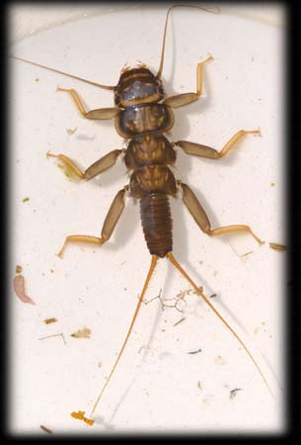  26.  Stonefly | 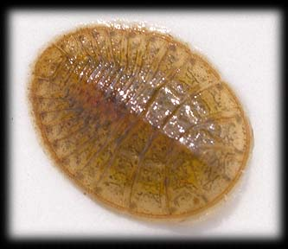  27.  Water Penny
28.  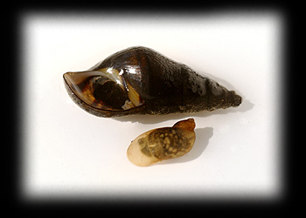  Gilled Snail | 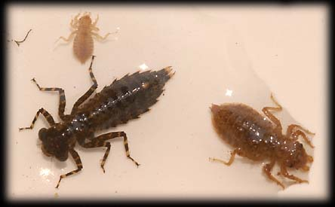  29.  Dragonfly
30.  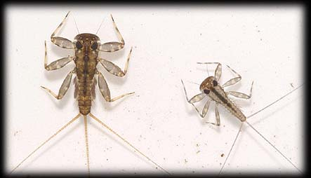  Mayfly | 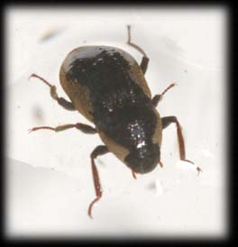  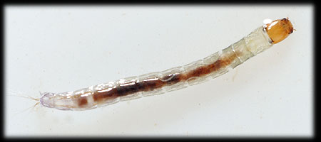  31.  Riffle Beetle

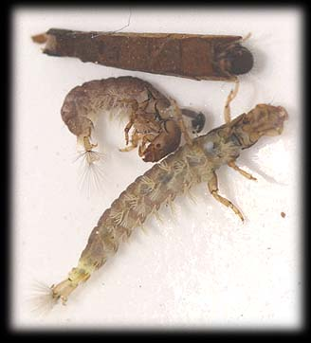  32.  Caddisfly | 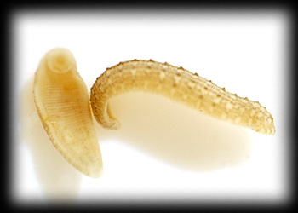  33.  Leech
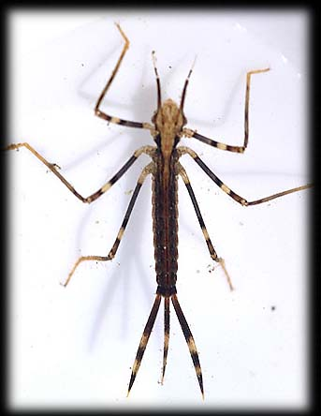  34.  Damselfly | 35.  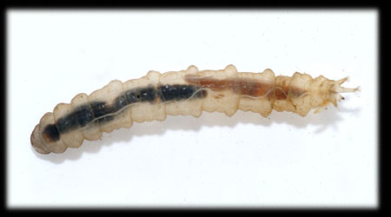  Crane Fly
Calculate the cumulative pollution tolerance index for the above organisms. Use the values below to help, if needed. Full credit will not be given if the work is not shown.
Class 1  (pollution sensitive) | Class 2  (moderately sensitive | Class 3  (moderately tolerant) | Class 4  (pollution tolerant)
Index Value = 4 | Index Value = 3 | Index Value = 2 | Index Value = 1
Record your answers on the answer sheet.
26. 4
27. 4
28. 4
29. 3
30. 4
31. 4
32. 4
33. 2
34. 3
35. 3
Work: (4 x 6) + (3 x 3) + (2 x 2) + (1 x 0) = 37 Cumulative Pollution Tolerance Index: 37
Part C – Water Monitoring and Analysis
Use your salinometer/hydrometer to measure the saltwater concentration that we have provided. Once you have your results, please write them on the answer sheet.
Salinity: _______________

