Remote Sensing (C)

Nebraska Science Olympiad

State Competition

University of Nebraska-Lincoln

Saturday, April 2nd 2011

Table and Figure Sheet

Table 1: Radiance grid from a satellite image layer

|  |  |
| --- | --- |
| 34 | 123 |
| 49 | 67 |
| 175 | 223 |

Table 2: Example spectral response from a MODIS pixel

|  |  |
| --- | --- |
| Band # | Reflectance (%) |
| 1 | 4.7 |
| 2 | 48.0 |
| 3 | 2.5 |
| 4 | 7.9 |
| 5 | 49.2 |
| 6 | 48.7 |
| 7 | 48.2 |

Fig. 1: Land cover maps derived from Landsat MSS/TM imagery. (Source: A Landscape approach for detecting and evaluating change in a semi-arid environment, San Pedro Watershed, by Keppner for US EPA, Las Vegas, NV).

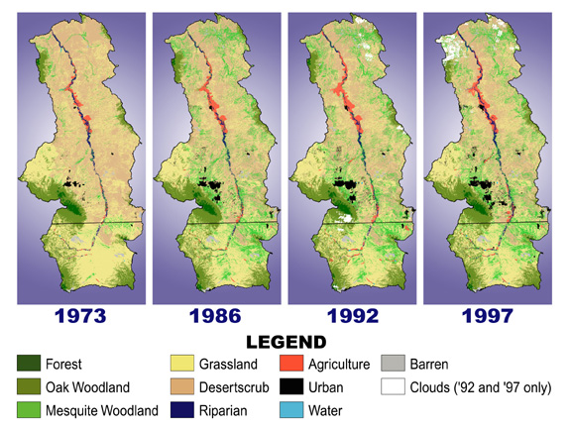

Fig. 2: Hemlock and Hemlock Wooly Aphid distribution as of 2004. (Source: USFS).

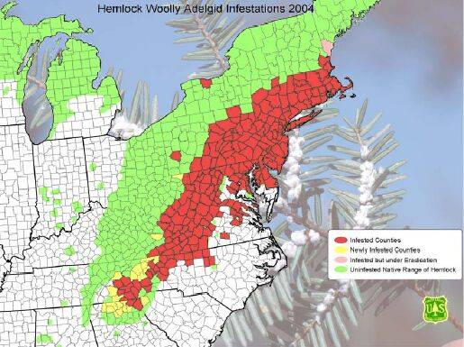

Fig. 3: Hydrologic cycle (Source: Geosystems: An introduction to physical geography by R.W. Christopherson).

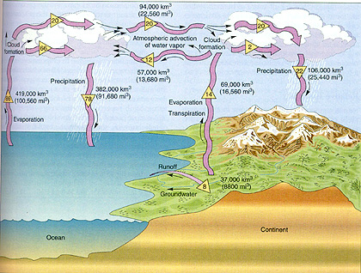

Fig. 4: Map of risk of fire potential on 8/6/08. (Source USFS)

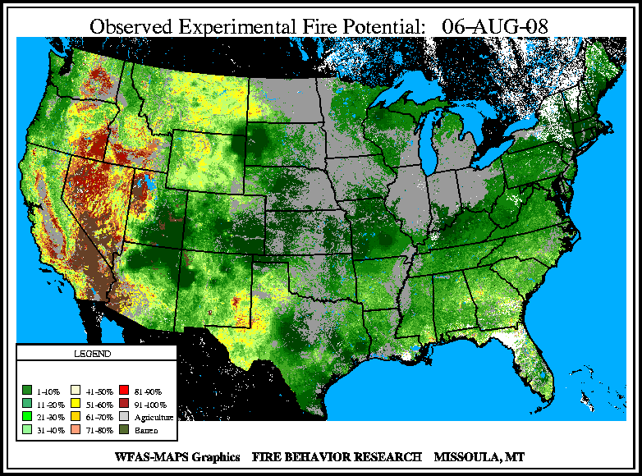

Fig. 5: Generalized reflectance spectra of common earth surface materails (source: Remote Sensing Applications Consultants website: http://www.rsacl.co.uk/rs.html)

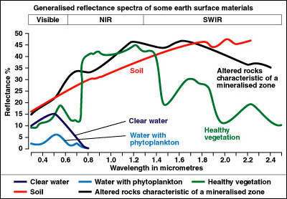

Fig. 6: Average land surface temperature for the month of July, 2003 (Source: MODIS product, NASA)

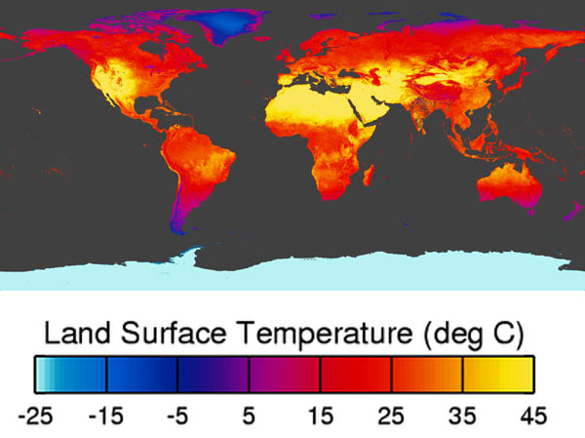

Fig. 7 Average surface temperature average for the month of July from 1982-1998. Values are in K (Source: AVHRR product, NOAA)

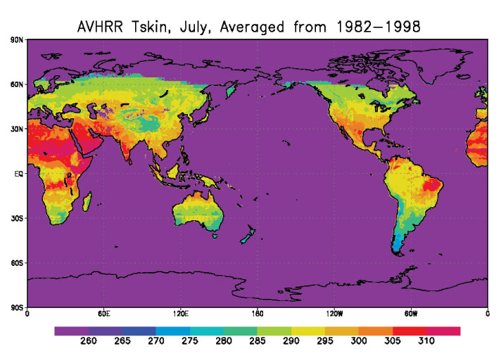

Fig. 8. Subsidence map created using PALSAR taken on 8/14/07 (Source: Cooperative Research Centre for Spatial Information and the School of Surveying & Spatial Information Systems, the University of New South Wales, using PALSAR data provided by ERSDAC)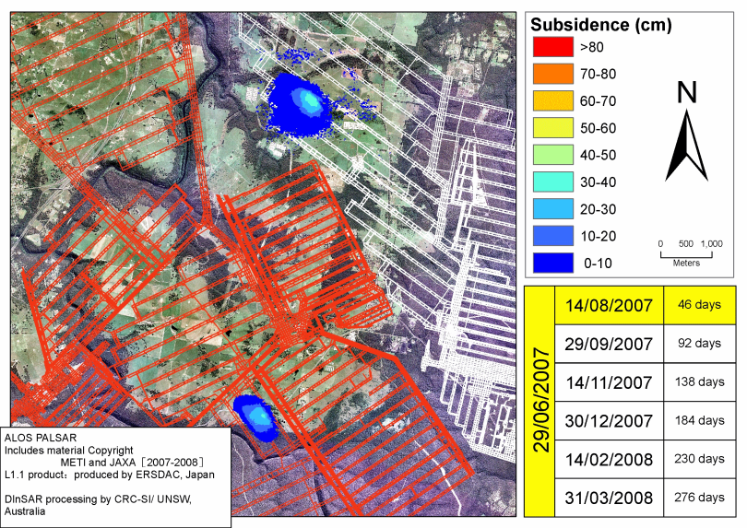

Fig. 9. Subsidence map created using PALSAR taken on 12/30/07 (Source: Cooperative Research Centre for Spatial Information and the School of Surveying & Spatial Information Systems, the University of New South Wales, using PALSAR data provided by ERSDAC)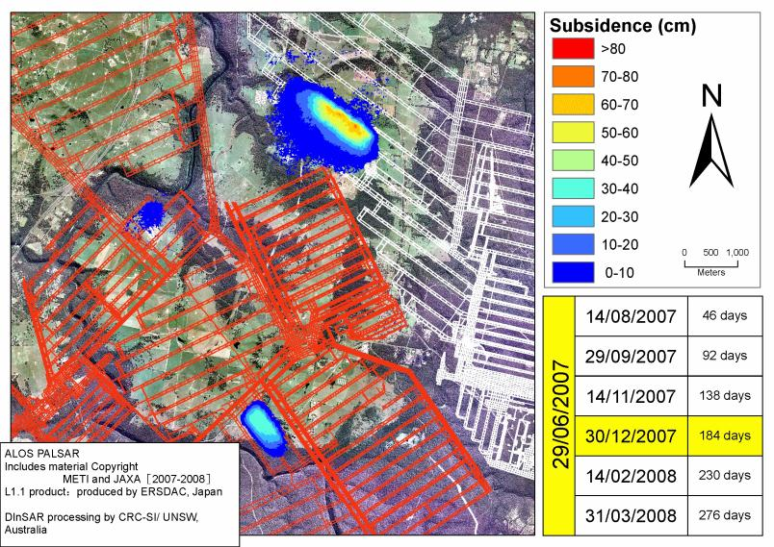

Fig. 10 RapidEye imagery of the Coastline of Miyagi Prefecture (Source: JAXA via www.diastercharter.org)

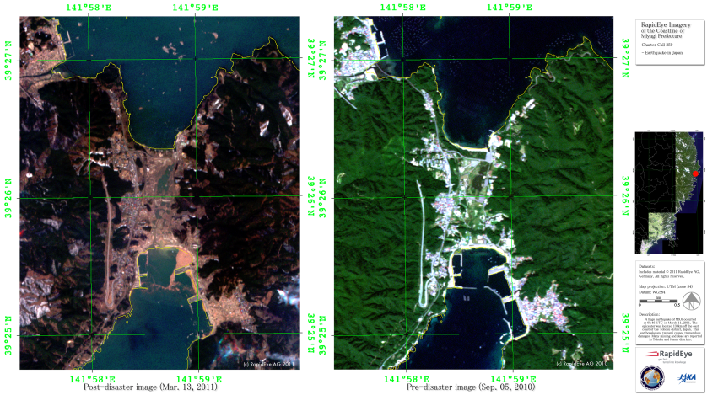

Fig. 11 Percentage of impervious surfaces in Uccle (Belgium) (Source: Estimating Urban Heat Island Effects on the Temperature Series of Uccle (Brussels, Belgium) Using Remote Sensing Data and a Land Surface Scheme by Hamdi in Remote Sensing, 2010, 2(12), 2773-2784)

