Dynamic Planet- Division B

Team Number: _______________
Student Names: ______________

Team Points: ______/88
Tie-Breaker (if needed):
Final Rank:
Please read each question carefully and answer as completely as possible. Good Luck!
Earth’s Interior: (9 points total)
1. Draw and label the layers of the Earth (five main layers). 5 points

2. Which layer is the thickest? 1 point

3. Which layer is the thinnest? 1 point

4. What two metals make up most of the inner core? 2 points

Plate Movement and Boundaries: (23 points total)
5. What are four pieces of evidence commonly used to support the theory of continental drift? (There are more than four, but pick four that are commonly used) 4 points

6. Draw and label a Convergent-Continental boundary. Make sure you label the type of plates, draw arrows to represent the direction in which they are moving, and include any common landforms/features that occur at this type of boundary. 4 points

7. Draw and label a Transform-fault boundary. Make sure you label the type of plates, draw arrows to represent the direction in which they are moving, and include any common landforms/features that occur at this type of boundary. 4 points

8. Draw and label a Convergent-Subduction boundary. Make sure you label the type of plates, draw arrows to represent the direction in which they are moving, and include any common landforms/features that occur at this type of boundary. 4 points

9. Draw and label a Divergent boundary. Make sure you label the type of plates, draw arrows to represent the direction in which they are moving, and include any common landforms/features that occur at this type of boundary. 4 points

10. What happens within the Earth that causes the plates to move? 1 point

11. What is the Ring of Fire? Where is it located? 2 points

Volcanoes: (15 points)
12. What is the difference between magma and lava? 1 point

13. Identify which type of volcano is described in the following statements: 4 points
a.) Steep sides, usually symmetrical, large, explosive eruptions, example- Mt. St. Helens
b.) “Simple” volcanoes, rarely grow over 1,000 feet, single vent, example- Paricutin
c.) Small masses of thick lava, grows mainly from within, example- Katma Volcano
d.) Gentle slopes, broad/wide, effusive eruptions, example- Mauna Loa

14. Which type of volcano usually starts underwater (at hot spots or mid-ocean ridges)? 1 point

15. Identify which volcano features are described in the following statements: 5 points
a.) Natural fountains of hot water and steam that escape at regular intervals through vents on the Earth’s surface
b.) Solidified layers of lava that flowed through openings in the crust
c.) Bowl shaped crater at the top of a volcano
d.) The result when (c) becomes filled with water
e.) Lava that solidified in the pipe of a volcano and is exposed when the outside of the volcano erodes.
f.) A spot where hot water that gushes from the within the Earth

16. Identify which volcano hazards are described in the following statements: 4 points
a.) Fragments of volcanic rock less than 2mm in size
b.) A mixture of gas, ash, and rock that moves quickly down the slope of a
volcano

c.) “Mudflow” formed from volcanic materials and water that travels down the slope of a volcano
d.) Carbon Dioxide, Hydrogen Chloride, and Hydrogen Fluoride are some examples

Earthquakes: (18 points total)
17. What is the difference between a seismometer and a seismogram? 1 point

18. What are S waves? How do they travel? 2 points

19. What are P waves? How do they travel? 2 points

20. Which seismic body wave travels the fastest? 1 point

21. What is the difference between surface waves and body waves? 2 points

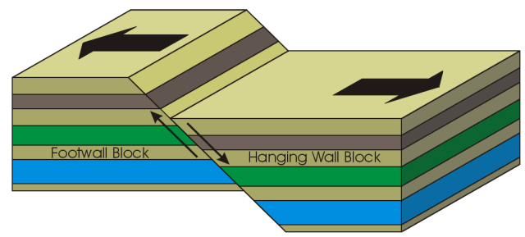
22. Identify the type of fault shown in each picture: 3 points
a.)

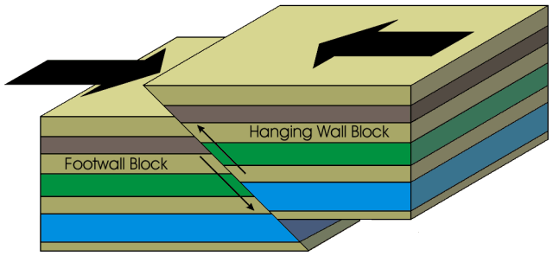
b.)

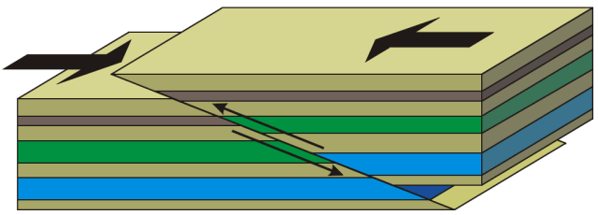
c.)

23. The _______________________________ scale measures the magnitude of an
earthquake, while the _______________________________ scale measures the intensity of ground shaking and damage. 2 points

24. What is the difference between the focus (or hypocenter) and epicenter? 1 point

- How do scientists use seismic waves to determine the location an earthquake
began? You may use a picture to help support your written answer. 4 points

Tsunamis: (5 points total)
26. True or False: A tsunami is a tidal wave. 1 point

27. True or False: A tsunami is a series of waves. 1 point

28. What are the three possible causes of tsunamis? (there are more than three- you only need to identify three) 3 points

Emergency Preparedness: (18 points)
29. What items should be in an emergency kit, regardless of the type of disaster possible? List at least five specific items. 5 points

30. Identify the following steps as important prior to or during an earthquake,
volcano, or both: 10 points

a.) Evacuate according to authorities
b.) Have a communication plan in place to get in touch with family members
c.) Use a dust mask or damp cloth to cover your mouth and nose
d.) Find a doorway or study table to stand/sit under
e.) Wear goggles to protect your eyes
f.) Listen to a radio for emergency updates
g.) Drop, cover, and hold on
h.) If you are outside, find a clear place and drop to the ground
i.) If you are outside, get inside the nearest building
j.) Attach bookcases and other tall furniture to a wall

31. If there is a threat of a tsunami, should you… (circle all that apply) 3 points
a.) stay in your home, regardless of its location
b.) go to the highest floor of a tall building
b.) move to the highest ground in your area
c.) head to the beach to watch the tsunami
e.) (if you are already out in a boat) head farther out from shore
f.) (if you are already out in a boat) dock your boat in the harbor and stay there
Tie Breaker- Respond in a paragraph:
What are some of the benefits of volcanoes?

Resources:
Fault Pictures from: facweb.bhc.edu/.../GEOL101/study/structur.htm
Information on plate boundaries, earthquakes, volcanoes, and tsunamis: www.usgs.gov and http://www.tulane.edu/~sanelson/geol204/index.html
More information on volcanoes: http://library.thinkquest.org/17457/volcanoes/
Preparedness Information: American Red Cross- www.redcross.org

