Bio Process 2009 Instructions

The event has 10 stations and a total of 60 questions. Students will print their name on a cover sheet and on their answer sheet as well. There will be 4 minutes per station.
Bio Process 2008 Instructions

Station A (Questions 1-5)

- How many 1 cc cubes can fit into a box that is a cubic meter in volume?
- Convert 9.768 kg to grams.
- Express 7645 mm in meters. Your answer should have a decimal in it, and should have the following form: 34.28 m
- What metric unit would be the best to express the mass of 10 gal of water ? (1 gal water has mass of about 8.2 pounds)
- What metric unit would be the best to express the distance traveled by a snail in 1 minute?
Station B (Questions 6-9)

Questions 6-7 involve the following information:

Serving size 75 g
Calories/serving 500
Fat 25g
Total carbohydrates 52 g
Protein 4 g
Calories per gram carb 5
Calories per gram protein 4
Calories per gram fat 10

- What per cent of calories in this food come from fat?

- Suppose the recommended daily amount of protein is 20 g. If the above food were the only source of protein in the diet, how much (in grams) of this food would have to be eaten?

- Using the table below, which food will have the least amount of carbohydrates per 8 0z serving?
Food | Serving size | Carbs/serving
A | 2 oz | 8 g
B | 4oz | 18 g
C | 6 oz | 20g

- Which of the following would be a good source of protein?
- steak
- macaroni and cheese
- salad
- apple
Station C (Questions 10-19)
For questions10-13, identify the dependent variable in each of the following statements. YOUR ANSWER MUST BE 4 WORDS OR LESS

- Height of venus fly trap is recorded daily for two weeks.
- Speed with which the venus fly trap closes in different amounts of light.

- Light absorption of a pigment is measured for different colors of light.
- Rate of growth pea plants at different temperatures

For questions 14-17, identify the independent variable in each of the following. YOUR ANSWER MUST BE 4 WORDS OR LESS

- The heart rate after different distances walked.
- Colors produced after exposure to different wavelengths of light
- Types of animals found in different climates.

- Amount of weight gained on various single food diets.

-------------------------

- When drawing a graph, which variable is placed on the x-axis?

- Papers are treated with different chemicals and people are asked if they can taste the chemical. What is an appropriate control for this experiment? YOUR ANSWER MUST BE 4 WORDS OR LESS

Station D (Questions 20-25)
A scientist collected samples from two different 2m x 2m areas. The results appear in the table below

Sampling area | Organism A | Organism B | Organism C | Organism D | TOTAL
1 | 20 | 15 | 25 | 40 | 100
2 | 87 | 10 | 3 | 0 | 100
Total | 107 | 25 | 28 | 40 | 200

- Which sampling area, 1 or 2, has the greatest diversity?
- What is the population density per square meter of organism A in sampling area 1?

- What is the population density per square meter of organism A in sampling area 2?

- What percent of the total number of organisms sampled is organism C?

- What percent of the organisms in area 1 is represented by organism B?

- All of the following explanations could explain the differences between the two sampling areas except:
- Area 2 has a predator of D but area 1 does not have the predator.
- Area 1 has more sources of food than area 2.
- Organism C is able to leave to go to different areas.
- Area 1 has a chemical that interferes with the growth of organism D
Station E (Questions 26-35)
For questions 26-28, refer to the following TABLE

YEAR | NUMBER OF PINES PER ACRE | NUMBER OF HARDWOODS PER ACRE
1905 | 300 | 37
1910 | 300 | 38
1915 | 273 | 50
1920 | 221 | 78
1925 | 198 | 103
1930 | 152 | 114

- How many pines were lost per acre between years 1910 and 1925?
- What was the percentage increase in hardwoods between 1920 and 1930?
- All of the following statements could explain the increase in hardwood trees except
- Pine beetles arrived in the forest in 1913.
- Ecological succession is occurring.
- C. In 1916 the squirrel population exploded, and the squirrels ate all of the acorns.
- The production of newspapers tripled in 1921.

- Which of the following safety rules is misstated?
- When working with chemicals, wearing safety goggles should be done only if the chemicals are not known.
- Closed-toed shoes should be worn in the lab.
- Test tube tongs should be used when handling hot glassware.
- Long hair should be pulled back when working with flames.

- A person in a tent in the tropical rain forest sees that the thermometer reads 31º. This thermometer is calibrated in which scale?
- Degrees Celsius (centrigrade)
- Degrees Fahrenheit
- Either scale is possible
- Unable to determine from the information given.
For Questions 31-35, match the temperature with the indicated situation. Some choices may be used more than once, others not at all.

A. -15⁰C to 0ºC; B. 0ºC to 20ºC; C. 35ºC to 40ºC; D. >100ºC
31. ice cubes taken from a freezer 34. mountain stream in January
32. normal human body temperature 35. typical temperature in Georgia in late January
33. oven for baking bread
Station F (Questions 36-39)

- Will the cells of a carrot contain chloroplasts?
- Yes. A carrot is a plant, and plants carry out photosynthesis.
- Yes, but the orange pigments in the carrot will make it difficult to see the chloroplasts.
- No, a carrot will not be exposed to light while it is maturing.
- No. Photosynthesis occurs only in the spring, and carrots are harvested in the fall.

- Which of the following statements best describes a single-celled organism that is found to contain cilia?
- It probably lives on the skin.
- It probably lives in water
- It probably can capture its food by grabbing it with the cilia
- It probably uses the cilia to hook to other cells with cilia.

- The three graphs below represent three different enzymes, A, B, C, that are required for growth by a protozoan. What water pH is the best pH for the organism?

20 _
18 _
16 _
A
B

C
14 _
Enzyme Rate
(mg/sec)
12 _
10 _
08 _
06 _
04 _
02 _
___________________________________________
| | | | | | | | | | | |
1 2 3 4 5 6 7 8 9 10 11 12
pH

- What is the approximate rate of enzyme C at pH 6? Be sure to use proper units.
Station G (Questions 40-42)

- Consider the following cross: GG X gg. If 240 progeny are produced, how many are expected to be gg?

Use the genotype table below to answer questions 41-42. Tongue rolling is dominant to non-rolling (R vs r). Arched is dominant to flat feet. (A vs a) A couple, each with the genotype RrAa, mate and have children. Sperm

AR Ar aR ar

Eggs AR AA RR AARr AaRR AaRr

Ar AARr AArr AaRr Aarr

aR AaRR AaRr aaRR aaRr

ar AaRr Aarr aaRr aarr

- What fraction of their children will be rollers with flat feed? Express answer as a fraction.

- If they have 16 children, how many of their children will have arches?
Station H (Questions 43-47)
Refer to the liquid handling devices provided to answer the following questions.

- What is the name of the empty liquid handling device?

- How much colored water is in the graduated cylinder?

- What is the minimum volume capable of being accurately measured by the graduated cylinder?

- Is the beaker or the graduated cylinder more accurate to measure volume?

- Could 455 ml be accurately measured in the beaker provided?
Station I (Questions 48-56)

Questions 48-50 at this station pertain to the picture of the microscope below.
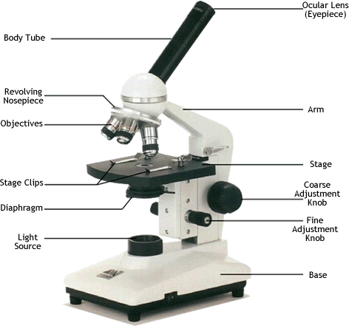

- Which part would be used to regulate the amount of light?
- Which part is used to change the magnification?
- When observing a specimen for the first time, do you adjust the coarse or fine focus first?

Station I (Continued)
For questions 51-54, match the picture with its correct statement. USE CAPITAL LETTERS IN YOUR ANSWER. Some choices will be used more than once, others not at all. Each question will have only one answer.

A. Could be used to identify cells that are dividing.
B. Probably plant cells.
C. These cells carry oxygen to tissues.
D. No answer given

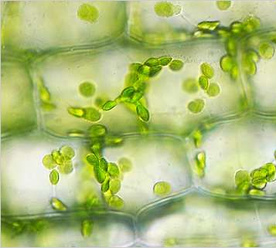Question 51 | 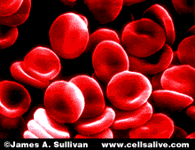Question 52
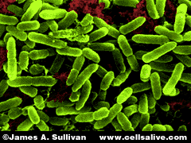  Question 53 | 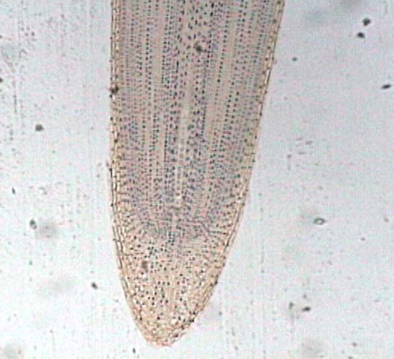  Question 54

Station I (Continued)

- What is most likely visualized on the photograph of the agarose gel depicted below?
top
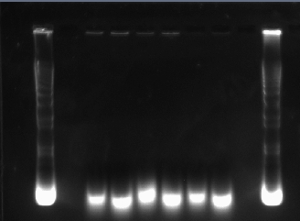
bottom

56. To what charge does the substance loaded in to the gel migrate?

Station J (Questions 57-60)

- An almost rectangular cell has the following dimensions: 0.04mm x 0.03mm x
6 mm. What is volume of cytoplasm? Use proper units.
- A sample contained 6.4 x10⁶/cm³ red blood cells and 2.2 x10⁶/cm³ white blood cells. What percentage of cells were red blood cells?
- In humans the small intestine is about 25 feet long. There are 2.5 cm/inch. How long in cm is the small intestine?
- A scientist studies the number of organisms in a circular area with a diameter of 400 m.. What is the approximate area of the field? Use π=3.14 for your calculations. Be sure to use proper units.
School_______________________________________________

Names_________________________________________

1__________________________________
2. __________________________________
3. __________________________________
4__________________________________
5. __________________________________
6. __________________________________
7. __________________________________
8__________________________________
9. __________________________________
10. __________________________________
11__________________________________
12. __________________________________
13__________________________________
14__________________________________
15__________________________________
16__________________________________
17__________________________________
18__________________________________
19__________________________________
20__________________________________
21__________________________________
22__________________________________
23__________________________________
24__________________________________
25__________________________________
26__________________________________
27__________________________________
28__________________________________
29__________________________________
30__________________________________

31__________________________________
32__________________________________
33__________________________________
34__________________________________
35__________________________________
36__________________________________
37__________________________________
38__________________________________
39__________________________________
40__________________________________
41_________________________________
42__________________________________
43__________________________________
44__________________________________
45__________________________________
46__________________________________
47__________________________________
48__________________________________
49__________________________________
50__________________________________
51__________________________________
52__________________________________
53__________________________________
54__________________________________
55__________________________________
56__________________________________
57__________________________________
58__________________________________
59__________________________________
60__________________________________

Bio Process Lab Answer Key
DO NOT COPY WITH EVENT!!
To break a tie, the group that answered the most of following questions correctly: #8, 22, 42, 45, 56, and 60

1 1,000,00
2. 9768 G
3. 7.645 m
4 Kg,
5. mm or cm
6. 50%
7. 375 g (4g/75g =20g/x))
8 C
9. A-steak
10. height (of venus fly trap)
11 speed
12. light absorbed
13. growth rate
14. distances walked
15. wavelength (of light)
16. climate
17. type of food
18. independent
19. paper with no chemical
20. 1
21. 5 organisms/m² (20 org/4m²⁾
22 22 org/m² NOT 3.75
23. 14% (28/200)
24 15%
25. D
26 102 pines
27. 46% (WITH NO DECIMALS!!)
28. C
29. A
30. A

31. A
32. C
33. D
34. B
35. B
36. C
37 B
38 pH 8.5-9.5
39 4-5 mg/sec
40 120
41 3/16
42 12
43 erlenmeyer flask
44 640 mls
45 30 mls
46 graduated cylinder
47 no
48. diaphragm
49 REVOLVING NOSE PIECE (NOT OBJECTIVE)
50. coarse
51 B
52 C
53 D
54 A (B OK)
55. DNA
56. positive
57. 7.2 x 10⁻⁴ mm³
58 74 %
59 750 cm
^{60. 628 m}2

