Keep the Heat Test 1-28-2012

School Name

Team Number

Circle the all of the correct answer to the below questions.
One or more of the answers can be correct, if more than on one answer is correct, circle all correct answers.

- Temperature is a measure of ____ of the particles in an object.
  - the difference between the potential and kinetic energy
  - the sum of the potential and kinetic energy
  - the average potential energy
  - the average kinetic energy

- A liquid thermometer works because liquid ____ when warmed.
  - expands
  - solidifies
  - contracts
  - condenses

- An increase in heat in a system __________.
  - has less kinetic energy
  - increases entropy
  - decreases entropy
  - reduces temperature

- The specific latent heat of melting for lead is 22.4 kJ/kg and that of oxygen is 13.9 kJ/kg. This means:
  - Lead melts at a higher temperature.
  - More energy is needed to heat lead than is needed to heat the same mass of oxygen by the same amount.
  - More energy is needed to melt lead than is needed to melt oxygen.
  - Less energy is needed to heat lead than is needed to heat the same mass of oxygen by the same amount.
  - Lead melts at a lower temperature.

- Convert the temperature of 32 ºC to degrees Rankline
  - -409 ºR
  - -370 ºR
  - 485 ºR
  - 509 ºR
  - 549 ºR

- Convert the temperature of 100 ºF to degrees Celsius
  - 24 ºC
  - 38 ºC
  - 88 ºC
  - 122ºC
  - 148 ºC

- Convert the temperature of 32 ºF to degrees Kelvin
  - 259 ºK
  - 273 ºK
  - 299 ºK
  - 323 ºK
  - 388 ºK

- The temperature of Lightening is 28000 ºK. Convert this temperature to degrees Fahrenheit.
  - 15644 ºF
  - 15708 ºF
  - 49940 ºF
  - 50000 ºF (SIG Fig’s)
  - 50149 ºF

- An Object starts at 50 C, energy is added until the temperature increases to 60 C for a total ∆T of 10 C. What is the temperature change as expressed in degrees Kelvin
  - -263 ºK
  - 10 ºK
  - 50 ºK
  - 283 ºK
  - 510 ºK

- An Object starts at 85 C, energy is added until the temperature increases to 100 C for a total ∆T of 15 C. What is the temperature change as expressed in degrees Fahrenheit
  - 8.3 ºF
  - 15 ºF
  - 27 ºF
  - 40 ºF
  - 59 ºF

- Which of the following statement is/are correct?
  - Heat is a form of energy and it is contained inside a body
  - The temperature of a body does not depend on the internal energy it possesses
  - When two bodies of different temperatures are in thermal contact, internal energy are transferred from the body of higher temperature to that of lower temperature
  - It is impossible to transfer heat energy from one body to another if they are at the same temperature

- Which of the following statements about 'heat' is/are Correct?
  - it is the energy transferred due to temperature difference
  - if Object A has a higher temperature than Object B, Object A must have more thermal energy than Object B.
  - it has the same meaning as work
  - it is related to degree of hotness

- The specific heat capacity of a substance is the heat required to warm
  - it by 1 degree Celsius
  - 1 kilogram of water by one degree Celsius
  - 1 kilogram of it by one degree Celsius
  - an equal weight of water by one degree Celsius

- Given the specific heat capacity of ice is 2100 Jkg^{-1o}C⁻¹, and the specific heat capacity of water is 4200 Jkg^{-1o}C⁻¹. For the same mass of ice and water, if the same amount of heat is added to the ice and water:
  - The temperature of the Ice will increase 2 times the temperature increase of the water
  - The temperature of the Ice and water will increase the same amount.
  - The temperature of the Ice will increase 0.5 times the temperature increase of the water
  - Not enough information is provided determine the relative temperature change

- The specific heat capacity of a water is 4200 Jkg^{-1o}C⁻¹ means that if we have 1 kg of water:
  - a heater of power 1 W would take 4200s to heat the water before it boils
  - a heater of power 4200 W would take 1 s to heat the water from 300 K to 301 K
  - the water contains 4200 J of internal energy
  - 4200 J are needed to turn the water into steam

- By E = mc∆T and c = 4200 Jkg^{-1o}C⁻¹. Calculate the energy used to heat the water. (Given Mass of water m = 2 kg, Initial temperature T1 = 80 ºC, Final temperature T2 = 100 ºC )
  - 672000J
  - 840000J
  - 168000J
  - 120000J

- Sublimation occurs when
  - liquid water changes to gaseous water.
  - gaseous water changes to ice.
  - ice changes to gaseous water.
  - ice changes to liquid water.
  - liquid water changes to ice.

- Which of the following are expressions of microscopic energy:
  - A vehicle is sitting on top of a large hill
  - The kinetic energy of individual molecules
  - The potential energy stored in candle wax
  - A ball is flying through the air at 10 feet / second.
  - An average donut is 320 calories

- A heat engine has a thermal efficiency of 45%. How much power does the engine produce when heat is transferred into it at a rate of 10⁹ kJ/Hr?
  - 50 MW
  - 75 MW
  - 100 MW
  - 125 MW

- The thermodynamic efficiency of a heat engine that rejects heat at a rate of 20 MW when heat is supplied to it at a rate of 60 MW is:
  - 33.3%
  - 50%
  - 66.7%
  - 75%

- Which of the following laws of physics becomes the foundation of thermodynamics?
  - Newton’s laws of motion
  - Law of conservation of energy
  - Law of universal gravitation
  - Law of conservation of momentum

- All real refrigerators require work to get heat to flow from a cold area to a warmer area. Which of the following parts of the refrigerator does work for this purpose?
  - coils
  - lamp
  - condenser
  - motor

- What do you call an object that does not significantly change in temperature and internal energy even when heat is removed or added to it?
  - Heat sink
  - Reservoir
  - Working substance
  - Heat engine

- The natural direction of heat flow is from high-temperature reservoir to a low temperature reservoir, regardless of their respective heat contents. This fact is incorporated in the
  - first law of thermodynamics.
  - second law of thermodynamics.
  - law of conservation of energy.
  - law of conservation of entropy.

- If 50 grams of ice and 50 grams of water are both at 0ºC, then it is true that
  - the water molecules have a higher average kinetic energy than the ice molecules
  - the ice molecules have a higher average kinetic energy than the water molecules
  - the water molecules have a higher total potential energy than the ice molecules
  - the ice molecules have a higher total potential energy than the water molecules

- A block of ice at -10ºC is slowly heated and converted to steam at 100ºC. Which of the following curves represents the phenomenon qualitatively
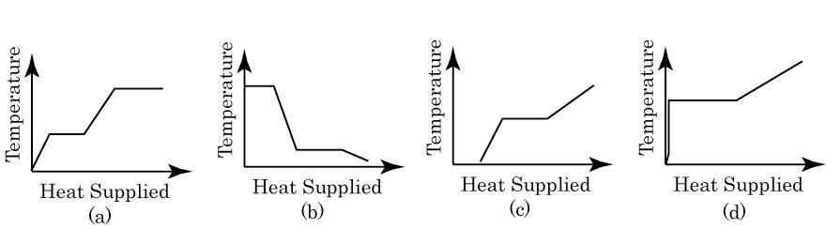
- A block of metal is heated to a temperature much higher than the room temperature and allowed to cool in a room free from air currents. Which of the following curves correctly represents the rate of cooling?
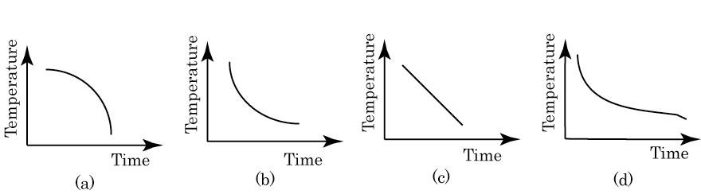

- An adiabatic expansion of a gas is one in which
  - the pressure is kept constant
  - the volume is kept constant
  - the temperature is kept constant
  - it neither loses nor gains heat

- In what year did Anders Celsius propose the international temperature scale bearing his name?
  - 1614
  - 1655
  - 1703
  - 1742
  - 1821

- This person is often called the father of thermodynamics
  - Nicolas Leonard Sadi Carnot
  - George Brayton
  - Anders Celsius
  - Rudolf Diesel
  - Daniel Gabriel Fahrenheit

- This person laid the ground work for the second law of thermodynamics
  - Nicolas Leonard Sadi Carnot
  - George Brayton
  - Anders Celsius
  - Rudolf Diesel
  - Daniel Gabriel Fahrenheit

- Who is most known as the first engineer to prove that fuel can be ignited without a flame or a spark, which he accomplished in the 1890s.
  - Nicolas Leonard Sadi Carnot
  - George Brayton
  - Rudolf Diesel
  - James Prescott Joule
  - Nikolaus August Otto

- Who invented the four stroke combustion cycle. He was the first to create a practical multistroke engine. His working model was the first internal combustion, four-stroke engine to efficiently burn fuel in a piston.
  - Nicolas Leonard Sadi Carnot
  - George Brayton
  - Rudolf Diesel
  - James Prescott Joule
  - Nikolaus August Otto

- Which of the following were NOT credited with optimizing or improving thermal engines?
  - Miller
  - Otto
  - Atkinson
  - Watt
  - Fahrenheit

- List the Number of the Law of Thermodynamics that is expressed in the following statements (0th Law,1st Law ,2nd Law,3rd Law or 4th Law).
  - Using logs in a fire place to heat a home (1st Law)
  - Lighting a Candle which gives off heat and light (1st Law)
  - A thermometer is placed in a cup of hot water to measure it’s temperature. (0th Law)
  - Coffee is placed in a coffee mug. The outside of the mug heats up. (1st Law)
  - An oscillating pendulum eventually stops and comes to rest. (2nd Law)
  - A heat engine takes that works between two heat reservoirs (2nd Law)

- A small candy bar has 52 calories. If all of its energy were converted to heat, by how much would it raise the temperature of 1 L of water?
  - 1° C
  - 52° C
  - 104° C
  - 0° C

- Who discovered the mechanical equivalent of heat?
  - Robert Boyle
  - Antoine Lavoisier
  - James Joule
  - James Watt

- If a fixed volume cylinder containing water, is heated by a bunsen burner, what is the type of thermodynamic process?
  - Isochoric
  - Isobaric
  - Adiabatic
  - Isothermal
  - Isentropic

- Express the following quantities in terms of base SI units (kg, m, and s): (a) power, (b) kinetic energy, and (c) specific weight.
  - Power = (force)(velocity) = (N)(m/s) = (kg·m/s²)(m/s) = kg·m²/s³
  - Kinetic energy = mass × velocity² = kg·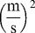= kg·m²/s²
  - Specific weight = weight/volume = N/m³ = kg·/m³= kg/(s²·m²)

- Identify which of the following are extensive properties and which are intensive properties: (a) a 10-m3 volume, (b) 30 J of kinetic energy, (c) a pressure of 90 kPa, (d) a stress of 1000 kPa, (e) a mass of 75 kg, and (f) a velocity of 60 m/s. (g) Convert all extensive properties to intensive properties assuming m = 75 kg.
  - Extensive. If the mass is doubled, the volume increases.
  - Extensive. If the mass doubles, the kinetic energy increases.
  - Intensive. Pressure is independent of mass.
  - Intensive. Stress is independent of mass.
  - Extensive. If the mass doubles, the mass doubles.
  - Intensive. Velocity is independent of mass.

- When you are setting a table, why does the metal fork feel cooler than a plastic cup? Use Thermodynamic terms to explain your answer. (This question is worth both points and is the first Tie Breaker)

The reason for that is conductivity. Metal is a better conductor of heat than plastic.
When you touch metal, the body heat from your body is conducted to the metal very quickly. Because of the high thermal conductivity of the metal, the heat from your body is heating a larger portion of the mass of the metal than of the plastic cup.

- The gas in a cubical volume with sides at different temperatures is suddenly isolated with reference to transfer of mass and energy. Is this system in thermodynamic equilibrium? Why or why not? (This question is worth both points and is the Second Tie Breaker)

It is not in thermodynamic equilibrium. If the sides of the container are at different temperatures, the temperature is not uniform over the entire volume, a requirement of thermodynamic equilibrium. After a period of time elapsed, the sides would all approach the same temperature and equilibrium would eventually be attained.

- Does exothermic truly mean the reaction releases only heat? Use Thermodynamic terms to explain your answer. (This question is worth both points and is the Third Tie Breaker)

In thermodynamics, the term exothermic ("outside heating") describes a process or reaction that releases energy from the system, usually in the form of heat, but also in the form of light (e.g. a spark, flame, or explosion), electricity (e.g. a battery), or sound (e.g. burning hydrogen).

- Use equations to show that -40 C is the same temperature as – 40 F. (This question is worth both points and is the Fourth Tie Breaker)

Two Equations - C = (F -32)*5/9; and F = C
Therefore F = (F-32)*5/9
F – 5/9*F = - 32 * 5/9
4/9 * F = - 32 *5/9
F = (- 32 * 5/9) / (4/9)
F = C = -40

