**DISEASE DETECTIVE**

**INVITATIONAL 2014**

Directions: Read the following scenarios and answer the questions that follow. Questions are matching, multiple choice, or short answer. The number in parenthesis indicates the point value

for each part.

.

**Part 1. Match the following terms on the left with the definitions on the**

**right. Each term will have only one answer. (15)**

|  |  |
| --- | --- |
| 1. Cohort ______  2. Epidemic curve ________  3. Fomite ________  4. Line list ________  5. Attack rate ________  6. Endemic ________  7. Odds ratio ______  8. Relative risk______  9. Case-control __________  10. Vector ________  11. Pandemic _________  12. Epidemic _________  13. Outbreak _______  14. Morbidity ________  15. Mortality _________ | a) An animate, living insect or animal that is involved with transmission of the disease agent.  b) Disease or infectious agent that is habitually present in a community, geographic area, or population group.  c) More cases of a particular disease than expected in a given area or among a specialized group of people over a particular period of time.  d) Occurrence of a disease clearly in excess of normal expectancy.  e) An inanimate object that is laden with disease-causing agents.  f) Study that follows a group of subjects who received a specific exposure in order to examine the differences in incidence of a specific disease or other outcome of interest.  g) The rate that a group experienced an outcome or illness.  h) Chart of information about each case.  i) An epidemic that spans a wide geographic area.  j) Measure of association between frequency of exposure and frequency of outcome (formula is AD/BC).  k) Occurrence of an illness or illnesses in a population.  l) A histogram showing the course of a disease or outbreak.  m) Study that compares individuals who have a disease with individuals who do not have the disease in order to examine differences in exposures or risk factors for the disease  n) Ratio of the risk of disease or death among the exposed to the risk among the unexposed.  o) Occurrence of death in a population. |

Part 2: Read the following information on ozone and

answer questions 1-4 on the answer sheet. (4 points)

Scientists 100 years ago would have been incredulous at the idea that, by the late twentieth century,

humankind would be affecting the stratosphere. Yet, remarkably, human-induced depletion of

stratospheric ozone has recently begun – after 8,000 generations of Homo sapiens.

Stratospheric ozone absorbs much of the incoming solar ultraviolet radiation (UVR), especially the

biologically more damaging, shorter-wavelength, UVR.

During the 1980s and 1990s at northern mid-latitudes (such as Europe), the average year-round

ozone concentration declined by around 4% per decade: over the southern regions of Australia,

New Zealand, Argentina and South Africa, the figure approximated 6-7%. Estimating the resultant

changes in actual ground-level ultraviolet radiation remains technically complex. However, exposures

at northern mid-latitudes, for example, are likely to peak around 2020, with an estimated 10% increase

in effective ultraviolet radiation relative to 1980s levels (World Health Organization)

1. What is a possible cause of ozone depletion in the stratosphere? ___________________
2. What is a possible health risk associated with increase exposure to ultraviolet radiation? ______
3. What measures have been taken by the US to lessen ozone depletion? ______________________________________________________________________
4. Ozone is also a pollutant given off by the burning of fossil fuels. Ground-level ozone can be

a health hazard for humans. The EPA has an index it uses to measure ozone levels.

What is the name of this index? _____________

**Part 3: Read the following article on Cholera and answer questions 1-8 on the answer sheet. (19 points)**

Cholera epidemics have been reported in many districts in Uganda in recent years. In the period

July 1999 to May 2000 up to 19 districts from all the four regions of the country registered cholera

outbreaks. A total of 4,388 cases with 219 deaths were recorded.

(Hon. Kiyonga C, 2000).

In Rukungiri district there have been several epidemics in the past two decades. In 1978 a severe

outbreak occurred in Rwenshama. This was a period of serious socio-economic problems in Uganda.

Although hard data were difficult to come by, reliable sources put the case fatality rate at over 40%.

In the period December 1997 to January 1998, an outbreak occurred in Rujumbura and Rubabo counties.

It affected six subcounties: Nyakagyeme, Kagunga, Rukungiri Town Council, Buyanja, Ruhinda

and Bugangari. Thirty-two people were taken ill and the case fatality rate was 12.5%. In 1998 from

April to June an epidemic occurred in Rwenshama. It affected 76 people with a case fatality rate

of 7.9%. Another outbreak in Rwenshama occurred again from November to December 1999

attacking 22 people with case fatality rate of 18% ([www.cdc.gov](http://www.cdc.gov))

1. What is cholera? ____________________________
2. What causes cholera? _____________________ Tie Breaker: Scientific Name
3. What are the symptoms of cholera? (two) ____________, ___________
4. What kind of study is this? Case-control study or cohort study
5. What was the case fatality rate in percent for the epidemic occurring between

July 1999 to May 2000? (first paragraph above)

1. Give a possible hypothesis for this cholera epidemic:
2. What are the ten steps in outbreak investigation?

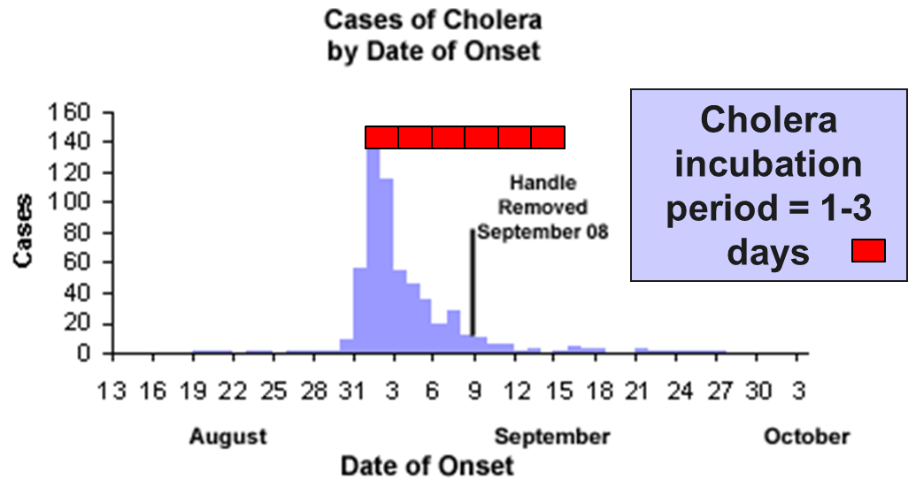

1. Given the above epidemic curve for the cholera outbreak of 1853 in London,

would you describe the source of the epidemic as point source or continuous common source? ____________

9. Describe the conditions in London at this time that lead to the cholera outbreak.

**Part 4: Read the following article on a Salmonellosis outbreak and answer**

**questions 1-3 on the answer sheet. (4 points)**

A community in Massachusetts experienced an outbreak of Salmonellosis. Health officials noted

that an unusually large number of cases had been reported during a span of several days. The table

below summarizes some of the salient facts about Salmonella infections. Descriptive epidemiology was conducted, and hypothesis-generating interviews indicated that all of the disease people had attended

a parent-teacher luncheon at a local school. In fact, it was a potluck luncheon, and the attendees each

brought a dish that they had either prepared at home or purchased. The descriptive epidemiology

convincingly indicated that the outbreak originated at the luncheon, but which specific dish was

responsible? The investigators needed to establish which dish was responsible in order to clearly

establish the source and to ensure that appropriate control measures were undertaken.

The source population was obviously the attendees of the luncheon, and 58% of the attendees

had developed symptoms consistent with the case definition. Of these, 45 attendees agreed to

complete a questionnaire regarding the foods that they had eaten at the luncheon. For each dish

served at the luncheon the investigators compared the incidence of Salmonellosis between those

who ate a particular dish (the exposed group) and those who had not eaten that dish (the non-exposed comparison group). For each dish they constructed a contingency table to summarize the result

from the survey. For example, the table below summarizes the findings from the survey regarding

the incidence of disease in those who ate the cheese appetizer compared to those who did not eat it.

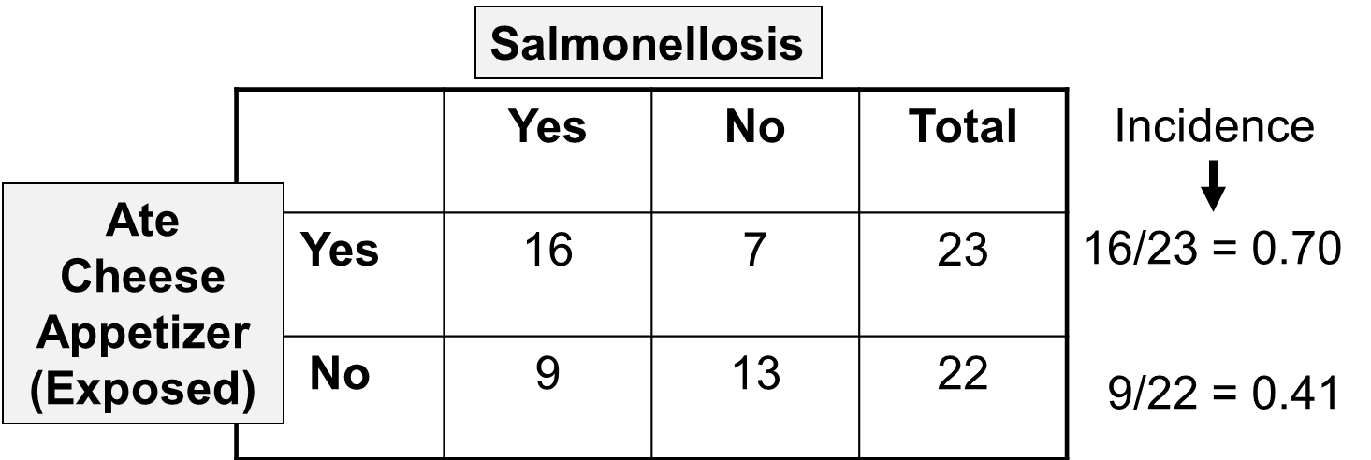

1. What kind of study is the above example; Cohort or Case-Control? _________
2. What is the incidence rate in percent for both exposed and non-exposed?

(percent) _________ and _______

1. Calculate the risk ratio to the nearest .01 _____________

Part 5: Comparing Data

Directions: Read the description below and answer

questions 1-3 on the answer sheet. (3 points)

Within a short period of time 20 cases of hepatitis A were identified in the Marshfield area.

The epidemic curve suggested a point source epidemic, and the spot map showed the cases

to be spread across the entire South Shore of Massachusetts, although the pattern suggested

a focus near Marshfield. Hypothesis-generating interviews resulted in five food establishments that

were candidate sources. Moreover, the disease was rare, so that even if they interviewed a sample

of patrons at each of the restaurants, it is most likely that few, if any would have had recent hepatitis,

even from the responsible restaurant.

Consider the following examples: Compare the odds ratio for each of these studies and determine

which study shows a strong correlation between eating at the restaurant and getting the disease?

|  |  |  |
| --- | --- | --- |
|  | **Cases** | **Controls** |
| Ate at Papa Gino's | 10 | 19 |
| Did not eat at Papa Gino's | 9 | 19 |
|  | 19 | 38 |

1. Odds ratio for Papa Ginos: ____________

In contrast, consider the findings for Ron's Grill:

|  |  |  |
| --- | --- | --- |
|  | **Cases** | **Controls** |
| Ate at Ron's Grill | 18 | 7 |
| Did not eat at Ron's | 1 | 29 |
|  | 19 | 38 |

2. Odds ratio for Ron’s grill: _______________

3. Which restaurant shows a greater tendency of being the source of the outbreak? _________

**Part 6: Using your knowledge and the information listed on the next page answer questions 1-8 on the answer sheet (8 points)**

Asthma affects people of all ages, but it most often starts during childhood. In the United States, more than 25 million people are known to have asthma.

1. Define asthma: ___________
2. What percent of children with asthma have allergies? ______
3. How many deaths per year are attributed to asthma __________of those deaths what

percent are women?

1. How many Americans miss work each day due to asthma? _________
2. What are three environmental factors that can trigger an asthma attack?
3. What are two signs of an asthma attack?
4. In the last ten years there has been a 48% increase in asthma cases. What can this be attributed to?
5. What is a quick-relief medication used to help relieve asthma symptoms?

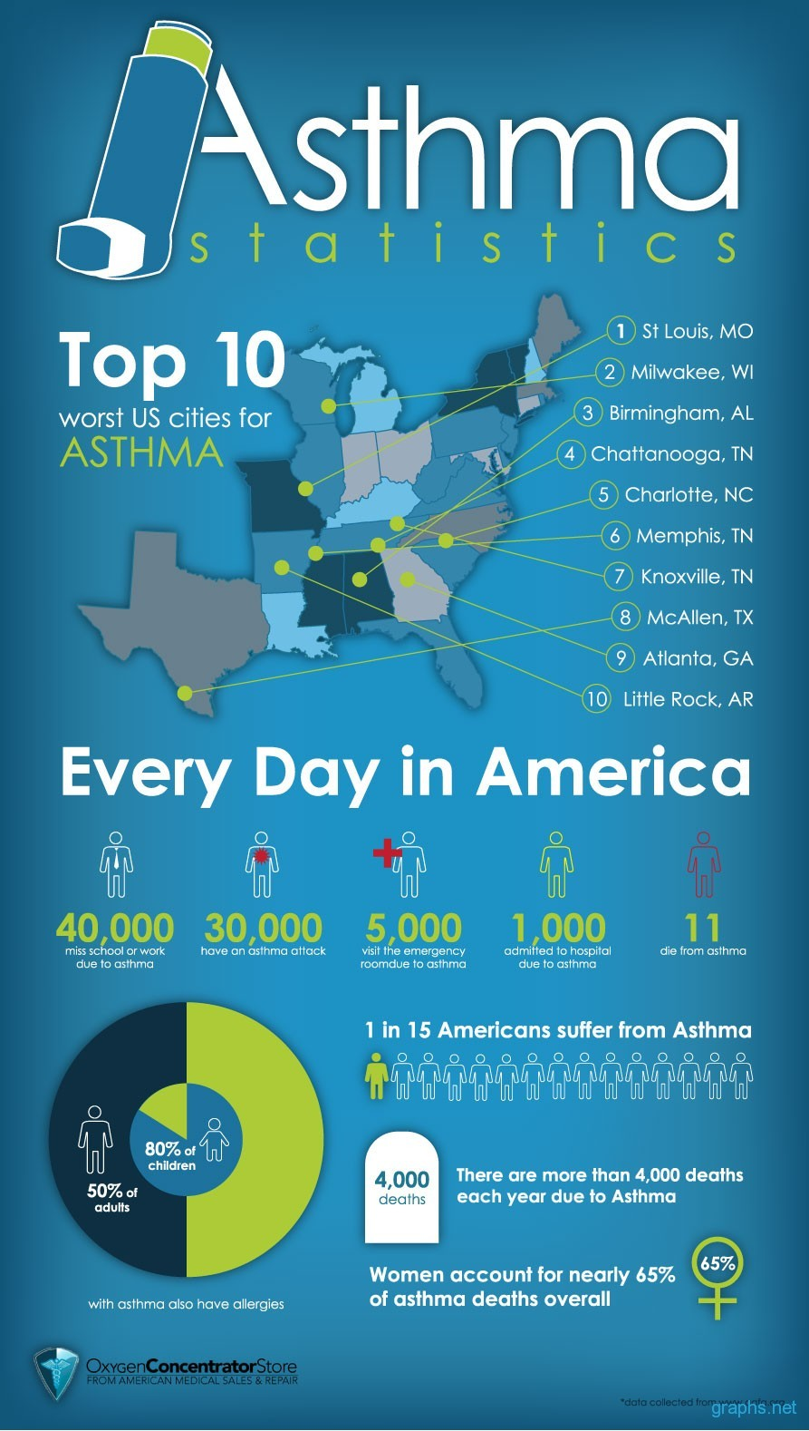

RUSTIN INVITATIONAL 2014

DISEASE DETECTIVE

DIVISION B

