

Virginia Science Olympiad
Physical Science Lab Exam
Division B
2009

While waiting to be called to demonstrate your CD wind machine you should work silently with your partner and complete this exam. You may not talk to anyone else while working on this exam. Total possible points on this exam is 300.

Multiple Choice Circle the best answer for each question. (10 points each)

- Which of the following is not considered to be a renewable energy source?
  - wind
  - solar
  - geothermal
  - natural gas
  - biomass

- Of these renewable energy sources which one does not depend directly on radiant energy from the Sun?
  - biomass
  - wind
  - solar
  - geothermal

- When the propeller blades of a wind turbine turn their motion is converted into electrical energy by
  - turning a magnet inside a magnetic field.
  - turning a magnet inside a wire coil.
  - turning a wire coil inside a magnetic field.
  - turning a wire coil inside another wire coil.

- Wind turbines are normally mounted100 feet or more above the ground. This is done in order to:
  - allow room for plants and trees to grow beneath them.
  - reduce noise for people who live and work nearby.
  - take advantage of faster, less turbulent winds.
  - reduce the number of birds that might be killed by the blades.

- Wind turbines are not cost effective to build and operate in all areas. The biggest reason for this is:
  - the wind patterns are not strong or consistent enough in that area.
  - not every community wants to look at them.
  - migratory bird patterns would pose increased risk to the birds.
  - there are less expensive energy sources in that region.

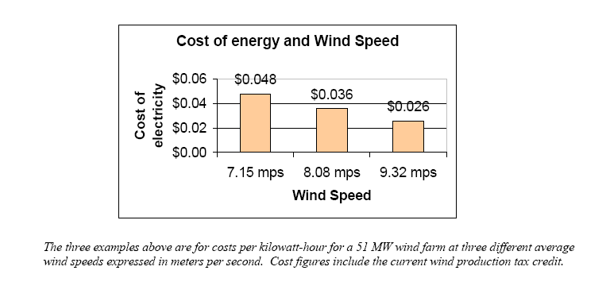
- Based on the graph of “Cost of energy and Wind Speed” what can you determine about wind energy costs?
Source: http://www.awea.org/pubs/factsheets/EconomicsOfWind-Feb2005.pdf

  - The cost of energy from wind increases as wind speed increases.
  - There is no relationship between wind speed and wind energy cost.
  - The cost of energy from wind increases as wind speed decreases.
  - The cost of energy from wind decreases as wind speed decreases.

- Which of the following is not a concern about wind energy?
  - Birds and bats can be killed when they fly into the turbine blades.
  - The noise can be disturb those who live and work nearby.
  - They are not pretty to look at and can destroy scenic views on mountains or along beaches.
  - They create no air pollution.

- Solar energy can be used for a variety of purposes. Solar energy can be used to either produce energy or reduce energy usage. Which statement best describes the use of solar energy to heat hot water for a home, school, or business?
  - Solar panels that heat hot water use photo-voltaic cells to reduce energy needed from non-renewable sources..
  - Solar panels that heat hot water use the Sun’s radiant energy to heat water and reduce energy needed from non-renewable sources.
  - Solar panels that heat hot water use the Sun’s thermal energy to heat water and reduce energy needed from non-renewable sources.

Use the following data table to answer Questions 9 through 13.
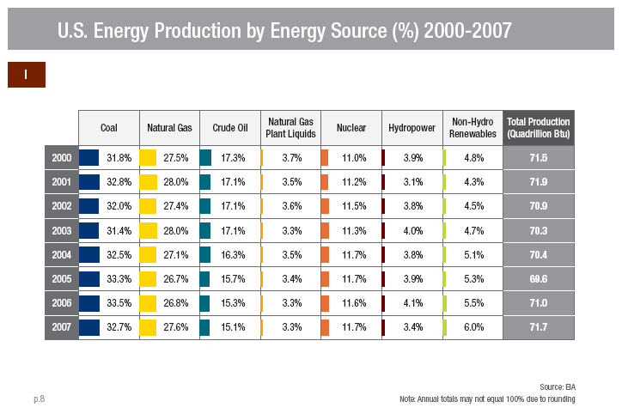
http://www1.eere.energy.gov/maps_data/pdfs/eere_databook_091208.pdf

- What percentage of U.S energy production in 2007 was based on non-renewable sources?
  - 21.1%
  - 45.6%
  - 78.7%
  - 90.4%

- Which energy source showed the greatest percentage increase in usage from 2000 to 2007?
  - natural gas
  - hydropower
  - nuclear
  - non-hydro renewables

- Based on the data on the table, how many quadrillion Btu’s were produced from non-hydro renewables in 2005?
  - 5.3 quadrillion Btu
  - 69.6 quadrillion Btu
  - 3.7 quadrillion Btu
  - 64.3 quadrillion Btu

- From this data table it is possible to conclude that
  - only non-hydro renewables showed an increase in the percentage of energy produced over this time.
  - non-hydro renewable energy production grew as a percentage of total energy production between 2000 and 2007.
  - every fossil fuel source accounted for a lower percentage of total energy produced in 2007 than it did in 2000.
  - nuclear power is produced less energy in 2007 than it did in 2000.

- Biomass accounted for 3% of all energy produced in the U.S. in 2007. What conclusion can you reach based on the information in the table?
  - The other non-hydro renewables combined accounted for a greater percentage of energy that biomass in 2007.
  - Biomass produces the most energy of all renewable energy sources including hydropower.
  - Biomass account for 50% of all non-hydro renewable power produced in 2007 in the U.S.
  - Biomass produced a greater percentage of energy than hydropower in 2007.

- Biomass can be defined as
  - the measure of how matter is contained in plants
  - inorganic material from plants and animals
  - material from nonliving material
  - Organic material from plants and animals

- Energy from biomass is obtained by
  - burning the biomass to convert its chemical energy into heat
  - processing the biomass to obtain gases like methane or fuels such as ethanol that can be burned turning their chemical energy into heat
  - both and b
  - neither a or b

- Hydro-electric power is produced primarily in the western U.S. This is because this type of renewable energy depends on
  - low flat areas subject to flash flooding to power the turbines
  - mountainous regions with substantial rain and snow
  - deep valleys that can be used to store mountain runoff behind dams
  - both c and b are correct

- Geothermal energy is different from both solar and wind because it
  - is substantially less expensive than either of them
  - can be efficiently generated anywhere in the U.S.
  - is much more expensive than either of them.
  - is the only one of the three that can generated 24 hours a day, 365 days a year

- California, Nevada, Utah and Hawaii are the only states with geothermal power plants. The best explanation for this is that these states are
  - all in the western portion of the U.S.
  - all adjacent to the Pacific Ocean
  - all are located near major plate boundaries where volcanoes and earthquakes are prevalent
  - none of the above

- In addition to using geothermal energy for hydrothermal steam production to power turbine driven generators, geothermal energy can also be used in geothermal heat pumps for home heating. Which of the following best explains how this is accomplished?
  - The Earth’s crust heats up in summer and then gradually loses this energy in the winter. the heat pump takes advantage of this phenomenon to heat and cool the home.
  - The Earth’s crust maintains a relatively constant temperature of between 10-15°C. This allows the heat pump to efficiently transfer energy and heat or cool the home.
  - These systems require drilling deep into the Earth’s crust to use the high temperatures found there to heat the homes. Cooling is not possible.
  - These systems require drilling deep into the Earth’s crust to use the low temperatures found there to cool the homes. Heating is not possible.

- Nuclear power plants are often included among alternatives to fossil fuel power plants but nuclear energy is not included as a renewable energy source. This is because
  - nuclear energy is very expensive
  - nuclear energy depends on uranium 235 which is a non-renewable resource
  - nuclear energy uses nuclear fusion and produces less energy it consumes
  - nuclear energy is extremely dangerous so we do not think of it as a good alternative.

Short answer (10 points each)

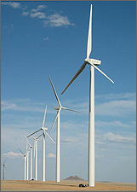
- These wind turbines near Lamar, Colorado, are part of the 162-MW Colorado Green Wind Farm. Each turbine produces 1.5 megawatts of electricity. How many wind turbines are in the farm? Show your work.

http://www.nrel.gov/learning/re_wind.html

- Based on the graph below, what would you predict the cost of energy would be if the wind speed was 5 m/s? Show your work.
Source: http://www.awea.org/pubs/factsheets/EconomicsOfWind-Feb2005.pdf

- Your CD wind machine had to spin very quickly in order to generate a small amount of electricity. When you watch full size wind turbines they only turn at about 60-100 revolutions per minute. Briefly explain what you know about how these relatively slow moving turbines are able to generate megawatts of electricity.

- List three things you learned from building your CD wind machine about how wind turbines work and issues associated with them.

Stations
(20 points each)

Station 1

Connect the available materials to get the highest voltage you can.

Sketch the circuit you built and fill in how many volts were produced.

Voltage produced

Station 2

Look at the materials that are set up. Describe what it is simulating. You may experiment with it, but do not change any of the connections.

Station 3

Choose one of the three diagrams. Tell which alternative energy source it represents and list two of its advantages and two of its disadvantages.

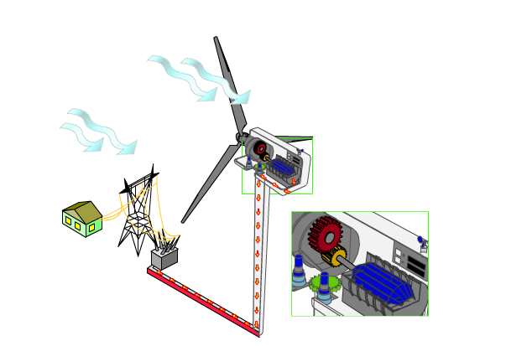
Source: http://www1.eere.energy.gov/windandhydro/wind_animation.html

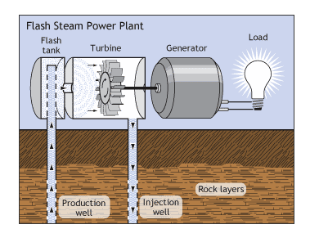

Source: http://www1.eere.energy.gov/geothermal/powerplants.html
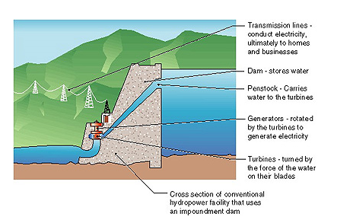
Source: http://www1.eere.energy.gov/windandhydro/hydro_plant_types.html

