Station 1: The Heart

- Describe the path of blood flow through the heart, starting with the vena cava and ending at the aorta. Include valves in your description. (10pts)

- Name the indicated arteries. (5pts)
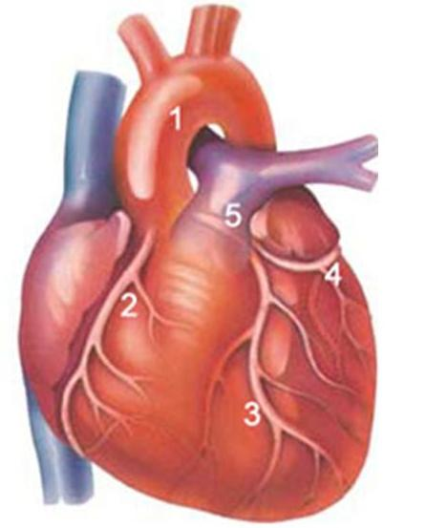
- The events of one complete heart beat are referred to as the cardiac cycle. Complete the following statements that describe these events. Record your answers on your answer sheet. (10pts)
The contraction of the ventricles is referred to as (1) , and the period of ventricular relaxation is called (2) . The monosyllables describing heart sounds during the cardiac cycle are (3) . The first heart sound is a result of closure of the (4) valves; closure of the (5) valves causes the second heart sound. The heart chambers that have just been filled when you hear the first heart sound are the (6) , and the chambers that have just been emptied are the (7) . Immediately after the second heart sound, the (8) are filling with blood, and the (9) are empty. Abnormal heart sounds, or (10) , usually indicate valve problems.

Station 2: Blood

- Complete the following table (28pts)
Blood Type | Antigens | Antibodies in plasma | Can donate blood to type | Can receive blood from type
Type A
Type B
Type AB
Type O

- _______ constitute(s) about 45% of whole blood. (2pts)
  - Formed elements
  - Erythrocytes
  - Plasma
  - Leukocytes

- Which of these would be classified as an agranular leukocyte? (2pts)
  - Eosinophil
  - Basophil
  - Monocyte
  - Neutrophil

- The normal pH range of blood is: (2pts)
  - 7.25-7.35
  - 7.35-7.45
  - 7.55-7.65
  - 7.65-7.75

- The cardiovascular system of an average adult contains approximately _____ liters of blood. (2pts)
  - 4
  - 4.5
  - 5
  - 5.5

- Which of the following is NOT a function of the cardiovascular system? (2pts)
  - Regulation of body temperature
  - Transport of hormones
  - Regulation of water content of cells
  - Absorption of lipids

- This cell is anucleate: (2pts)
  - Leukocyte
  - Monocyte
  - Erythrocyte
  - Lymphocyte

- Which of the following is NOT a stage of hemostasis? (2pts)
  - Fibrinolysis
  - A vascular spasm
  - Platelet aggregation
  - Coagulation

- This white blood cell increases in number during an allergic reaction: (2pts)
  - Neutrophils
  - Eosinophils
  - Basophils
  - Lymphocyte

- What major protein does an erythrocyte have that allows it to carry oxygen and carbon dioxide? (2pts)
  - Albumin
  - Hemoglobin
  - Globulin
  - Fibrin

- True or false: An abnormal decrease in the number of white blood cells is called leukopenia. (2pts)

- True or false: An abnormal increase in the number of red blood cells is called leukocytosis. (2pts)

Station 3: Name that Bone

1. Label the diagram below. (20pts)

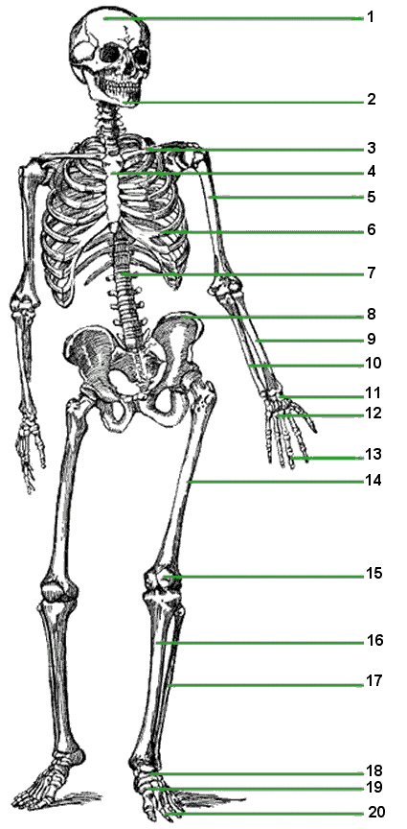
Name the following bone(s) and record your responses on your answer sheet. (2pts each)

21. What is the longest bone in the human body?

22. Name the three ossicles.

23. What is the only movable facial bone?

24. In the vertebral column, which vertebrae is the atlas?

25. In the vertebral column, which vertebrae is the axis?

26. The xiphoid process is part of this bone.

27. This bone contains the foramen magnum.

28. What bone is located in a tendon that passes anteriorly over the knee?

Station 4: Skeletal System

- Describe the type of movement allowed by each synovial joint (12pts)
  - Ball and socket
  - Hinge
  - Condyloid
  - Pivot
  - Gliding
  - Saddle
- Using the synovial joints listed above, classify each type of joint (7pts)
  - Between carpals
  - Carpometacarpal of thumb
  - Humerus and ulna
  - Scapula and humerus
  - Temporal bone and mandible
  - Atlas and axis
  - Pelvic bone and femur
- Label the indicated bone features below. (18pts)
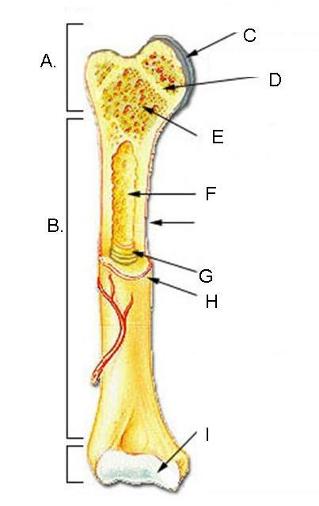
- Describe three functions of the skeletal system. (12pts)

Station 5: Circulatory System

Complete the following statements about blood vessels. (14pts)
The central cavity of a blood vessel is called the ____(1)____. Reduction of the diameter of this cavity is called ___(2)____, and enlargement of the vessel diameter is called ___(3)____. Blood is carried to the heart by___(4)____ and away from the heart by ___(5)____. Capillary beds are supplied by ___(6)____ and drained by ___(7)____.

8. Briefly explain why valves are present in veins but not in arteries. (6pts)

During the recent election, Joe Maverick and Joe the Plumber go for a pre-employment physical.

Joe Maverick is 5’8” and has a blood pressure of 110/70. He weighs 170lbs and is 35 years old. His hematocrit is 42%. His heart rate is 70 beats per minute and his stroke volume is 80mL. Joe Maverick’s cholesterol level is 190mg/dL.

Joe the Plumber is 6’2” and has a blood pressure of 140/90. He weighs 240lbs and is 40 years old. His hematocrit is 44%. His heart rate is 95 beats per minute and his stroke volume is 70mL. Joe the Plumber’s cholesterol level is 245mg/dL.

9. What is Joe Maverick’s cardiac output in liters per minute? (3pts)

10. What is Joe the Plumber’s pulse pressure? (3pts)

11. What is Joe Maverick’s mean arterial pressure? (3pts)

12. Do either of these men have high cholesterol? If so, who? (3pts)

- Which of these two men is a healthier candidate and why? (8pts) (tiebreaker)

Station 6: Skeletal System Disorders

Match each disease with its description. Some answers may be used multiple times or not at all.

Word bank: osteoarthritis, osteoporosis, disc herniation, scoliosis.

- Age and obesity are the largest risk factors for this disease. (2pts)
- This disease includes these classifications: functional, neuromuscular, and degenerative. (2pts)
- A symptom of this disorder includes pain that radiates to the limbs. (2pts)
- Estrogen is protective factor against this disease for women. (2pts)
- This disease is commonly diagnosed using a dual x-ray absorptiometry scan. (2pts)
- This disease commonly affects the hands, knees, and spine. (2pts)
- What disease is illustrated below? (2pts)
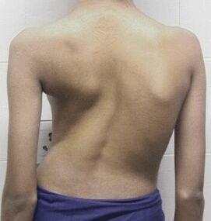

- What disease does the bone on the right indicate? (2pts)

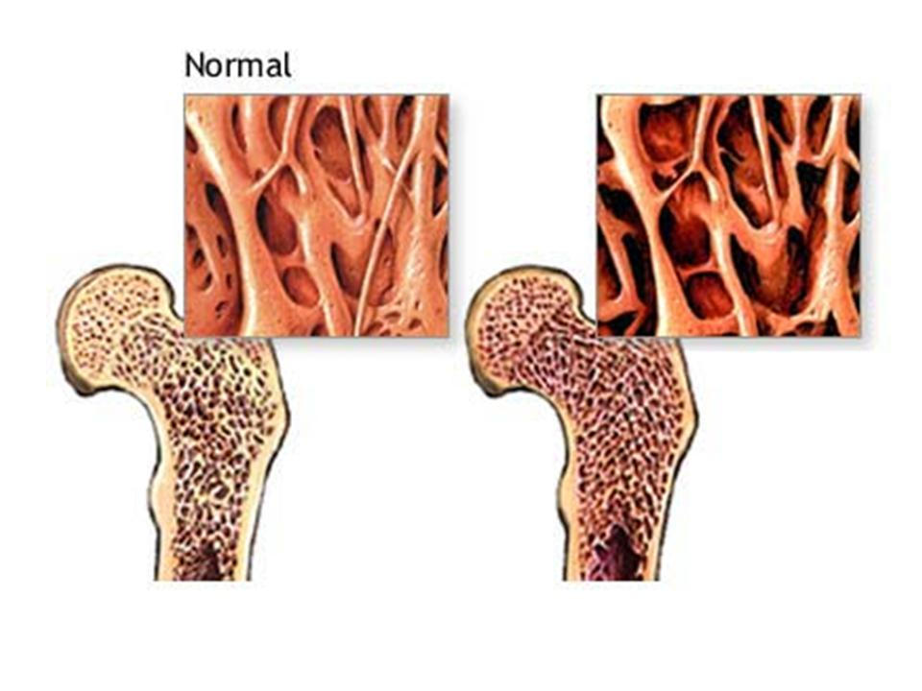

- A person with this hand may have what disease? (2pts)
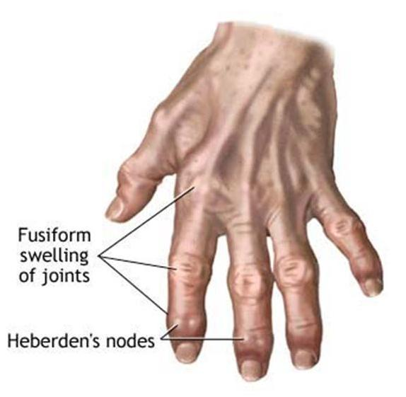
10. Identify the types of breaks illustrated below. (8pts)

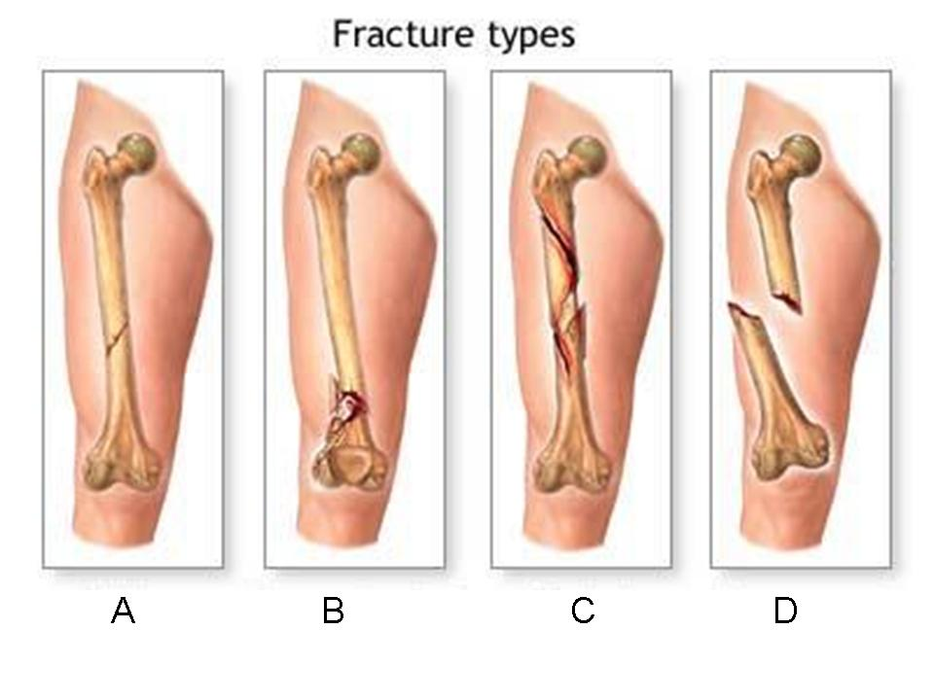

11. Pick one disease from the word bank and explain how exercise would help prevent this disease. (6pts)

