2004 New York State Regional

SCIENCE OLYMPIAD

FOSSILS (Division B)

Directions for Event Coordinators:

This event consists of 22 stations. Most stations consist of a fossils specimen with accompanying questions. Allow 2 minutes for each station.

Arrange the stations so that students can move in order from sample to sample. Tape the questions down. Students should be allowed to handle the specimens, unless they are particularly fragile. Contestants may bring and use any printed resource, hand lens, written notes and/or keys.

Provide a ruler for Station 15 so students can measure the dinosaur foot print. You may want to provide a calculator at this station.

Most stations require identification. Students should identify the specimen first to the degree indicated on the answer key (genus, phylum, common name, etc.). After identification, they should answer the questions that follow.

The selection of fossils was based on the list in the event description. Feel free to modify the event as necessary. If a sample can not be obtained, either substitute a different specimen with appropriate new questions or use a photograph or illustration. Photos and diagrams have been provided for Stations 2, 9, 17, 20 the dinosaur stations (Stations 10, 15 & 19), and relative age (Station 21). If you have trouble finding specimens, and need a good illustration, use Google image search at the following internet site: http://www.google.com/imghp?hl=en&tab=gi&ie=UTF-8

However, every effort should be made to use real fossil specimens. Please adjust the answer key and question choices if it is necessary to substitute a different sample. If you feel that there will be insufficient time, or don’t have a particular sample, then eliminate either some stations or questions.

For ease in grading, each identification should be worth 2 points (allow partial credit for correct ID if less specific than instructed). For example, at Station 4, I would give 2 points for the ID of Pentremites, and 1 point for Blastoid. Allow 1 point for each question. Station 20 (slab with several different fossils) is the 1st Tie Breaker. Use the number of correctly identified fossils in the sample. Station 22 is the 2nd Tie Breaker, if needed.

If you have any questions about the event, or fossils in general, you may contact me (Gary Vorwald) at glaciergary@aol.com or gvorwald@3villagecsd.k12.ny.us

New York State Regional

SCIENCE OLYMPIAD TOURNAMENT

February 2004

Divisions B

FOSSILS

Materials:
Fossil specimens, photos or illustrations, magnifier, Geologic Time Scale, tape

List of Samples:

Preservation

Petrification (petrified wood)

External Mold

Cast

Actual remains (insect in amber)

Carbonization (graptolite or fern in shale)

Mineral Replacement (pyritized specimen)

Internal Mold (gastropod steinkern or other preserved filling of shell)

- Eurypterid (use specimen, photo, or model)

- Ammonite (use sample with obvious suture pattern)

- Pentremites

- Mucrospirifer

- Exogyra (use Gryphaea if Exogyra not available; if both not available use any type of bivalve, but change question)

- Trilobite samples

A. Phacops B. Elrathia

- Horn Coral & Hexagonaria (or Favosites)

- Metasequoia (photo provided)

10. Dinosaur samples
A. Tyrannosaurus B. Allosaurus C. Carnotaurus (use models or photos provided)

- Shark tooth

- Worthenia (or any gastropod)

- Graptolite

- Bryozoan

- Dinosaur footprint (use illustration provided, cast, or actual print)

- Belemnite

- Stromatolite

- Brachiopod specimens
  - Rafinesquina B. Platystrophia C. Leptaena

- Dinosaur model, photo, or illustration
  - Iguanodon B. Plateosaurus

- Fossil slab with variety of fossils. If slab not available, use photos provided.

- Relative Age vs Absolute Age (use diagram provided)

- Fossil Range Chart

New York State Regional SCIENCE OLYMPIAD

Division B: FOSSILS

Directions for Proctors:

- This event consists of 22 Stations. Students will identify samples and answer questions. They may use any printed resource, written notes and/or keys.

- Organize stations so that they are in numerical order and allow contestants to move easily from station to station.

- Tape the questions down next to the sample.

- Label all specimens clearly with the station or code.

- Cover the samples with a sheet of paper before allowing students to enter testing room.

- Read the instructions below to the contestants before starting.

- Make sure to instruct the contestants to proceed, especially from Station 22 to Station 1.

- Remind students to record their answers in the appropriate location on the answer sheet. Most students will not be starting at Station 1.

- Allow 2 minutes for each station.

- Students should be allowed to handle the samples, but they need to treat them with care.
Any student who intentionally violates the spirit of the event will be disqualified (mixing up
samples, removing samples, damaging samples, etc.) This generally doesn’t happen, but it is
always a good idea to be aware of the possibility.

- Please read the attached instructions to the contestants.

New York State Regional SCIENCE OLYMPIAD

February, 2004

Division B: FOSSILS

Directions for Contestants

1. Do not touch any of the fossil samples or papers covering them until we begin.

2. Write your school, team number, and your name(s) legibly on ALL answer sheets.

3. There are 22 stations. At each station, read the directions and identify the specimen if required,
record its name, and answer the questions about it.

4. Make sure you write neatly and spell correctly.

5. You may start at any station. Be sure to record your answers at the appropriate Station
on the answer sheet.

6. You will be given 2 minutes at each station. When time is up, proceed to the next station
and begin work at once.

7. Make sure you go to the next station, except from Station 22 back to Station 1.

8. You may use any printed resources, written notes and/or keys.

AT THE END OF THE COMPETITION

9. Be sure you have properly filled in each answer neatly.

10. Make sure your school name and team number are on the answer sheet.

11. Do not leave until your paper has been collected.

2004 New York Regional State

SCIENCE OLYMPIAD

DIVISION B

FOSSILS

STATION QUESTIONS

STATION 1

Indicate the method of preservation for each specimen.

Choose from the following:

internal mold external mold cast actual remains
carbonization mineral replacement petrification

- Explain the processes that need to occur for most fossils to become preserved.

- Why are some organisms more likely to become fossils than others?

STATION 2

Name the phylum that this animal belongs to.

3. What characteristics do all members of this phylum share?
- exoskeleton and jointed legs
- they all have mineralized shells and eyes
- they are all marine
- all members of this phylum are extinct

4. Although this animal lived in an ancient sea, it is most closely related to modern
a. lobsters (crustaceans) b. insects c. scorpions (arachnids) d. trilobites

STATION 3

Name the class that this animal belongs to.

5. How is the shell of this animal different from snails?
a. it is made out of calcium carbonate
b. it is coiled
c. it has chambers that separate the internal parts of the shell
d. it is harder than snail shells

6. Which mode of life best describes this group of animals?
a. They were active predators who swam by jet propulsion and used tentacles to
help capture prey.
b. They lived on the ocean bottom and drilled holes in clam shells to feed.
c. They lived in a marine environment and fed on algae
d. They attached their shell to the ocean bottom and were filter feeders.

STATION 4

Identify the genus.

- Which terms best describe this organism’s mode of life?
  - land environment, reproduced with seeds, producer
  - marine environment, bottom dwelling, filter feeder
  - marine environment, planktonic, filter feeder
  - shallow ocean, free swimming, predator

- This organism is most closely related to
  - seed ferns and primitive plants
  - stromatolites and algae
  - starfish, sea urchins, and crinoids
  - seed plants and flowers

STATION 5

Identify the genus.

9. What group does this sample belong to?
a. Mollusca b. Bivalvia c. Brachiopoda d. Invertebrata

10. This fossil is common in upstate NY rocks and is a good index fossil for which
geologic period?
a. Silurian b. Devonian c. Paleozoic d. Ordovician

STATION 6

Identify the genus.

11. What modern animal is most similar to this fossil shell?
a. snail b. clam c. mussel d. oyster

12. This genus is commonly found as a fossil because
a. the shell was made out of silica which made it hard to dissolve
b. the shell is large and very thick and hard to destroy after death
c. it is not very old, and had enough time to become a fossil
d. the animal was poisonous to predators, so many shells survived

STATION 7

Identify each specimen’s genus.

13. Most of these organisms are believed to have lived
a. in tidal flats near shore where they fed on algae and stromatolites
b. in cold, deep ocean trenches where they fed on organic matter
c. in the ocean where they swam in shallow water and were predators
d. in warm, shallow seas eating mud and small organisms living on the sea bottom

14. Features that separate specimen A from specimen B include:
a. Specimen A has an equal size tail and head.
b. Specimen A has a large central lobe on its head and large compound eyes.
c. Specimen A has a body divided into three lobes.
d. Specimen A has an exoskeleton made of the mineral calcite.

STATION 8

Give the common name for Sample A and the Genus name for Sample B.

15. How is Sample A’s life habit different from Sample B?
  - Sample A lived in an ocean, Sample B in a lakes.
  - Sample A is solitary, Sample B is colonial.
  - Sample A floated in the sea, Sample B lived on the bottom of the sea.
  - Sample A is related to jelly fish; sample B is related to bryozoans.

- If these samples are found in rocks in upstate New York, what environment is indicated?
a. deep ocean b. fresh water lake c. tropical rain forest d. shallow marine

STATION 9

Identify the genus of this plant fossil.

17. This plant reproduces by
a. spores on the underside of its leaves
b. seeds which form in cones when pollen is blown by the wind
c. seeds that become fertilized in a flower
c. simple cell division

18. This fossil is most closely related to modern
a. ferns c. oaks & maples
b. horsetails d. spruce and redwoods

STATION 10

Identify the genus name of the three dinosaur samples.

19. What do all three dinosaurs have in common?
a. They all have very small arms with two fingers.
b. They are all sauropods, with lizard-like hips.
c. They are two-legged theropods, with three toed feet.
d. They all lived during the Cretaceous period.

20. What are some unusual features of sample C?
a. It has stout horns over very small eye sockets.
b. It has small arms with three fingers.
c. It has blade like serrated teeth.
d. It’s skin has scales that overlap like those of lizards

STATION 11

Identify the specimen and give the common name and the part of the body.

- Although the teeth of this organism are common fossils, why are fossils of the
entire animal rarely preserved?
- the skeleton of this animal was made out of cartilage, which usually decays because it does not contain minerals
- the animal did not have an internal skeleton
- the animal had a skeleton that was made of minerals, which doesn’t get preserved.
- the bones were dissolved by acid rain

22. This group (class) has been highly successful, and is considered a “living fossil.”
When did this group first appear in the fossil record?
- Mississipian
- Ordovician
- Devonian
- Tertiary

STATION 12

What is the common name of the group of organisms represented by this fossil?

- This group is very successful, and various species have adapted to live in
a. most aquatic environments
- exclusively marine environments
- in marine, nonmarine, and land environments
- in rivers and lakes

- These organisms have a mouth structure for feeding called the
a. radula b. siphuncle c. tentacle d. mandible

STATION 13

Name the class or common name of this specimen.

25. The mode of life of these organisms is believed to be
a. swimmer c. planktonic
b. benthic d. deposit feeder

26. What type of rock is this fossil preserved in?
a. limestone b. basalt c. sandstone d. shale

27. A number of species of this group are excellent index fossils for Ordovician rocks
because
a. they are found only in New York and are very old
b. they are found over a wide area and they existed for a short period of time
c. they are found everywhere and lived a long time
d. they are always found in black shale

STATION 14

Identify the phylum.

28. Which method of feeding applies to this group?
a. detritus feeder c. predator
b. scavenger d. filter feeder

29. Which term best describes this organism’s mode of life?
a. solitary c. colonial
b. single cell d. sponge-like

STATION 15

30. This type of fossil is known as
a. actual remains c. petrified remains
b. a trace fossil d. a coprolite

31. Generally, for most bipedal dinosaurs, hip height = 4 X foot length.

How long was the leg (hip height) of the dinosaur that made this print? Measure the print in cm and record your answer in cm or meters.

32. A number of dinosaur trackways have been found in New Jersey and Connecticut. What are two things, other than size, that paleontologists can learn from studying these tracks?

STATION 16

Give the name of this order of cephalopod.

33. These organisms were most closely related to modern
a. reptiles c. squids
b. plants d. snails

34. How is this order different from most other cephalopods found as fossils?
a. This group is older than other cephalopods.
b. This group lived at the same time as the ammonites.
c. This group lived in a marine environment.
d. This specimen is an internal support, while the others had external shells.

STATION 17

Identify this fossil.

35. The fine layers of this fossil were formed by
a. the daily growth of a sponge c. blue-green algae trapping fine sediment
b. annual growth of a woody plant d. seasonal growth of an ancient tree fern

36. This group used to be one of the most common organisms on earth. However, today
they survive only in a few extreme environments. What is an explanation for their
decline?

a. Grazing organisms appeared which ate the algal mats.
b. They could not adapt to the changing oxygen levels of the atmosphere.
c. The extreme environments in which they lived disappeared.
d. A meteor collided with earth and caused the extinction of many of the group.

STATION 18

Identify each genus of each brachiopod.

37. How are these bivalved animals distinguished from other groups?
- All brachiopods have a shell made of calcium phosphate, a clam’s shell is calcite
- Brachiopods are symmetrical across the shells; each valve of a clam is identical
- Brachiopods have identical valves; each valve of a clam is asymmetrical
- The shell of a brachiopod is usually poorly preserved; clam shells are usually well preserved

38. All members of this phylum
a. live in marine environments, burrow in the mud and get food from the mud.
b. attach their shells to the ocean floor and are filter feeders
c. live in marine or nonmarine environments, and swim by flapping their shells
d. attach their shells to the sea floor, and feed by capturing prey with stinging cells

STATION 19

Identify the genus of each dinosaur.

39. What do these have in common?
a. They lived at the same time.
b. They both were herbivores.
c. They both are duck-billed dinosaurs.
d. They have the same hip structure.

40. A. Explain the asteroid theory for the extinction of the dinosaurs.

B. List one piece of evidence that supports this theory.

C. What is one problem with this theory?

STATION 20 (Fossil Slab)

41. Identify as many types of fossils in the rock as possible

(Common names of major groups, such as brachiopod, clam, snail (or gastropod), horn coral, etc. are acceptable. If you have more than one type of a group, you can list them as Brachiopod 1 and Brachiopod 2, etc. YOU CAN GIVE MORE DETAILED NAMES IF YOU KNOW THEM)

42. What type of rock are the fossils preserved in?

43. Based on the fossils, what is the most likely Geologic Era or Period of the rock? (Give the most detail that you can).

44. What ancient environment is indicated by the sample?

STATION 21 (Relative/Absolute Age)

Use the cross section through earth’s crust and the index fossils indicated to answer the questions.

45. What is the relative age of rock layer B?
a. It is the oldest rock layer in the cross section.
b. It is older than rock layer A, and younger than rock layer C.
c. It is younger than 82 million years.
d. It is older than 82 million years, and younger than rock layer A.

46. What geologic period is indicated by the fossils in layer B?
a. Cambrian b. Cretaceous c. Ordovician d. Triassic

47. During which geologic period did intrusion R form?
a. Cambrian b. Cretaceous c. Ordovician d. Jurassic

48. What is the relative age of Mystery Fossil Z?
a. It is younger than Igneous Intrusion Q
b. It is older than Igneous Intrusion Q and rock layer B.
c. It is older than 82 million years, but younger than the brachiopod Platystrophia.
d. It is the same age as Igneous Intrusion Q, but older than rock layer C.

STATION 22 (Fossil Range Chart)

The following fossils are all found in the same limestone bedrock in South Dakota.

Fossil Geologic Range
Belemnite (Cephalopod) Mississippian - Cretaceous
Nucula (Clam) Silurian – Recent
Exogyra (Bivalve) Jurassic – Cretaceous
Baculites (Cephalopod) Cretaceous
Turitella (Snail) Cretaceous – Recent

Plot the ranges of the fossils on the form provided. Use arrows or shading to indicate the range of each fossil. Use your completed range chart to answer the questions that follow.

49. What geologic period is indicated by the fossils?

50. Which is the best index fossil? Explain your answer.

School_________________________________ Team # ___________________

Name(s) ______________________________

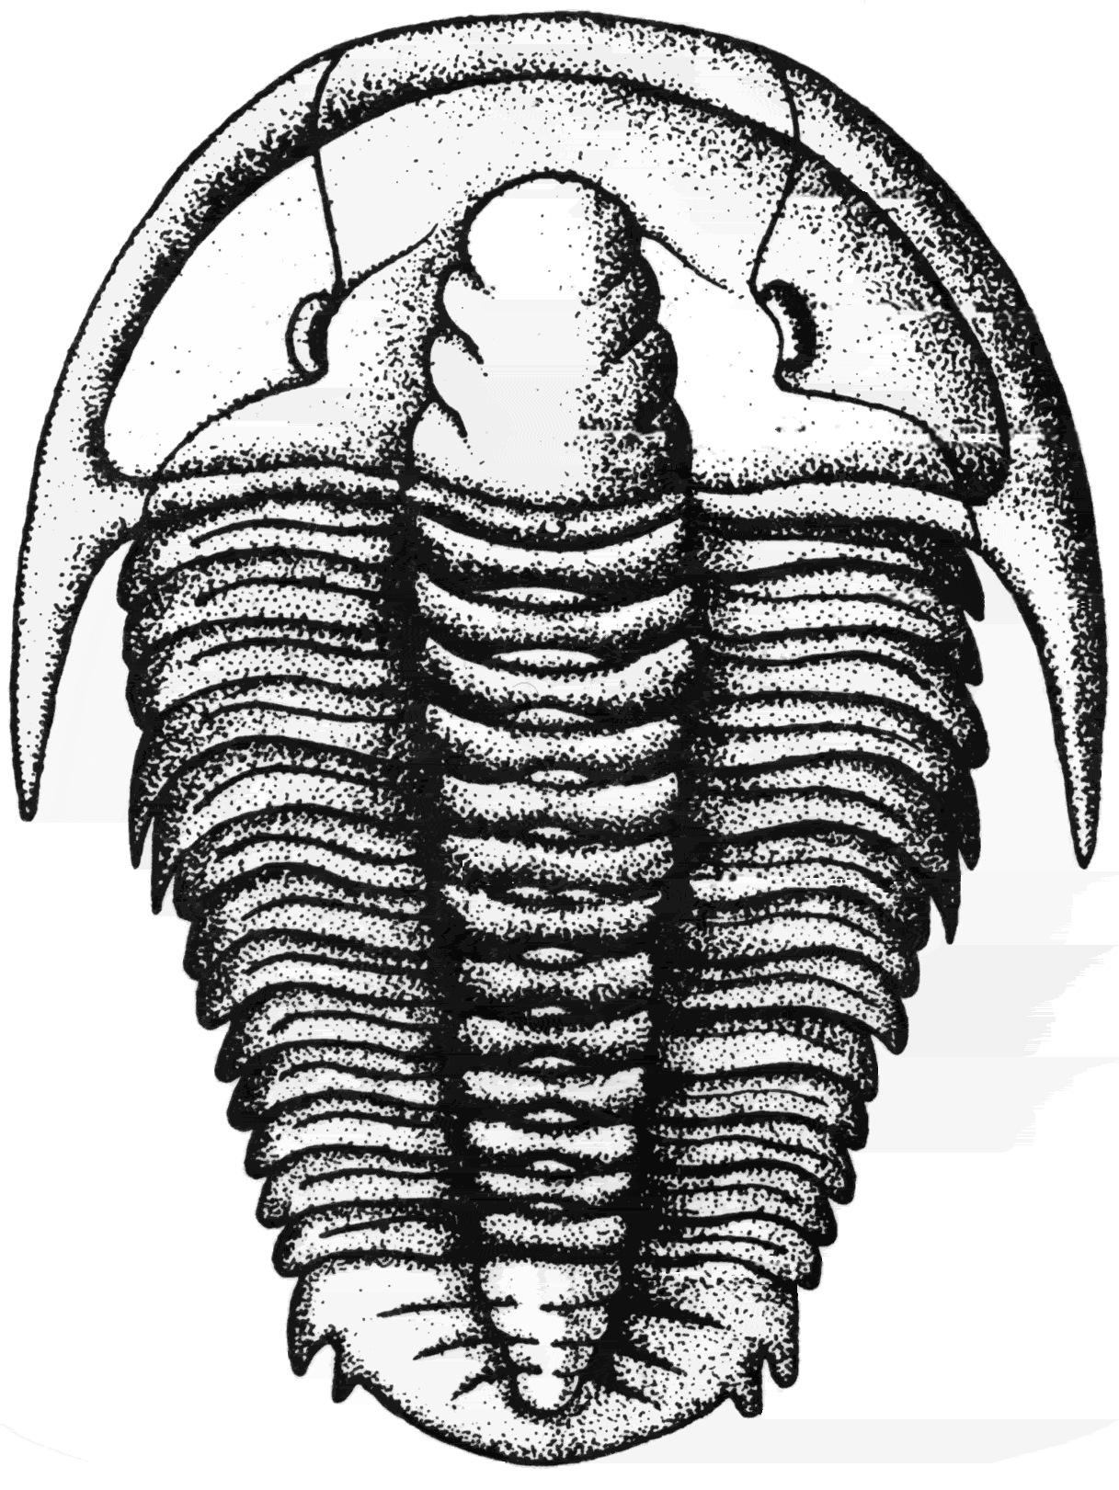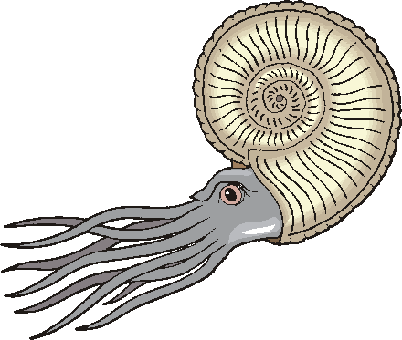
FOSSILS

Directions: AT each station, IDENTIFY the fossil. Make sure you record what is being asked for. Some stations require phylum or class, while others ask for common name or genus. Answer the multiple choice questions by placing the letter of the correct choice in the space provided. Some stations require you to fill in your answers in the space provided. You may use any printed resource materials. Be careful, spelling counts, and you must write legibly. Please print. Good luck!
_______________________________________________________________________________________

STATION 1 PRESERVATION

    - __________________________

    - __________________________

    - __________________________

    - __________________________

    - __________________________

    - __________________________

    - __________________________

1. _______________________________________________________________________

_________________________________________________________________________

2. _______________________________________________________________________

__________________________________________________________________________

School_________________________________ Team # ___________________

STATION 2 Phylum _____________________________
3. _______

4. _______

STATION 3 Class _______________________________
5. _______

6. _______

STATION 4 Genus _________________________________
7. _______

8._______

STATION 5 Genus _________________________________
9. _______

10. _______

STATION 6 Genus ___________________________________
11. _______

12._______

STATION 7 Genus A.____________________

B. ____________________

13. _______

14. _______

School_________________________________ Team # ___________________

STATION 8 Common Name A. __________________________

Genus B. ______________________
15. _______

16._______

STATION 9 Genus ______________________
17. _______

18. _______

STATION 10 Genus A. ___________________________

B. ___________________________

C. _______________________________
19. _______

20. _______

STATION 11 Common Name ___________________________
21. _______

22. _______

STATION 12 Common Name _______________________________

23. _______

24._______

School_________________________________ Team # ___________________

STATION 13 Class or common name _________________________________

25. _______

26. _______

27. _______

STATION 14 Phylum _______________________________________

28. _______

29. _______

STATION 15 Dinosaur footprint 30. _______

31. Foot length ________________________ Hip Height __________________

32. __________________________________________________________________

___________________________________________________________________

____________________________________________________________________

STATION 16 Order _____________________________

33. _______

34. _______
STATION 17 Fossil name ______________________

35. _______

36. _______

School_________________________________ Team # ___________________

STATION 18 Genus A. ________________________

B. ________________________

C. _________________________

37. _______

38. _______
STATION 19 Dinosaur Genus A. __________________________

B. __________________________

39. _______

40. A. Theory: ______________________________________________________________________

__________________________________________________________________________________

B. Evidence _____________________________________________________________________

C. Problems ___________________________________________________________

STATION 20 Ancient Environments

41. __________________________________________________________________

___________________________________________________________________

42. Rock type: _____________________________________

43. Geologic Era__________________________ Geologic Period ___________________

44. Environment ___________________________________________________________

STATION 21 Relative/Absolute Age
45._______

46._______

47._______

48._______

School_________________________________ Team # ___________________

STATION 22 INDEX FOSSILS

49. Geologic Period _________________________________

50. Index Fossil: _________________________________________________________

_______________________________________________________________________

Geologic Age Range of Fossils
ERA | GEOLOGIC PERIOD | Belemnite | Nucula | Exogyra | Baculites | Turitella
CENOZOIC | Recent  (1.6-0 my)
CENOZOIC | Tertiary  (65 -1.6 my)
MESOZOIC | Cretaceous  (142-65 my)
MESOZOIC | Jurassic  (206-142 my)
MESOZOIC | Triassic  (251-206 my)
PALEOZOIC | Permian  (290-206 my)
PALEOZOIC | Carboniferous  (363-290 my)
PALEOZOIC | Devonian  (418-362)
PALEOZOIC | Silurian  (443-418 my)
PALEOZOIC | Ordovician  (490-443 my)
PALEOZOIC | Cambrian  (544-490 my)

School________KEY_________________________ Team # ____________

Name(s) ______________________________

FOSSILS

Directions: AT each station, IDENTIFY the fossil. Make sure you record what is being asked for. Some stations require phylum or class, while others ask for common name or genus. Answer the multiple choice questions by placing the letter of the correct choice in the space provided. Some stations require you to fill in your answers in the space provided. You may use any printed resource materials. Be careful, spelling counts, and you must write legibly. Please print. Good luck!
_______________________________________________________________________________________

STATION 1 PRESERVATION

A.__________________________ Depends on samples

B. __________________________

C. __________________________

D.__________________________

E__________________________

F__________________________

G__________________________

1 . Rapid burial, under water. Various answers may be acceptable.

2. Some organisms have hard parts such as shells or internal skeletons.

School____________KEY_________________ Team # ___________________

STATION 2 Phylum __Arthropoda_(or Arthropod)___
(Eurypterid, photo or specimen) 3. ____A___

4. ____C_ _

STATION 3 Class ____Cephalopoda (Cephalopod)__
(Ammonite) 5. __ C___

6. ___A____

STATION 4 Genus ________Pentremites______
(Pentremites) 7. ___B___

8. ___C___

STATION 5 Genus _______Mucrospirifer____________
(Mucrospirifer) 9. ___C___

10. ___B___

STATION 6 Genus _________Exogyra____________________
(Exogyra) 11. ___D___

12 __ _B__

STATION 7 Genus A._____Phacops_______________
(Phacops/Elrathia)
B. _____Elrathia_______________

13. ___A___

14. ___B____

School__________KEY_______________ Team # ___________________

STATION 8 Common Name A. ______Horn Coral_____
(Horn Coral/Hexagonaria)
Genus B. _____Hexagonaria_____

15. __B_____

16.___D____

STATION 9 Genus _____Metasequoia_________
17. ___B____
(Metasequoia)
18. ___D____

STATION 10 Genus A. ______Tyrannosaurus___________
(Tyrannosaurus
Allosaurus, Carnotaurus) B. _______Allosaurus______________
C. _______ Carnotaurus_________
19. ___C____

20. ____A___

STATION 11 Common Name ___Shark tooth_______
21 . __A____
(Shark Tooth)
22. _ C____

STATION 12 Common Name ____Snail or Gastropod___

(Worthenia or any snail) 23. __C_____

24.___A____

School____________KEY___________ Team # ________________

STATION 13 Class or common name __Graptolite or Graptolithina

(Graptolite on shale) 25. __C_____

26. __D____

27. ___B____

STATION 14 Phylum ____Bryozoa________________
(Bryozoan) 28. ___D____

29. ___C____

STATION 15 Dinosaur footprint

(print provided or use cast or sample) 30. __B____

31. Foot length ________________________ Hip Height __________________

32. ____ecologic relationships, herding behavior, walking and running speed

STATION 16 Order _____Belemnitida or Belemnite
(Belemnite)
33. __C_____

34. ___D____
STATION 17 Fossil name __Stromatolite__

(Stromatolite photo or specimen) 35. ___C____

36. ___A____

School____________KEY________________ Team # ___________________

STATION 18 Genus A. ___Rafinesquina_______

B. ____Platystrophia______

C. ____Leptaena__________

37. __B_____

38. ___B____
STATION 19 Dinosaur Genus A. _____Iguanodon______

B. _____Plateosaurus______

39. __B_____

40. a. Theory: Large asteroid or comet crashed into earth causing catastrophic tidal waves, fires, etc. Dust in atmosphere led to climate change. Many organisms became extinct.

b. Evidence: volcanic ash layer worldwide with Iridium, an element found in extra-terrestrial objects (meteorites)at 65 million yrs; crater discovered in Yucatan.

c. Problem: dinosaur species found after K/T boundary; other organisms survived through boundary, including turtles, crocodiles, birds, mammals, marine life.

STATION 20 Ancient Environments

(sample or use photo provided) Answers given based on photo provided.

41. Depends on sample:_Photo includes the following:

42. Rock type: _____Limestone (depends on sample)___

43. Geologic Era___Paleozoic__________ Geologic Period _____Ordovician_____

44. Environment ___shallow marine_______

STATION 21 Relative/Absolute Age
45.___D____

46.___C___

47.___B____

48.___B____

School_____________KEY______________ Team # ___________________

STATION 22 INDEX FOSSILS

49. Geologic Period _____Cretaceous____________________________

50. Index Fossil: ____Bacculites is the best index fossil because it has the shortest range.

Geologic Age Range of Fossils
ERA | GEOLOGIC PERIOD | Belemnite | Nucula | Exogyra | Baculites | Turitella
CENOZOIC | Recent  (1.6-0 my)
CENOZOIC | Tertiary  (65 -1.6 my)
MESOZOIC | Cretaceous  (142-65 my)
MESOZOIC | Jurassic  (206-142 my)
MESOZOIC | Triassic  (251-206 my)
PALEOZOIC | Permian  (290-206 my)
PALEOZOIC | Carboniferous  (363-290 my)
PALEOZOIC | Devonian  (418-362)
PALEOZOIC | Silurian  (443-418 my)
PALEOZOIC | Ordovician  (490-443 my)
PALEOZOIC | Cambrian  (544-490 my)

