Anatomy and Physiology Tryout Test

- Sound is produced by vibrations of the

  - notochords
  - pharynx
  - vocal folds
  - trachea

- During inhalation, the contraction of the diaphragm causes the volume of the chest cavity to ______ and the pressure inside it to ______.

  - Decrease, increase
  - decrease, decrease
  - increase, increase
  - increase, decrease

- Breathing is regulated by the levels of which substance in the blood?

  - carbon dioxide
  - hemoglobin
  - carbon monoxide
  - oxygen

- The air which is inhaled or exhaled at normal breathing levels is called the

  - vital capacity
  - tidal volume
  - inspiratory volume
  - functional residual capacity

- Which of the following is not true about emphysema?

  - It is a form of chronic obstructive pulmonary disease.
  - There is no cure for it.
  - Bronchodilators are not effective for reducing its symptoms.
  - It may be caused by a deficiency in the protein alpha-1 antitrypsin

- Hemoglobin carries _______ of the blood’s oxygen and ______ of its carbon dioxide.

  - most, none
  - most, some
  - all, none
  - some, some

- Which of the following is not a stage in respiration?

  - pulmonary ventilation
  - internal respiration
  - gas transport
  - pulmonary respiration

- Which air movement is always reflexive?

  - coughing
  - sneezing
  - yawning
  - laughing

- The epiglottis closes directly over the ___________ to prevent food from going down the wrong way.

  - esophagus
  - pharynx
  - larynx
  - trachea

- The pH of the stomach is about ___ and the pH of the small intestine is about ___.

  - 10, 4
  - 3, 3
  - 5, 7
  - 2, 8

- What is the purpose of villi?
  - Contain taste buds on the tongue
  - Increase surface area for absorption in the intestines
  - Help move food down the esophagus
  - Secrete gastric acid in the stomach

- Bile is produced in the ___________ and stored in the __________.

  - gallbladder, spleen
  - gallbladder, liver
  - spleen, gallbladder
  - liver, gallbladder

- The average length of the large intestine is

  - 3 ft
  - 5 ft
  - 11 ft
  - 23 ft

- Peptic ulcers are most common in the

  - duodenum
  - lining of the stomach
  - lower esophageal sphincter
  - anterior wall of stomach

- Which enzyme helps digest proteins?

  - lipase
  - amylase
  - trypsin
  - phytase

- Which of the following is not a possible effect of strenuous exercise on the digestive system?
  - overall improvement of metabolism when exercise is regular
  - decreased activity of the stomach during exercise
  - gastroesophageal reflux or diarrhea after exercise
  - increased blood flow through the entire system during exercise

- What are the passageways that convey urine from the kidneys to the bladder?

  - ureter
  - urethra
  - renal artery
  - renal vein

- The hormone ADH, also known as vasopressin, affects the urinary system by
  - decreasing the concentration of urea in urine
  - increasing the amount of water reabsorbed into body
  - reducing the amount of aquaporins in collecting ducts
  - increasing the efficiency of blood filtration

- The urea which is lost in urine is an end product of ________ breakdown.

  - creatine
  - carbohydrate
  - protein
  - fat

- If a person has a glomerular disorder, _________ , which cannot usually pass through, can be found in their urine.

  - protein
  - lipids
  - sodium
  - glucose

- The ________ is the basic functional unit responsible for the production of urine.

  - glomerolus
  - Bowman's capsule
  - urethra
  - nephron

- The glomerolus and Bowman's capsule are contained in the renal ____________ of the kidneys.

  - corpuscle
  - pyramids
  - capsule
  - cortex

The following questions must be answered TRUE or FALSE.

- The left lung is composed of 3 lobes, while the right has 2 lobes. ___
- The uvula has no known purpose. ___
- Lowered levels of carbon dioxide cause the bronchioles to dilate. ___
- Cystic fibrosis is caused by an accumulation of mucus in the airways. ___
- The esophagus is lines with stratified squamous epithelium. ___
- The liver releases bicarbonate juice to reduce the acidity of food entering the duodenum. ___
- The ileum is connected to the large intestine. ___
- Bile is an emulsifier for proteins. ___
- Almost 100% of glucose is reabsorbed in the loop of Henle. ___
- The kidneys regulate the pH of blood plasma. ___
- Many drugs are eliminated by tubular secretion. ___
- Reabsorption of water and solutes into the blood is driven by both diffusion and active transport. ___
Digestive System

- _____________________
- _____________________
- _____________________
- _____________________
- _____________________
- _____________________
- _____________________
- _____________________
- _____________________
- _____________________
- _____________________
- _____________________
- _____________________
- _____________________
- _____________________
- _____________________
- _____________________
- _____________________
- _____________________
- _____________________
- _____________________
- _____________________
- _____________________
Label These Diagrams

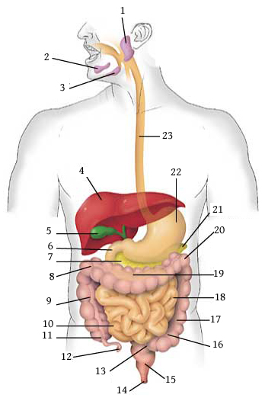

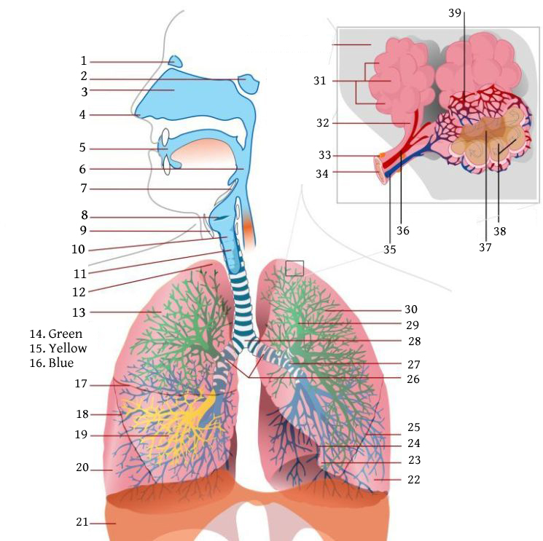
Respiratory System (just label as many as you can)

- ____________________
- ____________________
- ____________________
- ____________________
- ____________________
- ____________________
- ____________________
- ____________________
- ____________________
- ____________________
- ____________________
- ____________________
- ____________________
- ____________________
- ____________________
- ____________________
- ____________________
- ____________________
- ____________________
- ____________________
- ____________________
- ____________________
- ____________________
- ____________________
- ____________________
- ____________________
- ____________________
- ____________________
- ____________________
- ____________________
- ____________________
- ____________________
- ____________________
- ____________________
- ____________________
- ____________________
- ____________________
- ____________________
- ____________________

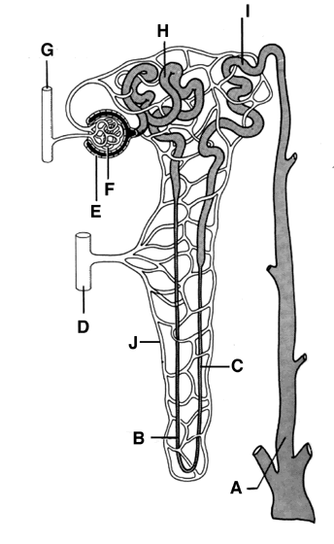
Nephron

- _________________
- _________________
- _________________
- _________________
- _________________
- _________________
- _________________
- _________________
- _________________
- _________________

