REACH FOR THE STARS

Please fill in the following accurately:

School name:
Team color:
Team number:

Part 1 (Total 50 pts)

For each of the following images, give the following information: (Total points : 32)
i. The name of the deep-space object.
ii. The portion of the electromagnetic spectrum used to take the image. (gamma ray, x-ray, etc.)
iii. The approximate distance from earth, in light years.
iv. The constellation in which the object can be found

- 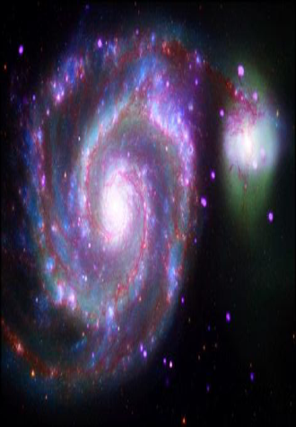

2.

3.

9. Refer to the following star chart for all questions in this section. (10 points total; 1 pt each question)
Constellations:
Give constellation names. Refer to the red capital letters in the star chart.

A
B
C
D
E
F

Stars:
Give star names. Refer to the stars marked as red circles labeled with lowercase letters on the star chart
a
b
c
d

- Evolutionary stage (Total 8 pts)
Name the evolutionary stage for each star. Then, there is a blank H-R diagram on the next page. Plot the stars given on the chart. Clearly label each star. (1 point each to a total of 4 pts for first part of question; plotting of stars on HR is additional 1 pt each to a maximum of 4 pts)

 | Absolute Magnitude | Spectral Type | Evolutionary Stage
  Star
Spica |  | B1
  -3.55 MV
Aldebaran | -0.63 MV | K5
Deneb | -7.0 MV | A2
Proxima Centauri | 15.49 MV | M5.5
Part I
Part II (total pts: 50 pts)

- What is the Sun’s spectral class? (1 pt) ________________________________________________________
- What is the Sun’s absolute magnitude? (1 pt) _________________________________________________
- At what distance are apparent and absolute magnitude the same? (1 pt) __________________
- What do the H and R stand for in “H-R diagram”? (2 pts) ____________________________________ _____________________________________________________________________________________________________
- What does the H_R diagram plot? (2 pt)
_____________________________________________________________________________________________________
- Antares emits a large portion of its energy in what non-visible wavelength? (1 pt) _____________________________________________________________________________________________________
- White dwarfs can go supernova when they approach a certain mass. What is the name of this “critical mass”? (1 pt) __________________________________________________________________
- What type of supernova results from a white dwarf gaining too much mass and exploding? (1 pt) ________________________________________________________________________________
- Vega, Altair, and Regulus are flattened at the poles and bulging at the equator. What are the reasons for this ? (2 pts) ______________________________________________________________________________
- Which star, excluding the sun, is the closest to Earth? How far is it (to .1 light years)? (2 pts) ___________________________________________________________________________________________
- What is the term for stars that don’t have enough mass to start nuclear fusion? (1 pt)
_____________________________________________________________________________________________________
- What are the evolutionary stages of a Sun-sized star? (4 pts)
  - ________________________________________________
  - ________________________________________________
  - Red giant
  - ________________________________________________
  - ________________________________________________

- For the sake of convenience, astronomers have divided the sky into 88 constellations. In which of these does the current Polar star, Polaris, lie? (1pt)

14. What is the general relationship between the mass of a star and its lifespan? (1 pt) _____________________________________________________________________________________________________
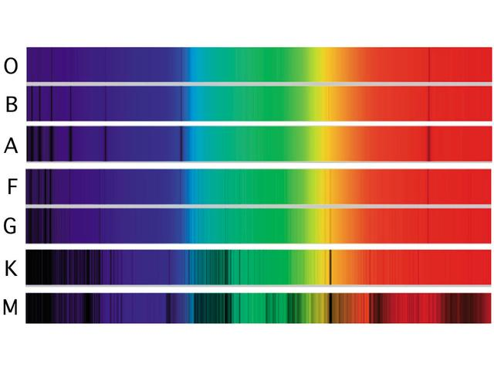
The following questions refer to the spectral sequence shown above. For questions 15 to 19 below, list the spectral type which is best described by the statement. (1 pt for each)
15. The sun is this spectral class. ______________________________________

16. This spectral class contains the hottest stars. ______________________________________

17. This spectral class contains the coolest stars. ______________________________________

18. Stars in this spectral class emit most of their energy in the ultraviolet______________________________________

19. Stars in this spectral class emit most of their energy in the infrared ______________________________________

20. Which star is the brightest in the nighttime sky? (1 pt) ______________________________________

21. Stars in clusters are bound together by what? (1 pt) _________________________________________

22. What is Keppler’s third law? (1 pt)
_________________________________________

23. What are the stellar luminosity classes? (5 pts)
_________________________________________
_________________________________________
_________________________________________
_________________________________________
_________________________________________

24. What are the 3 types of binary star systems? (3 pts)
_________________________________________
_________________________________________
_________________________________________

25. What are the two most important properties of a telescope and explain each term. (4 pts)
_________________________________________
_________________________________________
_________________________________________
_________________________________________
26. What is luminosity? (1 pt)

_________________________________________

27. What are the 3 main types of galaxies? (3 pts)
_________________________________________
_________________________________________
_________________________________________

28. What is pulsar and what is it composed of ? (2 pts)

_________________________________________
_________________________________________

29. What is the difference between absolute and apparent magnitude (1pt)
_________________________________________
_________________________________________

30. Explain following terms (2 pts)
a. Astronomical unit
b. Light year
_________________________________________
_________________________________________

