Microbe Mission Tryout Test

- A particular bacteria stains red when Gram stained, which means the test came out positive/negative (circle one) and the bacteria has a thick/thin (circle one) peptidoglycan cell wall.

- Put these in order from smallest to largest:

1. ___
2. ___
3. ___
4. ___
5. ___
6. ___
7. ___
8. ___
  - red blood cell
  - amoeba
  - E. coli
  - carbon atom
  - rhinovirus
  - paramecium
  - yeast
  - phage

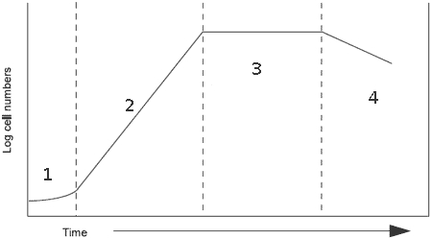

- Label the phases of this growth curve.
1. _________________
2. _________________
3. _________________
4. _________________

- Which of the following is a characteristic of all viruses?
  - A nucleic acid genome
  - A viral envelope
  - A protein capsid
  - A and C
  - A, B, and C

- What are prions?
  - misfolded versions of normal brain protein
  - tiny molecules of RNA which infect plants
  - viral DNA that has attached itself to the host genome
  - viruses which infect bacterial-type
  - mobile segments of DNA

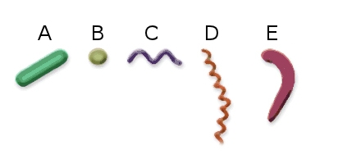
- Match the bacteria type to its shape:
____ Spirochete
____ Baccilus
____ Vibrio
____ Spirilium
____ Coccus

- What makes cyanobacteria different from other bacteria?
  - They are photoautotrophic
  - They may form biofilms on bodies of water
  - Their name comes from their color
  - All of the above

- Which of the following is characteristic of the lytic cycle (virus reproduction)?
  - Many bacterial cells containing viral DNA are produced.
  - Viral DNA is incorporated into the host genome.
  - The viral genome replicates without destroying the host.
  - A large number of phages are released at a time.
  - The virus-host relationship usually lasts for generations.

- Which of the following is not a possible effect of an algal bloom?
  - Increased diversity because of more food provided
  - Decreased sunlight and oxygen in the water, eutrophication
  - Production of toxins
  - Increased risk of paralytic shellfish poisoning

- Match the disease to the microbe which causes it (some diseases may have multiple answers).

______ Botulism
______ Herpes
______ Ringworm
______ Meningitis
______ Malaria
______ Tetanus
______ Rabies
______ Pneumonia
______ Typhus
______ Thrush
______ Mononucleosis

a. Virus
b. Bacteria
c. Fungus
d. Protozoa

- Which of the following is correct?
  - Chloroplasts have their own DNA
  - Eukaryotic cells may have formed from aggregates of prokaryotic cells
  - Mitochondria has a circular genome similar to that of the bacteria they may have originated from
  - A and C
  - All of the above

- Which is a characteristic of cysts?
  - Dormant stage of a bacterium or protist
  - Unit of asexual reproduction
  - May or may not have flagellae
  - B and C
  - All of the above

- A group of coccus bacteria which occurs in a chain is called
  - sarcina
  - streptococci
  - staphylococci
  - diplococci
- Algae are used to make which of the following products?
  - yoghurt
  - petroleum
  - medicine
  - wine

- In which of the following biogeochemical cycles do microbes not play a significant role?
  - nitrogen cycle
  - carbon cycle
  - sulfur cycle
  - phosphorus cycle
  - none of the above

- Lichens are a symbiotic association between a photosynthetic organism and a
  - fungus
  - virus
  - protozoan
  - bacterium

- A plant is found that has mycorrhizae associated with its roots. This plant will
  - be more resistant to cold temperatures
  - be more resistant to herbicides and other toxins
  - be able to form spores
  - die sooner, since it cannot take in nutrients from the soil

The following questions must be answered TRUE or FALSE.

- Most bacteria are beneficial for humans. ___
- Microbes can help break down oil from oil spills. ___
- Eukaryotic microbes may move through flagella, pili, or pseudopodia. ___
- Archaea are part of the Domain Bacteria. ___
- Fungi are saprophytes which digest food internally through hydrolization. ___
- Trichocysts help dinoflagellates capture food. ___
- Conjugation is a form of sexual reproduction in bacteria. ___
- Diatoms are sometimes a component of toothpaste. ___
- Fungi are never sessile. ___
- The ribosome structure of bacteria is different from that of eukaryotes. ___
- Insects often serve as vectors for viruses. ___
- Protists can be multicellular. ___

- Match the images to the microscope they can be seen with.
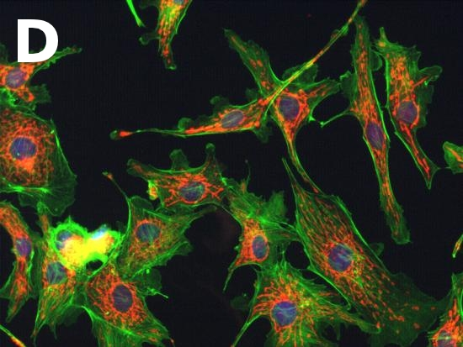
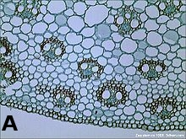
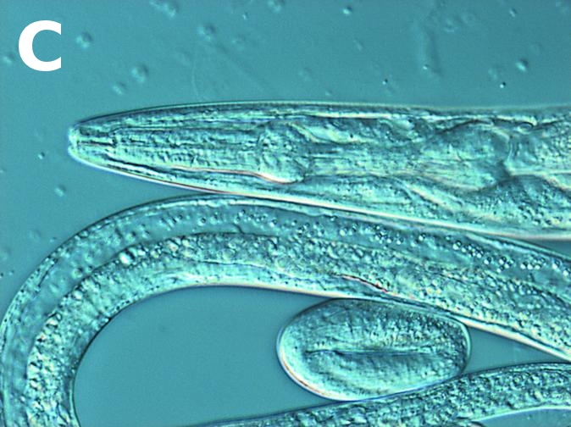
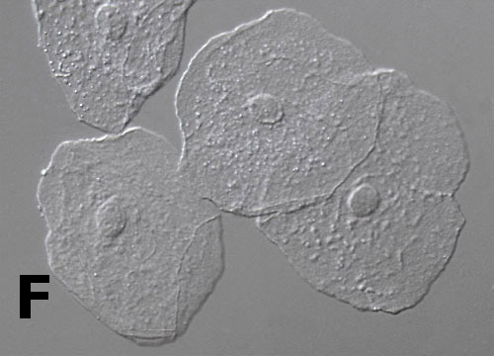
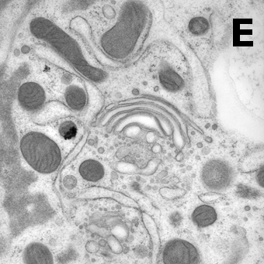
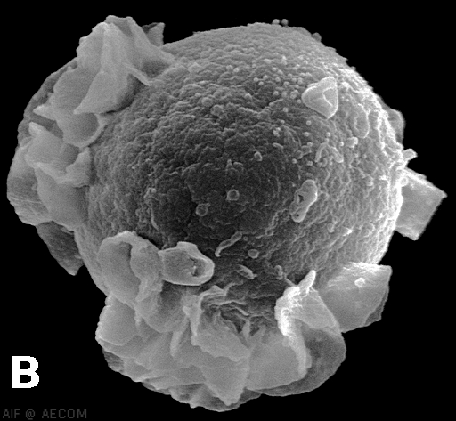

There is only one possible answer for each image, and each possible answer can only correspond to one image (there are extra answer choices).

A. ________________________
B. ________________________
C. ________________________
D. ________________________
E. ________________________
F. ________________________

Bright Field
Dark Field
Phase Contrast
Differential-Interference
Fluorescent
Confocal
Transmission Electron
Scanning Electron

