It’s About Time

Tiger Invitational




February 7th, 2009

SCHOOL NAME_____________________________TEAM NUMBER ____________

Participant’s (1) Name __________________________________ (Be Neat)

Participant’s (2) Name ___________________________________ (Be Neat)

INSTRUCTIONS

1. Turn in all exam materials when directed. Missing exam materials will result in immediate disqualification of the team in question.

2. Inappropriate drawings, comments or answers will result in disqualification of the team from this event.

3. You may separate the pages but they ALL must be restapled at end of the test. If they are not, I will take off 2 pts.

4. Only the answers provided on the Answer Sheet (not scrap paper or the test) will be considered.

5. Point values for each question are shown. Tie breaker are listed. (T1-T10).

6. When the time is up, the time is up. Continuing to write after the time is up risks immediate disqualification.

7. Unless otherwise stated the terms second, minute, hour, day, month, and year will represent the common daily usage of these terms.

60 second = 1minute 60 minutes = 1 hour 24 hours = 1 day 365.25 days = 1 year

g=9.8m/sec² c=3*10⁸m/sec G=6.67*10⁻¹¹ N*m²/kg² h=6.63*10⁻³⁴ J*sec m_{sun}=1.99*10³⁰kg

m_{moon}=7.36*10²² kg m_{Earth}=5.98*10²⁴kg

mean Earth-Sun distance=1.496*10¹¹m=1AU mean Earth-Moon distance=3.84*10⁸m

Matching: For 1-18 choose from the following list of dates for when each event happened. You may choose to use dates more than once. (1/2 point each)
1090 | 1344 | 1530 | 1582 | 1583 | 1586 | 1658 | 1675 | 1686
1730 | 1792 | 1808 | 1841 | 1876 | 1884 | 1900 | 1929 | 1955
- Alexander Bain of Watten in Caithness is granted the first British patent for driving a clock using an electric current.
- Christiaan Huygens invents the balance spring for portable timekeepers at the same time as Robert Hooke claims the same invention and expounds his law - ut tensio sic vis - for the properties of springs.
- Christiaan Huygens' Horologium, published.
- Eli Terry, clockmaker of Plymouth, Connecticut undertook to make 4,000 wooden clock movements at $4 each marking the beginning of mass production.
- French Revolutionary Calendar began at mid night between 21 and 22 September but was not formally adopted until 4 Frimaire year II.
- Galileo recognized the isochronous properties of the pendulum.
- Gemma Frisius of Louvain first suggests that a clock could be used to establish differences in longitude.
- International conference agrees Greenwich as 0 degrees longitude and establishes the international date line and 24 time zones.
- Isaac Newton publishes Principia.
- Jacopo Dondi built a striking clock in Padua which automatically strikes the equinoctial hours rather than canonical hours.
- John Harrison's manuscript, in which he explains how he used the observation of a star giving him sidereal time and by adjusting the result by 3 minutes 54 seconds arrived at mean solar time.
- Louis Essen and J.V. Parry's first atomic clock installed at the National Physics Laboratory at Teddington. Used to synchronize a quartz-crystal clock.
- Paris International Exhibition includes a speaking clock with human voice reproduced by a phonograph.
- Pope Gregory XIII's calendar reform adopted in most catholic states in Europe but not universally so.
- Sanford Flemming introduces time-zones in America for the railway system.
- Su Sung's planetary machine.
- Tycho Brahe, Astronomiae Instauratae Progymnamata published.
- Warren A. Marrison's first Quartz-crystal controlled clock.

19. What does GMT stand for? (1pt) 21. What does TAI stand for? (1pt)

20. What does UTC stand for? (1pt) 22. What does CE stand for? (1pt)

23. How many seconds in one year? (1pt)

24. If the sun suddenly ceased to shine, how many seconds would it take Earth to become dark? (1pt)

25. A drop of water contains 1.7*10²¹ molecules. If the water evaporated at the rate of one million molecules per second, how many years would it take for the drop to completely evaporate? (1pt)

26. When is the next full moon of 2009 in GMT? (2pts)

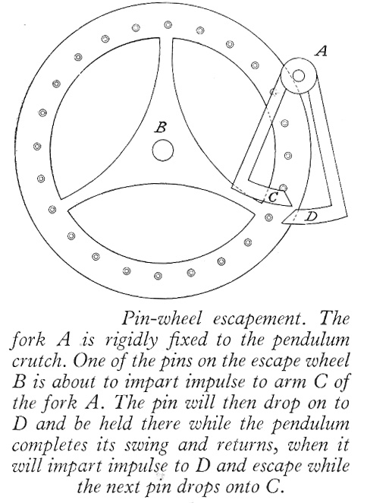
27. What is the name of the clock part shown above? (2pts)

28. What is the purpose of this clock part? (1pt)
29. Starting in the 16th century and ending in the 19th century Japan considered one day to be made of how many hours? (1pt)

30. Besides the number of hours, what was different about these Japanese hours compared to standard hours? Be specific. (1pt)

31. How many days were in an Aztec month? (1pt)

32. Who made the clocks H1, H2, H3, H4, and H5? (1pt)

33. Why did the clockmaker in question #32 build these clocks? Be specific. (1pt)

34. If it is 9:00 a.m. 20 March 2009 in Philadelphia, PA, USA, what time is it in San Diego, CA? (1pt)

35. If it is 9:00 a.m. 19 March 2005 in Honolulu, Hawaii, what time is it in Denver, CO? (1pt)

36. If it is 9:00 a.m. 19 March 2009 in Honolulu, Hawaii, what time is it in Chicago, IL? (1pt)

37. If it is 9:00 a.m. 07 February 2009 in New Tripoli, PA, what time is it in Kabul, Afghanistan? (1pt)

38. A person in a rocket moving away from the Earth at 95% the speed of light observes 2.1 hours of time passing. How much time is observed by a stationary observer on Earth? (1pt)

39. The current definition of the SI time unit of a second is based on a given number of periods for which isotope? (1/2pt)

40. The current definition of the SI time unit of a second is based on an isotope at what temperature in Kelvin? (1/2pt)

41. A projectile is launched from the ground on Earth with an initial velocity of 300m/sec at an angle of 60degrees. Neglecting air resistance, how long until the projectile returns to the ground? (1pt)
42. The decomposition of a certain insecticide in water follows first-order kinetics with a rate constant of 1.45yr⁻¹ at 12ºC. A quantity of this insecticide is washed into a lake on June 1, leading to a concentration of 5.0*10⁻⁷g/cm³. Assume that the average temperature of the lake is 12ºC. What is the concentration of the insecticide on June 1 of the following year? Show work (2pts)

43. How long will it take for the concentration of the insecticide to drop to 3.0*10⁻⁷ g/cm³? Show work (2pts)

44. What is the current 7 digit Julian Date for today (Feb 7th, 2009)? (1pt)
45. What is the standard Calendar Date for the Julian Date 2369916? (1pt)

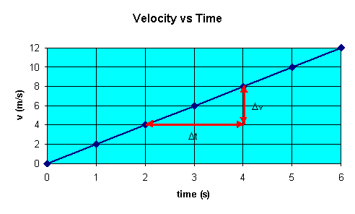
Based on the velocity vs time graph above answer questions 46 and 47.

46. How long would it take to travel 1 m? (1pt)
47. How long would it take to travel 9 m? (1pt)

48. Planet X is 20.0 times the distance from the Sun that Earth is. How standard Earth years, how long does it take for Planet X to circle the Sun once? (2pts)

49. To the nearest minute, what is the current difference in time between a Sidereal Year and a Tropical Year? (1pt)

50. How many days does it take Venus to make one orbital period around the sun? (1pt)

51. If 75.00g of a radioactive sample decays to 30.00g in 3.500 years, what is the half-life of this substance? Show work(2pts)

52. A river flows south at 4 m/sec and is 45 m wide. A boat can move at 3m/sec on still water. If this boat leaves the east bank of the river and travels west, how long does it take to get to the other side? (1pt)

53. If a simple pendulum is made with a 1.0 kg mass hanging from the end of a 2.0 m string of negligible mass, what is the period of the pendulum? (1pt)
54. If a simple pendulum is made with a 4.0 kg mass hanging from the end of a 2.0 m string of negligible mass, what is the period of the pendulum? (1pt)

