KCLL 082153Z 10004KT 5SM -RA FEW025 BKN100 22/18 A3002 RMK AO2 RAB36 SLP162 P0000 T02220183

- What is the time?

- Where is the wind coming from (degrees)?

- What type of station is this?

- What does this have that some do not?

- What is the actual temperature and dew point?

- How many clouds are there

7. What is the visibility?

- What is the wind speed?

9. What is the pressure in milibars?

10. Take the data from above and draw a Station ball symbol.

KEY
- 21:53 Zulu
2 100 degrees south east
3. It is an automated station
4. Precipitation discriminator
5. 22.2 18.3
6. few
7. 5 statute miles
8. 4 kts
9. 30.02
10. this image is what yours should look similar too
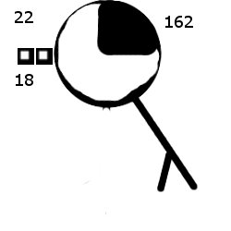
Hopefully yours was neater

