WSU Dynamic Planet 2012. Answer these 45 questions on the provided Student Answer Form

Multiple Choice
Identify the choice that best completes the statement or answers the question.

____ 1. In a stream channel, which of the following will be deposited first?
a. | the dissolved load | c. | gravel-sized particles
b. | fine sand and silt | d. | clay-sized particles

____ 2. Which type of rock usually underlies a karst landscape?
a. | limestone | c. | basalt
b. | granite | d. | shale

____ 3. What are the boundaries called that separate streams in adjacent drainage basins?
a. | mountain ranges | c. | valleys
b. | divides | d. | levees

____ 4. Plants release water into the atmosphere through a process called ____.
a. | evaporation | c. | infiltration
b. | transpiration | d. | precipitation

____ 5. A good indicator of water quality for drinking or swimming is the number of colonies of
a. | coliform bacteria.
b. | algae.
c. | dinoflagellates.
d. | manatees.
e. | protozoa.

____ 6. The suspended load of a stream ____.
a. | is deposited before the bed load
b. | consists primarily of highly soluble substances
c. | moves along the bottom of the channel by rolling or sliding
d. | usually consists of fine sand, silt, and clay-sized particles

____ 7. Of the following organisms, the group that is least likely to cause disease is
a. | bacteria.
b. | protozoa.
c. | algae.
d. | parasitic worms.
e. | viruses.

____ 8. Which of the following statements is false?
a. | Requiring cities to withdraw water downstream of the city would reduce pollution.
b. | Slow-flowing rivers are less susceptible to pollutants than fast-flowing streams.
c. | The width and depth of the oxygen sag curve depend on water volume and flow rate.
d. | Streams can recover from degradable pollutants as long as they are not overloaded.
e. | Oxygen sag curves show the time and distance needed for a stream to recover.

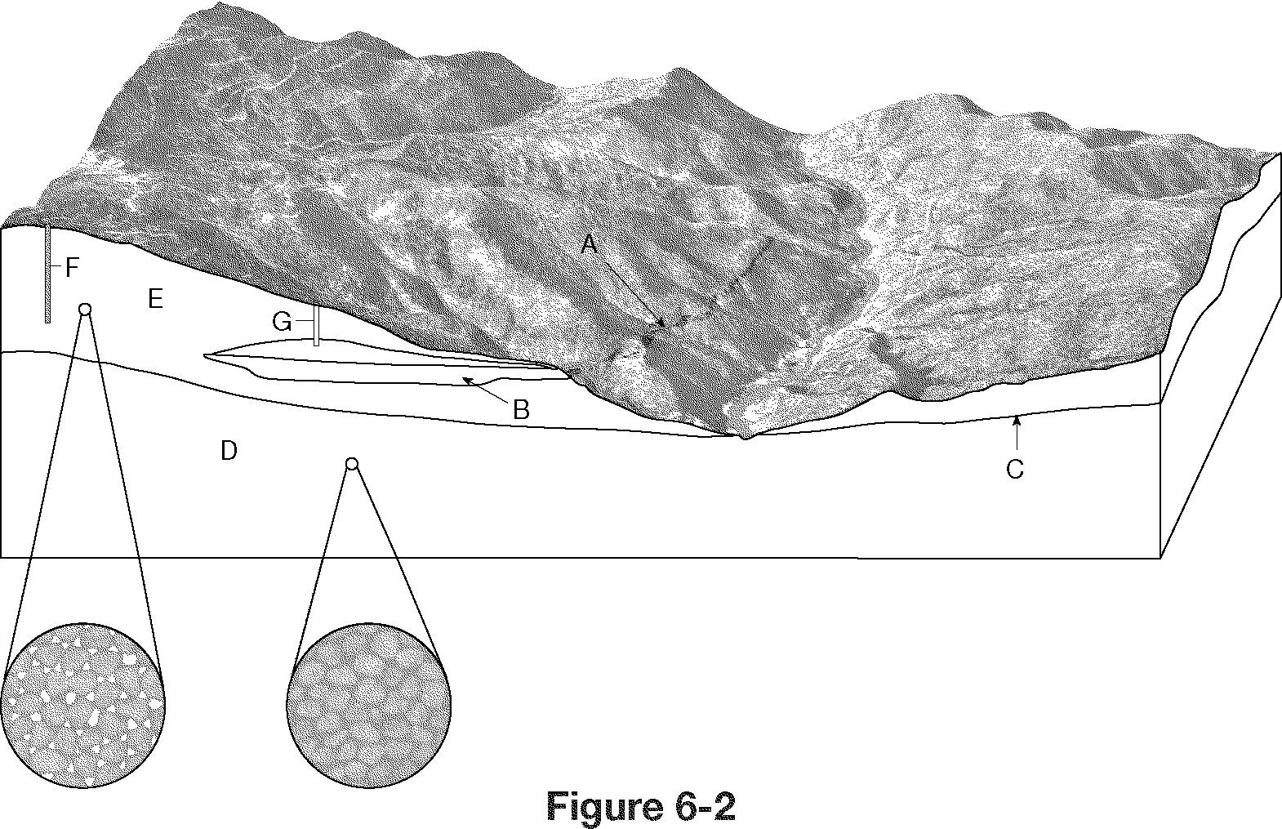

____ 9. What feature is labeled C in Figure 6-2?
a. | zone of aeration | c. | an aquitard
b. | zone of saturation | d. | the water table

____ 10. In Figure 6-2, what letter labels the zone of saturation?
a. | E | c. | C
b. | B | d. | D

____ 11. In Figure 6-2, which of the wells shown will be able to pump water?
a. | both F and G | c. | G only
b. | F only | d. | neither F nor G

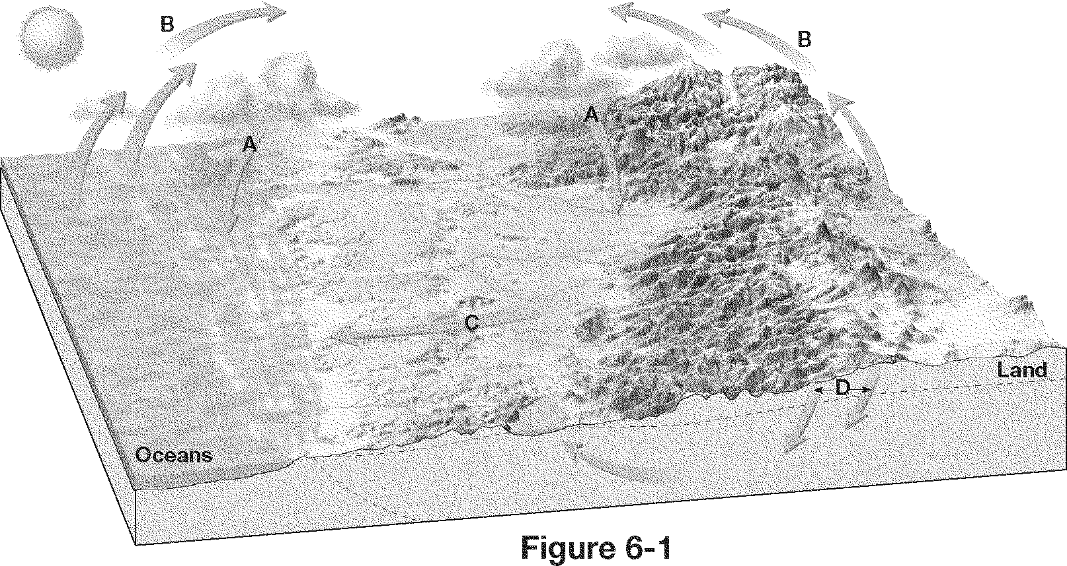

____ 12. What process is illustrated by the arrows labeled A in Figure 6-1?
a. | precipitation | c. | runoff
b. | evaporation | d. | Infiltration

____ 13. In Figure 6-1, what process is illustrated by the arrows labeled D?
a. | precipitation | c. | runoff
b. | evaporation | d. | Infiltration

____ 14. If a river originates 200 meters above sea level and travels 400 kilometers to the ocean, what is the average gradient in meters per kilometer?
a. | 0.5 m/km | c. | 5 m/km
b. | 2 m/km | d. | 0.2 m/km

____ 15. The only effective way to protect groundwater is to
a. | prevent contamination.
b. | use monitoring wells.
c. | cover all wells carefully.
d. | treat all water from underground sources.
e. | using advanced sewage treatment.

____ 16. Base level is ____.
a. | any part of the stream that is below sea level
b. | the lowest point to which a stream can erode its channel
c. | the source from which the stream flows
d. | the elevation of a stream’s largest tributary

____ 17. The ability of a stream to erode and transport material depends largely on its ____.
a. | width | c. | velocity
b. | length | d. | density

____ 18. When groundwater enters underground fractures or caverns in hot igneous rocks, where it is heated to boiling temperatures, what feature can form?
a. | spring | c. | aquitard
b. | geyser | d. | Sinkhole

____ 19. The flat portion of a valley floor adjacent to a stream channel is called a ____.
a. | floodplain | c. | divide
b. | meander | d. | tributary

____ 20. Nitrates and phosphates are examples of
a. | disease-causing agents.
b. | oxygen-demanding wastes.
c. | organic chemicals.
d. | inorganic plant nutrients.
e. | sediment.

____ 21. Limiting development on floodplains is effective because it ____.
a. | allows floodplains to absorb floodwaters with little harm to structures
b. | eliminates wide stream meanders
c. | is more expensive to build structures on flat land
d. | helps keep floodwaters within stream channels

____ 22. As stream discharge increases, which of the following occurs?
a. | Stream velocity, channel width, and depth all increase.
b. | Stream velocity, channel width, and depth all decrease.
c. | Stream velocity increases, but channel width and depth both decrease.
d. | Stream velocity decreases, but channel width and depth both increase.

____ 23. Balance in the water cycle means that ____.
a. | the average annual precipitation over Earth equals the amount of water that evaporates
b. | water that falls to Earth only enters oceans
c. | the amount of water that falls to Earth weighs the same as the amount that condenses in clouds
d. | water that evaporates from Earth’s surface remains forever in the atmosphere

____ 24. Which of the following statements is false?
a. | Rivers are more vulnerable than lakes to contamination by plant nutrients, oil, toxins, and pesticides.
b. | Acid deposition and fallout represent a more serious hazard to lakes than rivers.
c. | Eutrophication is a natural process and can occur without the influence of humans.
d. | Human activities can accelerate the eutrophication process.
e. | Eutrophication is caused by inputs of nutrients and silt from the surrounding land basin.

____ 25. Which of the following statements about disadvantages of large dams is false?
a. | Reservoir formation displaces people and destroys wildlife habitat.
b. | They can contribute to the incidence of earthquakes.
c. | Eventually siltation requires their abandonment.
d. | They often cause flooding downstream.
e. | They cause water loss through evaporation.

____ 26. A cavern is an underground chamber formed by ____.
a. | erosion | c. | evaporation
b. | deposition | d. | runoff

____ 27. Which of the following statements is false?
a. | Heat can lower dissolved oxygen and make fish vulnerable to disease.
b. | Organic wastes that can be decomposed by aerobic bacteria reduce the amount of oxygen in the water supply.
c. | Radioactive wastes and toxins can be concentrated by biological amplification.
d. | Inorganic nutrients such as fertilizers have no adverse effects on aquatic ecosystems.
e. | Sediment can cloud water and reduce photosynthesis.

____ 28. Which of these landforms is NOT common in an area of karst topography?
a. | sinkholes | c. | stalagmites
b. | caverns | d. | surface drainage systems

____ 29. What does groundwater naturally contain that allows it to dissolve limestone and form caverns?
a. | hydrochloric acid | c. | carbonic acid
b. | sulfuric acid | d. | nitric acid

____ 30. Which of the following statements about underground contaminants is false?
a. | Degradable organic wastes do not decompose as rapidly underground as on the surface.
b. | There is little dissolved oxygen to aid in degradation of wastes.
c. | Waste products are diluted and dispersed quickly in underground aquifers.
d. | It can take hundreds to thousands of years for contaminated groundwater to cleanse itself of degradable wastes.
e. | In some coastal areas, groundwater has been contaminated by saltwater intrusion.

____ 31. Benefits of floods include all of the following except
a. | provision of productive farmland downstream.
b. | refilling of wetlands.
c. | provision of important breeding and feeding grounds for wildlife.
d. | filling up of soil air spaces to prevent oxidation of nutrients.
e. | none of these answers.

____ 32. Which of the following would least likely be found in a wide valley?
a. | oxbow lake | c. | rapids
b. | meanders | d. | a cutoff

____ 33. Which of the following would not reduce nonpoint-source pollution?
a. | Require buffer zones of permanent vegetation between cultivated fields and surface water.
b. | Divert runoff of animal wastes into detention basins to be used as fertilizer.
c. | Establish wastewater lagoons.
d. | Use biotic control or integrated pest management.
e. | Reduce the need for fertilizers.

____ 34. Which of the following statements about the Aral Sea is false?
a. | Water has been diverted from the Aral Sea and the two rivers that replenish its water for use in manufacturing.
b. | The volume of the Aral Sea has dropped by 75%.
c. | The salinity levels have risen dramatically.
d. | Most native fish species have disappeared.
e. | The surface area has decreased by 54%.

____ 35. Springs form where ____.
a. | there is no water table
b. | flooding makes streams overflow their banks
c. | groundwater sinks into the soil
d. | the water table intersects the ground surface

____ 36. A natural levee is ____.
a. | an erosional feature perpendicular to the stream channel
b. | a depositional feature perpendicular to the stream channel
c. | an erosional feature parallel to the stream channel
d. | a depositional feature parallel to the stream channel

____ 37. One major cause of floods is ____.
a. | rapid spring snow melt | c. | light rain over a large area
b. | a decrease in stream discharge | d. | increased capacity of stream channels

____ 38. During which of the following does water move in a direction different from the others?
a. | percolation
b. | transpiration
c. | infiltration
d. | precipitation
e. | Runoff

____ 39. All of the following are available to improve water efficiency except
a. | xeriscaping.
b. | policies allowing use of gray water.
c. | systems to purify and completely recycle wastewater from houses, apartments, or office buildings.
d. | condensing water vapor from indoor air.
e. | using water meters to monitor and charge for municipal water use.

____ 40. Which of the following statements is false?
a. | Recharging of water is a slow process.
b. | Fossil aquifers are nonrenewable resources on a human time scale.
c. | Aquifers could be called slow-moving underground lakes.
d. | Groundwater is stationary and does not move.
e. | The water table is located at the top of the zone of saturation.

____ 41. What is the measure of the largest particles a stream can carry?
a. | competence | c. | discharge
b. | capacity | d. | gradient

____ 42. Approximately ____% of the Earth's water is fresh rather than salt water.
a. | 3
b. | 9
c. | 27
d. | 60
e. | 85

____ 43. Which of the following statements is false?
a. | Because of their flow, dilution, and bacterial decay, most streams recover rapidly from pollution by heat and biodegradable waste.
b. | In rapidly flowing rivers, dissolved oxygen is replaced quickly.
c. | The amount of oxygen in rivers declines in dry seasons.
d. | The amount of oxygen in rivers increases as the water's temperature rises.
e. | The amount of oxygen in rivers increases as the water's temperature falls.

____ 44. Along straight stretches of a stream channel, the highest velocities of water are found in what part of the stream?
a. | near the water surface in the center of the stream
b. | near the water surface along the stream banks
c. | along the stream bottom in the center of the stream
d. | along the stream bottom near the stream banks

Short Answer

Exhibit 11-1

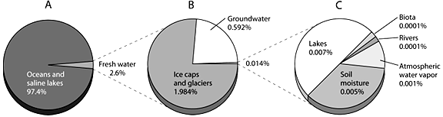

45. Refer to Exhibit 11-1. On the planet's water budget figure, choose the graph that represents the amount of fresh water readily available to the public without the need for energy inputs .

WSU Dynamic Planet 2012. Answer these 45 questions on the provided form.
Answer Section

MULTIPLE CHOICE

1. ANS: C PTS: 1 DIF: L2 REF: p. 166
OBJ: 6.7 Explain how stream deposition occurs. STA: SES3.d
MSC: comprehension

2. ANS: A PTS: 1 DIF: L2 REF: p. 178
OBJ: 6.15 Describe landforms in karst areas. MSC: comprehension

3. ANS: B PTS: 1 DIF: L2 REF: p. 170
OBJ: 6.10 Explain the relationship between streams and drainage basins.
MSC: knowledge

4. ANS: B PTS: 1 DIF: L1 REF: p. 159
OBJ: 6.1 Explain how the water cycle circulates Earth’s water supply in an unending cycle.
STA: SES1.e MSC: knowledge

5. ANS: A PTS: 1 DIF: E
TOP: 11-5 WATER POLLUTION: TYPES | EFFECTS | AND SOURCES

6. ANS: D PTS: 1 DIF: L1 REF: p. 165
OBJ: 6.6 Explain how streams erode their channels and transport sediments.
STA: SES3.d MSC: knowledge

7. ANS: C PTS: 1 DIF: E
TOP: 11-5 WATER POLLUTION: TYPES | EFFECTS | AND SOURCES

8. ANS: B PTS: 1 DIF: D
TOP: 11-6 POLLUTION OF FRESHWATER STREAMS | LAKES | AND AQUIFERS

9. ANS: D PTS: 1 DIF: L2 REF: p. 172
OBJ: 6.11 Describe the location and movement of groundwater.
MSC: knowledge

10. ANS: D PTS: 1 DIF: L2 REF: p. 172
OBJ: 6.11 Describe the location and movement of groundwater.
MSC: knowledge

11. ANS: C PTS: 1 DIF: L2 REF: p. 172
OBJ: 6.11 Describe the location and movement of groundwater.
MSC: analysis

12. ANS: A PTS: 1 DIF: L1 REF: p. 159
OBJ: 6.1 Explain how the water cycle circulates Earth’s water supply in an unending cycle.
STA: SES1.e MSC: knowledge

13. ANS: D PTS: 1 DIF: L2 REF: p. 159
OBJ: 6.1 Explain how the water cycle circulates Earth’s water supply in an unending cycle.
STA: SES1.e MSC: knowledge

14. ANS: A PTS: 1 DIF: L3 REF: p. 160
OBJ: 6.4 Compare and contrast the changes in gradient and discharge between a stream’s headwaters and mouth. MSC: analysis

15. ANS: A PTS: 1 DIF: D TOP: Pollution of Groundwater

16. ANS: B PTS: 1 DIF: L2 REF: p. 162
OBJ: 6.5 Define base level. MSC: knowledge

17. ANS: C PTS: 1 DIF: L1 REF: p. 160
OBJ: 6.3 Describe the ability of a stream to erode and transport material.
STA: SES3.d MSC: knowledge

18. ANS: B PTS: 1 DIF: L2 REF: p. 173
OBJ: 6.12 Describe the formation of a spring. MSC: comprehension

19. ANS: A PTS: 1 DIF: L1 REF: p. 167
OBJ: 6.8 Identify the two general types of stream valleys. STA: SES3.d
MSC: knowledge

20. ANS: D PTS: 1 DIF: E
TOP: Water Pollution: Source, Types, and Effects

21. ANS: A PTS: 1 DIF: L3 REF: p. 169
OBJ: 6.9 Predict the causes of floods and describe major flood control measures.
MSC: evaluation

22. ANS: A PTS: 1 DIF: L3 REF: p. 162
OBJ: 6.4 Compare and contrast the changes in gradient and discharge between a stream’s headwaters and mouth. MSC: analysis

23. ANS: A PTS: 1 DIF: L3 REF: p. 159
OBJ: 6.2 Explain how the water cycle is kept in balance. STA: SES1.e
MSC: analysis

24. ANS: A PTS: 1 DIF: D TOP: Pollution of Freshwater Lakes

25. ANS: D PTS: 1 DIF: D TOP: 11-2 SUPPLYING MORE WATER

26. ANS: A PTS: 1 DIF: L1 REF: p. 177
OBJ: 6.14 Describe the formation of caverns. MSC: knowledge

27. ANS: D PTS: 1 DIF: D
TOP: 11-5 WATER POLLUTION: TYPES | EFFECTS | AND SOURCES

28. ANS: D PTS: 1 DIF: L2 REF: p. 179
OBJ: 6.15 Describe landforms in karst areas. MSC: comprehension

29. ANS: C PTS: 1 DIF: L2 REF: p. 177
OBJ: 6.14 Describe the formation of caverns. MSC: application

30. ANS: C PTS: 1 DIF: M
TOP: 11-6 POLLUTION OF FRESHWATER STREAMS | LAKES | AND AQUIFERS

31. ANS: D PTS: 1 DIF: M TOP: 11-4 TOO MUCH WATER

32. ANS: C PTS: 1 DIF: L3 REF: p. 167
OBJ: 6.8 Identify the two general types of stream valleys. STA: SES3.d
MSC: analysis

33. ANS: C PTS: 1 DIF: D
TOP: 11-8 PREVENTING AND REDUCING SURFACE-WATER POLLUTION

34. ANS: A PTS: 1 DIF: D TOP: 11-2 SUPPLYING MORE WATER

35. ANS: D PTS: 1 DIF: L1 REF: p. 172
OBJ: 6.12 Describe the formation of a spring. MSC: knowledge

36. ANS: D PTS: 1 DIF: L1 REF: p. 167
OBJ: 6.7 Explain how stream deposition occurs. STA: SES3.d
MSC: knowledge

37. ANS: A PTS: 1 DIF: L1 REF: p. 168
OBJ: 6.9 Predict the causes of floods and describe major flood control measures.
MSC: knowledge

38. ANS: B PTS: 1 DIF: M
TOP: 11-1 WATER'S IMPORTANCE | USE | AND RENEWAL

39. ANS: D PTS: 1 DIF: D
TOP: 11-3 REDUCING WATER WASTE

40. ANS: D PTS: 1 DIF: D
TOP: 11-1 WATER'S IMPORTANCE | USE | AND RENEWAL

41. ANS: A PTS: 1 DIF: L2 REF: p. 165
OBJ: 6.6 Explain how streams erode their channels and transport sediments.
STA: SES3.d MSC: knowledge

42. ANS: A PTS: 1 DIF: E
TOP: 11-1 WATER'S IMPORTANCE | USE | AND RENEWAL

43. ANS: D PTS: 1 DIF: M
TOP: 11-6 POLLUTION OF FRESHWATER STREAMS | LAKES | AND AQUIFERS

44. ANS: A PTS: 1 DIF: L2 REF: p. 160
OBJ: 6.3 Describe the ability of a stream to erode and transport material.
STA: SES3.d MSC: comprehension

SHORT ANSWER

45. ANS:
C

PTS: 1 DIF: E OBJ: Labeling
WSU Dynamic Planet 2012. Answer these 43 questions on the provided Student Answer Form

Multiple Choice
Identify the choice that best completes the statement or answers the question.

____ 1. What process is illustrated by the arrows labeled A in Figure 6-1?
a. | precipitation | c. | runoff
b. | evaporation | d. | infiltration

____ 2. In Figure 6-1, what process is illustrated by the arrows labeled D?
a. | precipitation | c. | runoff
b. | evaporation | d. | infiltration

____ 3. Plants release water into the atmosphere through a process called ____.
a. | evaporation | c. | infiltration
b. | transpiration | d. | precipitation

____ 4. Balance in the water cycle means that ____.
a. | the average annual precipitation over Earth equals the amount of water that evaporates
b. | water that falls to Earth only enters oceans
c. | the amount of water that falls to Earth weighs the same as the amount that condenses in clouds
d. | water that evaporates from Earth’s surface remains forever in the atmosphere

____ 5. The ability of a stream to erode and transport material depends largely on its ____.
a. | width | c. | velocity
b. | length | d. | density

____ 6. Along straight stretches of a stream channel, the highest velocities of water are found in what part of the stream?
a. | near the water surface in the center of the stream
b. | near the water surface along the stream banks
c. | along the stream bottom in the center of the stream
d. | along the stream bottom near the stream banks

____ 7. If a river originates 200 meters above sea level and travels 400 kilometers to the ocean, what is the average gradient in meters per kilometer?
a. | 0.5 m/km | c. | 5 m/km
b. | 2 m/km | d. | 0.2 m/km

____ 8. As stream discharge increases, which of the following occurs?
a. | Stream velocity, channel width, and depth all increase.
b. | Stream velocity, channel width, and depth all decrease.
c. | Stream velocity increases, but channel width and depth both decrease.
d. | Stream velocity decreases, but channel width and depth both increase.

____ 9. Base level is ____.
a. | any part of the stream that is below sea level
b. | the lowest point to which a stream can erode its channel
c. | the source from which the stream flows
d. | the elevation of a stream’s largest tributary

____ 10. The suspended load of a stream ____.
a. | is deposited before the bed load
b. | consists primarily of highly soluble substances
c. | moves along the bottom of the channel by rolling or sliding
d. | usually consists of fine sand, silt, and clay-sized particles

____ 11. What is the measure of the largest particles a stream can carry?
a. | competence | c. | discharge
b. | capacity | d. | gradient

____ 12. A natural levee is ____.
a. | an erosional feature perpendicular to the stream channel
b. | a depositional feature perpendicular to the stream channel
c. | an erosional feature parallel to the stream channel
d. | a depositional feature parallel to the stream channel

____ 13. In a stream channel, which of the following will be deposited first?
a. | the dissolved load | c. | gravel-sized particles
b. | fine sand and silt | d. | clay-sized particles

____ 14. The flat portion of a valley floor adjacent to a stream channel is called a ____.
a. | floodplain | c. | divide
b. | meander | d. | tributary

____ 15. Which of the following would least likely be found in a wide valley?
a. | oxbow lake | c. | rapids
b. | meanders | d. | a cutoff

____ 16. One major cause of floods is ____.
a. | rapid spring snow melt | c. | light rain over a large area
b. | a decrease in stream discharge | d. | increased capacity of stream channels

____ 17. Limiting development on floodplains is effective because it ____.
a. | allows floodplains to absorb floodwaters with little harm to structures
b. | eliminates wide stream meanders
c. | is more expensive to build structures on flat land
d. | helps keep floodwaters within stream channels

____ 18. What are the boundaries called that separate streams in adjacent drainage basins?
a. | mountain ranges | c. | valleys
b. | divides | d. | levees

____ 19. In Figure 6-2, what letter labels the zone of saturation?
a. | E | c. | C
b. | B | d. | D

____ 20. What feature is labeled C in Figure 6-2?
a. | zone of aeration | c. | an aquitard
b. | zone of saturation | d. | the water table

____ 21. In Figure 6-2, which of the wells shown will be able to pump water?
a. | both F and G | c. | G only
b. | F only | d. | neither F nor G

____ 22. Springs form where ____.
a. | there is no water table
b. | flooding makes streams overflow their banks
c. | groundwater sinks into the soil
d. | the water table intersects the ground surface

____ 23. When groundwater enters underground fractures or caverns in hot igneous rocks, where it is heated to boiling temperatures, what feature can form?
a. | spring | c. | aquitard
b. | geyser | d. | Sinkhole

____ 24. A cavern is an underground chamber formed by ____.
a. | erosion | c. | evaporation
b. | deposition | d. | runoff

____ 25. What does groundwater naturally contain that allows it to dissolve limestone and form caverns?
a. | hydrochloric acid | c. | carbonic acid
b. | sulfuric acid | d. | nitric acid

____ 26. Which type of rock usually underlies a karst landscape?
a. | limestone | c. | basalt
b. | granite | d. | shale

____ 27. Which of these landforms is NOT common in an area of karst topography?
a. | sinkholes | c. | stalagmites
b. | caverns | d. | surface drainage systems

____ 28. Approximately ____% of the Earth's water is fresh rather than salt water.
a. | 3
b. | 9
c. | 27
d. | 60
e. | 85

____ 29. During which of the following does water move in a direction different from the others?
a. | percolation
b. | transpiration
c. | infiltration
d. | precipitation
e. | runoff

____ 30. Which of the following statements is false?
a. | Recharging of water is a slow process.
b. | Fossil aquifers are nonrenewable resources on a human time scale.
c. | Aquifers could be called slow-moving underground lakes.
d. | Groundwater is stationary and does not move.
e. | The water table is located at the top of the zone of saturation.

____ 31. Which of the following statements about disadvantages of large dams is false?
a. | Reservoir formation displaces people and destroys wildlife habitat.
b. | They can contribute to the incidence of earthquakes.
c. | Eventually siltation requires their abandonment.
d. | They often cause flooding downstream.
e. | They cause water loss through evaporation.

____ 32. Which of the following statements about the Aral Sea is false?
a. | Water has been diverted from the Aral Sea and the two rivers that replenish its water for use in manufacturing.
b. | The volume of the Aral Sea has dropped by 75%.
c. | The salinity levels have risen dramatically.
d. | Most native fish species have disappeared.
e. | The surface area has decreased by 54%.

____ 33. All of the following are available to improve water efficiency except
a. | xeriscaping.
b. | policies allowing use of gray water.
c. | systems to purify and completely recycle wastewater from houses, apartments, or office buildings.
d. | condensing water vapor from indoor air.
e. | using water meters to monitor and charge for municipal water use.

____ 34. Benefits of floods include all of the following except
a. | provision of productive farmland downstream.
b. | refilling of wetlands.
c. | provision of important breeding and feeding grounds for wildlife.
d. | filling up of soil air spaces to prevent oxidation of nutrients.
e. | none of these answers.

____ 35. Of the following organisms, the group that is least likely to cause disease is
a. | bacteria.
b. | protozoa.
c. | algae.
d. | parasitic worms.
e. | viruses.

____ 36. A good indicator of water quality for drinking or swimming is the number of colonies of
a. | coliform bacteria.
b. | algae.
c. | dinoflagellates.
d. | manatees.
e. | protozoa.

____ 37. Which of the following statements is false?
a. | Heat can lower dissolved oxygen and make fish vulnerable to disease.
b. | Organic wastes that can be decomposed by aerobic bacteria reduce the amount of oxygen in the water supply.
c. | Radioactive wastes and toxins can be concentrated by biological amplification.
d. | Inorganic nutrients such as fertilizers have no adverse effects on aquatic ecosystems.
e. | Sediment can cloud water and reduce photosynthesis.

____ 38. Which of the following statements is false?
a. | Because of their flow, dilution, and bacterial decay, most streams recover rapidly from pollution by heat and biodegradable waste.
b. | In rapidly flowing rivers, dissolved oxygen is replaced quickly.
c. | The amount of oxygen in rivers declines in dry seasons.
d. | The amount of oxygen in rivers increases as the water's temperature rises.
e. | The amount of oxygen in rivers increases as the water's temperature falls.

____ 39. Which of the following statements is false?
a. | Requiring cities to withdraw water downstream of the city would reduce pollution.
b. | Slow-flowing rivers are less susceptible to pollutants than fast-flowing streams.
c. | The width and depth of the oxygen sag curve depend on water volume and flow rate.
d. | Streams can recover from degradable pollutants as long as they are not overloaded.
e. | Oxygen sag curves show the time and distance needed for a stream to recover.

____ 40. Which of the following statements about underground contaminants is false?
a. | Degradable organic wastes do not decompose as rapidly underground as on the surface.
b. | There is little dissolved oxygen to aid in degradation of wastes.
c. | Waste products are diluted and dispersed quickly in underground aquifers.
d. | It can take hundreds to thousands of years for contaminated groundwater to cleanse itself of degradable wastes.
e. | In some coastal areas, groundwater has been contaminated by saltwater intrusion.

____ 41. Which of the following would not reduce nonpoint-source pollution?
a. | Require buffer zones of permanent vegetation between cultivated fields and surface water.
b. | Divert runoff of animal wastes into detention basins to be used as fertilizer.
c. | Establish wastewater lagoons.
d. | Use biotic control or integrated pest management.
e. | Reduce the need for fertilizers.

Short Answer

Exhibit 11-1

42. Refer to Exhibit 11-1. On the planet's water budget figure, choose the graph that represents the amount of fresh water readily available to the public without the need for energy inputs .

Exhibit 11-5

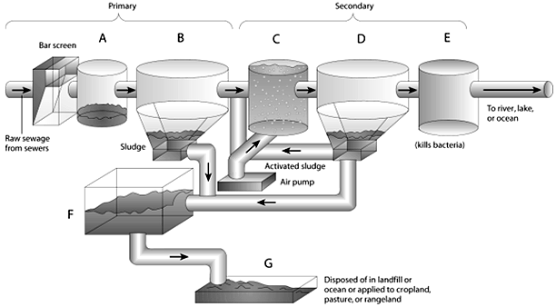

43. Refer to Exhibit 11-5. On the primary and secondary sewage treatment figure, choose the letter that represents where the water is aerated.

BISOT Dynamic Planet 2011. Answer these 43 questions on the provided Scantron form
Answer Section

MULTIPLE CHOICE

1. ANS: A PTS: 1 DIF: L1 REF: p. 159
OBJ: 6.1 Explain how the water cycle circulates Earth’s water supply in an unending cycle.
STA: SES1.e MSC: knowledge

2. ANS: D PTS: 1 DIF: L2 REF: p. 159
OBJ: 6.1 Explain how the water cycle circulates Earth’s water supply in an unending cycle.
STA: SES1.e MSC: knowledge

3. ANS: B PTS: 1 DIF: L1 REF: p. 159
OBJ: 6.1 Explain how the water cycle circulates Earth’s water supply in an unending cycle.
STA: SES1.e MSC: knowledge

4. ANS: A PTS: 1 DIF: L3 REF: p. 159
OBJ: 6.2 Explain how the water cycle is kept in balance. STA: SES1.e
MSC: analysis

5. ANS: C PTS: 1 DIF: L1 REF: p. 160
OBJ: 6.3 Describe the ability of a stream to erode and transport material.
STA: SES3.d MSC: knowledge

6. ANS: A PTS: 1 DIF: L2 REF: p. 160
OBJ: 6.3 Describe the ability of a stream to erode and transport material.
STA: SES3.d MSC: comprehension

7. ANS: A PTS: 1 DIF: L3 REF: p. 160
OBJ: 6.4 Compare and contrast the changes in gradient and discharge between a stream’s headwaters and mouth. MSC: analysis

8. ANS: A PTS: 1 DIF: L3 REF: p. 162
OBJ: 6.4 Compare and contrast the changes in gradient and discharge between a stream’s headwaters and mouth. MSC: analysis

9. ANS: B PTS: 1 DIF: L2 REF: p. 162
OBJ: 6.5 Define base level. MSC: knowledge

10. ANS: D PTS: 1 DIF: L1 REF: p. 165
OBJ: 6.6 Explain how streams erode their channels and transport sediments.
STA: SES3.d MSC: knowledge

11. ANS: A PTS: 1 DIF: L2 REF: p. 165
OBJ: 6.6 Explain how streams erode their channels and transport sediments.
STA: SES3.d MSC: knowledge

12. ANS: D PTS: 1 DIF: L1 REF: p. 167
OBJ: 6.7 Explain how stream deposition occurs. STA: SES3.d
MSC: knowledge

13. ANS: C PTS: 1 DIF: L2 REF: p. 166
OBJ: 6.7 Explain how stream deposition occurs. STA: SES3.d
MSC: comprehension

14. ANS: A PTS: 1 DIF: L1 REF: p. 167
OBJ: 6.8 Identify the two general types of stream valleys. STA: SES3.d
MSC: knowledge

15. ANS: C PTS: 1 DIF: L3 REF: p. 167
OBJ: 6.8 Identify the two general types of stream valleys. STA: SES3.d
MSC: analysis

16. ANS: A PTS: 1 DIF: L1 REF: p. 168
OBJ: 6.9 Predict the causes of floods and describe major flood control measures.
MSC: knowledge

17. ANS: A PTS: 1 DIF: L3 REF: p. 169
OBJ: 6.9 Predict the causes of floods and describe major flood control measures.
MSC: evaluation

18. ANS: B PTS: 1 DIF: L2 REF: p. 170
OBJ: 6.10 Explain the relationship between streams and drainage basins.
MSC: knowledge

19. ANS: D PTS: 1 DIF: L2 REF: p. 172
OBJ: 6.11 Describe the location and movement of groundwater.
MSC: knowledge

20. ANS: D PTS: 1 DIF: L2 REF: p. 172
OBJ: 6.11 Describe the location and movement of groundwater.
MSC: knowledge

21. ANS: C PTS: 1 DIF: L2 REF: p. 172
OBJ: 6.11 Describe the location and movement of groundwater.
MSC: analysis

22. ANS: D PTS: 1 DIF: L1 REF: p. 172
OBJ: 6.12 Describe the formation of a spring. MSC: knowledge

23. ANS: B PTS: 1 DIF: L2 REF: p. 173
OBJ: 6.12 Describe the formation of a spring. MSC: comprehension

24. ANS: A PTS: 1 DIF: L1 REF: p. 177
OBJ: 6.14 Describe the formation of caverns. MSC: knowledge

25. ANS: C PTS: 1 DIF: L2 REF: p. 177
OBJ: 6.14 Describe the formation of caverns. MSC: application

26. ANS: A PTS: 1 DIF: L2 REF: p. 178
OBJ: 6.15 Describe landforms in karst areas. MSC: comprehension

27. ANS: D PTS: 1 DIF: L2 REF: p. 179
OBJ: 6.15 Describe landforms in karst areas. MSC: comprehension

28. ANS: A PTS: 1 DIF: E
TOP: 11-1 WATER'S IMPORTANCE | USE | AND RENEWAL

29. ANS: B PTS: 1 DIF: M
TOP: 11-1 WATER'S IMPORTANCE | USE | AND RENEWAL

30. ANS: D PTS: 1 DIF: D
TOP: 11-1 WATER'S IMPORTANCE | USE | AND RENEWAL

31. ANS: D PTS: 1 DIF: D TOP: 11-2 SUPPLYING MORE WATER

32. ANS: A PTS: 1 DIF: D TOP: 11-2 SUPPLYING MORE WATER

33. ANS: D PTS: 1 DIF: D
TOP: 11-3 REDUCING WATER WASTE

34. ANS: D PTS: 1 DIF: M TOP: 11-4 TOO MUCH WATER

35. ANS: C PTS: 1 DIF: E
TOP: 11-5 WATER POLLUTION: TYPES | EFFECTS | AND SOURCES

36. ANS: A PTS: 1 DIF: E
TOP: 11-5 WATER POLLUTION: TYPES | EFFECTS | AND SOURCES

37. ANS: D PTS: 1 DIF: D
TOP: 11-5 WATER POLLUTION: TYPES | EFFECTS | AND SOURCES

38. ANS: D PTS: 1 DIF: M
TOP: 11-6 POLLUTION OF FRESHWATER STREAMS | LAKES | AND AQUIFERS

39. ANS: B PTS: 1 DIF: D
TOP: 11-6 POLLUTION OF FRESHWATER STREAMS | LAKES | AND AQUIFERS

40. ANS: C PTS: 1 DIF: M
TOP: 11-6 POLLUTION OF FRESHWATER STREAMS | LAKES | AND AQUIFERS

41. ANS: C PTS: 1 DIF: D
TOP: 11-8 PREVENTING AND REDUCING SURFACE-WATER POLLUTION

SHORT ANSWER

42. ANS:
C

PTS: 1 DIF: E OBJ: Labeling

43. ANS:
C

PTS: 1 DIF: M OBJ: Labeling

