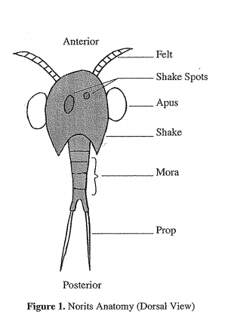

An interesting life form has been found in a water sample on the planet Norad. Biologists, in an attempt to organize their writings and descriptions of the organisms, have named and classified them. Use the dichotomous key to help them classify these three organisms. Record the pathway you follow through the key and then the name of the organism.

A. 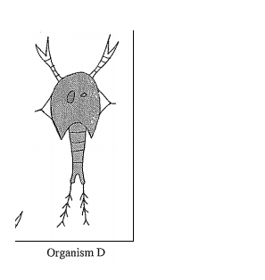

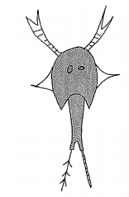
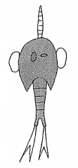
B.
C.
A.
1. What characteristics do all Nortis seem to have in common?
2. What characteristic do biologists seem to feel is most important when classifying Nortis?
3. Why might the key used to classify Nortis ever change?
4. How might observing living Nortis affect how they might be classified?
*5. Draw a picture of what a Rossi multiops might look like.

