Awesome Aquifers for the Less Experienced

Compliments of silentsage (with the help of the Noob, Dalish Elf)

Station 1

Completion Questions (5pt. ea.):

1. An extended period with little or no precipitation.
2. Openings in geologic material that can contain air and/or water.
3. A bored, drilled, or driven shaft, or a dughole, whose depth is greater than the largest surface dimension and whose purpose is to reach underground water supplies to inject, extract, or monitor water.
4. Treatment of contaminated groundwater.
5. Water above the land surface.

Multiple Choice (2pt. ea.):

1. Overwithdrawal:
2. Withdrawing over
3. A large rock
4. Groundwater taken in large quantities from an aquifer
5. Withdrawal that exceeds the recharge rate.
6. Point-Source Pollution:
7. Pollution on a point.
8. Pollution from a specific location.
9. Pollution from a nonspecific location.
10. Nasty stuff in the sewer.
11. Unsaturated Zone:
12. Vadose zone.
13. Aeration zone.
14. Answers a. and b.
15. None of the above.
16. Artesian well:
17. Wells made by artisans.
18. A brick well
19. Wells that don’t require pumps.
20. Wells that use natural pressure to eject water.
21. Aquitard:
22. One who knows nothing about aquifers
23. The answer above.
24. A layer of geologic material that almost or completely restricts groundwater movement.
25. The answer above.

Station 2

[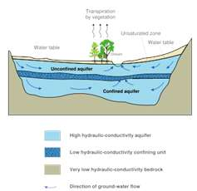](http://www.bing.com/images/search?q=aquifer&view=detail&id=4077E62D6DF75764948D09092FC0CD3F280068F8&first=0&qpvt=aquifer&FORM=IDFRIR)

Answer questions about the above (5 pt. ea.):

1. If a well was placed to the left of the trees and entered the unconfined aquifer, how could it affect the stream?
2. What do the blue arrows represent? What are names for this term?

[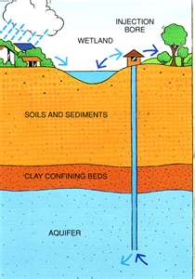](http://www.bing.com/images/search?q=aquifer&view=detail&id=4E83BFECE446EA4D6BF775402D961D6AA7FDC407&first=0&qpvt=aquifer&FORM=IDFRIR)

Answer questions about the above (5 pt. ea.):

1. What type of well is this?
2. What is this well used for?

Station 4

Build an aquifer based on these topics (50 pt.)

-confined/unconfined aquifer

-Nonpoint-source pollution

-wells

-porosity (at least 2 diff. materials)

-percolation

Score(x/100)

Station 1 /30

Station 2 /20

Station 4 /50

Total /100