Magnetic Levitation Written Exam

Do not open booklet until instructed to do so.
Team Name:
Participants:

For each question choose the best possible answer for the multiple choice section. For free response questions be sure to show all your work with units and provide full details for explanations.
1. The temperature above which a magnet loses its magnetic properties is called the...
A. Critical temperature. | B. Curie point.
C. Debye temperature. | D. Power point.

2. Magnetic field intensity CANNOT be measured in...
A. Gauss. | B. Maxwells.
C. Tesla. | D. Wb/m²
3. A magnet will NOT stick to... (Well, not without glue, anyway!)
A. Cobalt | B. Copper
C. Iron | D. Nickel

4. Incredibly strong magnetic fields are essential to the functioning of which medical imaging procedure?
A. CAT | B DOG
C. MRI | D. PET

5. The earth’s magnetic field is fundamental to which type of natural event?
A. Aurora Borealis | B. earthquakes
C. geysers | D. lightning

6. Traffic lights at busy intersections sense when cars are sitting over...
A. commutators. | B. switching hubs.
C. reed switches. | D. induction loops.

7. Superconductors are....
A. materials that conduct sound when exposed to ionizing radiation. | B. materials that conduct heat when exposed to a magnetic field.
C. musically inclined superheroes and superheroines. | D. materials that conduct electricity without resistance when below a certain temperature.

8. Identify the device that makes use of magnetism as it functions: (choose the best answer)
A. car crusher | B. computer
C. headphone speaker | D. credit card
E. All of these use magnetism | F. None of these use magnetism

9. The first commercial MAGLEV system operated in...
A. China. | B. Japan
C. Germany | D. United States

10. Superconductors are used extensively in the...
A. L.H.C. | B. Mount Wilson Observatory
C. Super Smash Flash game | D. Taj Mahal

11. Extremely weak magnetic fields can be detected by...
A. CLAMS. | B. SQUIDS.
C. MUSSELS. | D. OCTOPI.

12. What happens if a magnetic field exists in a superconductive material when it is brought below its “Critcal Temperature” (T_{c})? (This is known as the ‘Meisner Effect’)
A. A black hole forms! | B. The magnetic field remains in the superconductor even when the external field is switched off.
C. The magnetic field is immediately expelled from the superconductor when T_{c} is reached. | D. The polarity of the magnetic field immediately reverses when Tc is reached.

13. A beam of positively charged protons is moving horizontally toward you. As it approaches, it passes through a magnetic field directed downward. This magnetic field deflects the beam...
A. Down | B. Up
C. To your Left | D. To your Right

14. A frog can be levitated in a strong magnetic field. This effect is an illustration of…
A. Ferromagnetism | B. Diamagnetism
C. Paramagnetism | D. Paranormalism

15. In headline news recently, researchers at IBM demonstrated the ability of a small cluster of 12 iron atoms to retain a magnetic field. This atomic level magnetic storage device is a demonstration of…
A. Anti-disestablishmentarianism | B. Ferromagnetism
C. Anti-Ferromagnetism | D. Diamagnetism

16. The investigator associated with discovering the equations that form the basis of modern electromagnetic theory (and bad poetry)…
A. Michael Faraday | B. James Clerk Maxwell
C. Hans Christian Ørsted | D. Nicholai Tesla

17. The natural philosopher who is associated with the discovery and investigation of how currents cause magnetic forces…
A. Edwin Herbert Hall | B. André-Marie Ampère
C. Hans Christian Ørsted | D. Nicholai Tesla

18. The person associated with realizing that there was a connection between electricity and magnetism…
A. Nicholai Tesla | B. Michael Faraday
C. Hans Christian Ørsted | D. André-Marie Ampère

19. The physicist credited with discovering that when a current flows through a material simultaneously with a magnetic field, a voltage develops across that same material… (hint: this is the basis for many common, low cost, magnetic field detectors in use today named for the discoverer)
A. Michael Faraday | B. Heinrich Barkhausen
C. Edwin Herbert Hall | D. Louis Néel

20. The self taught investigator (also really bad at math) who was famous for his amazing lectures and demonstrations as well as discovering the induction motor (the forerunner of the electric motor)…
A. Nicholai Tesla | B. Heinrich Barkhausen
C. Hans Christian Ørsted | D. Michael Faraday

21. You are given three rods. Although they look identical, one is a permanent magnet, one is brass, and the other is solid steel. Using nothing but the three rods, your hands, and your wits, explain how you can determine which rod is the magnet, which is brass, and which is solid steel. [3 points]

22. What is the magnetic field at a point 50. mm from a long straight wire carrying a current of 3.0 A? Show your work! [2 points]

School Name _____________________________________ Team # _______
Answer as many questions as you can in the time allotted.
- Place each final answer in the appropriate space on the answer sheet.
- Show all work when requested.
- Written answers must incorporate correct spelling.
- Each answer is worth 1 point unless otherwise indicated.
- When SO instructed, move to the designated lab station and test your Mag Lev device.

- _________
- _________
- _________
- _________
- _________
- _________
- _________
- _________
- _________
- _________
- _________
- _________
- _________
- _________
- _________
- _________
- _________
- _________
- _________
- _________

21. [3]
22. [2]

School Name ______Answer Key____________ Team # _______
Answer as many questions as you can in the time allotted.
- Place each final answer in the appropriate space on the answer sheet.
- Show all work when requested.
- Written answers must incorporate correct spelling.
- Each answer is worth 1 point unless otherwise indicated.
- When SO instructed, move to the designated lab station and test your Mag Lev device.

- ____B____
- ____ B____
- ____ E____
- ____ C____
- ____ A____
- ____ D____
- ____ D____
- ____ E____
- ____ A____
- ____ A____
- ____ B____
- ____ C____
- ____ D____
- ____ B____
- ____ C____
- ____ B____
- ____ C____
- ____ D____
- ____ C____
- ____ D____

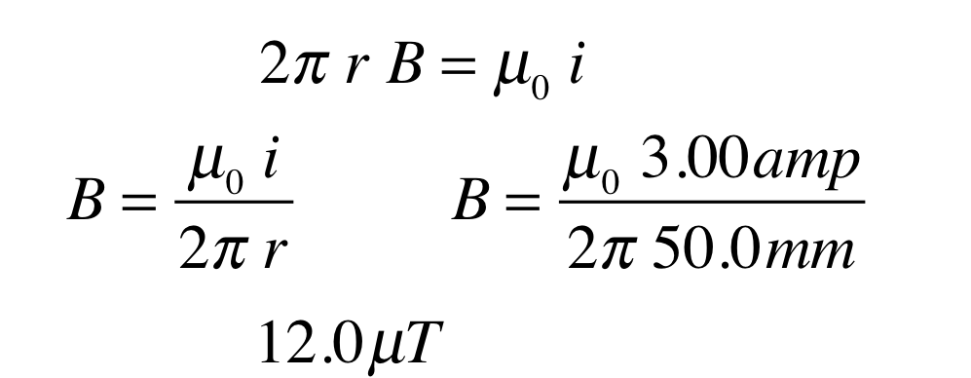
21. [3]
22. [2] Touch the ends of the rods together. The rod that doesn’t stick to either of the other rods is brass. As it is now identified, set it aside. The other two rods can be identified by touching the end of either rod to the center of the other. If there is a strong attraction, then the rod that was touched at its end is the magnet because the field of the magnet is strongest at its poles. If the attraction was weak (or non-existent) then the rod that was touched in the middle is the magnet. To confirm this, touch the end of the rod that was previously touched at its center to the center of the rod that was previously touched at its end. The results should confirm the previous designations. (Answers will vary. Give one point for each rod that would be properly identified by the Olympians’ instructions.)

