2012 Wright State Invitational
Experimental Design – Division B

Team Name: _______________________________________________________ Team Number: _______
Student Names: ______________________________________________________________________________________________

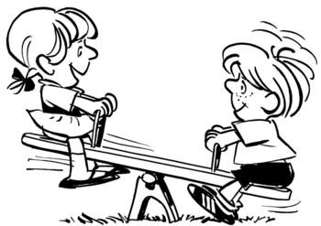
You are babysitting your cousins Andrea and Herman, and decide to take them to the playground for the afternoon. While there, Andrea and Herman decide to play on the seesaw. You immediately realize that a seesaw, also known as a teeter-totter, is actually just a simple machine comprised of a lever and fulcrum!

Instructions: You have 50 minutes to design, conduct, clean-up, and write up your findings on an experiment related to the SEESAW SIMPLE MACHINE.

Materials Available

In your bag:
Small cups (2)
Popsicle sticks (6)
Pebbles (10)
Straws (2)
Plastic spoons (2)
Rubber bands (4)
Paper clips (6)
Index cards (6)

At the common desk:
Masking tape
Scotch tape
String
Scissors
Foil
Pipe Cleaners
Extra pencils/paper
Stapler

May use if brought:
Non-programmable calculator
Timepiece
Ruler / Measuring stick
You do not need to wear goggles!

You have been given blank sheets paper to write up your experiment. If you need more, extra sheets are available at the common desk. Use this outline (points noted in parentheses):

- Statement of Problem (2)
- Hypothesis (4)
- Variables (10 points total)
  - Independent Variable (3)
  - Dependent Variable (3)
  - Controlled Variables (4)
- Experimental Control (2)
- Materials (3)
- Procedure, including Diagrams (6)
- Qualitative Observations (4)
- Quantitative Data: Data Table (6)
- Graph(s) (6)
- Statistics (2)
- Analysis & Interpretation of Data (4)
- Possible Experimental Errors (3)
- Conclusion (4)
- Applications and Recommendations for Further Use (4)

Scoring: Teams will be ranked based on scores out of a possible 60 points. Ties will be broken by comparing the point totals in 1) Procedure, 2) Graphs, and 3) Data Table (in that order). Any students violating proper safety procedures will be asked to leave the room, and their team will be disqualified from the event. Any irrelevant experiments will be ranked below those that do.

IMPORTANT Final Notes
- Return unused items to your bag or common desk, and discard any damaged items. Improper clean-up will result in loss of 5 points!
- Staple your write-up together, with this page as the cover sheet. Make sure your team name and number is written on this sheet! Turn in your completed write-up at the front desk within the 50-minte timeframe. Any late submissions will result in loss of 5 points!

