Awesome Aquifers
Station 1

Multiple Choice

1. The saturated zone is:
a. The zone below the water table containing just water in pore spaces
b. The zone above the water table containing both water and air in pore spaces
c. The zone below the water table containing both water and air in pore spaces
d. The zone above the water table containing only water in pore spaces
2. A confined aquifer is:
a. An aquifer with impermeable rock above and permeable rock below
b. An aquifer with impermeable rock above and below that will always create a free-flowing artesian aquifer
c. An aquifer underlain by impermeable rock and covered by permeable rock that is capable of creating a free-flowing artesian aquifer
d. An aquifer with impermeable rock above and below that is capable of creating a free-flowing artesian aquifer.
3. The potentiometric surface is:
a. A synonym of “water table”
b. A synonym of “capillary fringe”
c. The level that water in a confined aquifer would rise to
d. The surface below which all rocks are saturated with groundwater
4. Which of the following is a synonym for the unsaturated zone?
a. Air Zone
b. Zone of Aeration
c. Zone of Aviation
d. Dry Zone
5. A hole drilled into the ground for the purpose of pumping groundwater to the surface is referred to as a:
a. Sink hole
b. Spring
c. Water supply
d. Well
6. An area on the surface where groundwater naturally emerges from the ground is called a:
a. Sink hole
b. Spring
c. Water supply
d. Well
7. Which of the following is true?
a. Porosity is a synonym of permeability
b. Poorly sorted sediments usually have low porosity.
c. Highly cemented sedimentary rock usually has high porosity.
d. Well-rounded and coarse grained sediments have low porosity.

8. The word “aquifer” refers to:
a. The permeable rock that can store and yield water.
b. The water within permeable rock.
c. The area beneath the water table that is filled with water.
d. The collection of water beneath the ground, and all rock, both permeable and impermeable.
9. Which of the following are uses of groundwater in the United States?
a. Irrigation
b. Industrial Processes
c. Recreation, such as boating and swimming
d. Drinking
e. All of the above
f. A, B, and C
g. A, B, and D
h. B and D only

True or False

10. Groundwater is sometimes more useful in certain areas than others, as it is not always accessible or fresh enough for use without treatment.
11. The water table is in a fixed position and never increases or decreases. If it rains and more water enters the groundwater, an equal amount must immediately leave in order to maintain hydrostatic pressure.
12. Groundwater travels faster than surface streams, as the highly permeable rocks which contain aquifers create much less friction than the rocks in the beds of streams.
13. Groundwater is an active weathering agent and can leach ions from rock.
14. Shallow groundwater can migrate thousands of miles a year. Deep groundwater can travel even faster.
15. Groundwater can exist below any land throughout the Earth, including deserts; however in some areas the water table is too low to cause any surface water or readily accessible water.
16. Every confined aquifer will cause an artesian well.

Short Answer
17. Is there ever a situation in which a highly porous rock is not highly permeable? If so, describe.
18. Describe the process of non-artesian well construction in 2 to 4 sentences, using proper terminology.

Awesome Aquifers
Station 2:
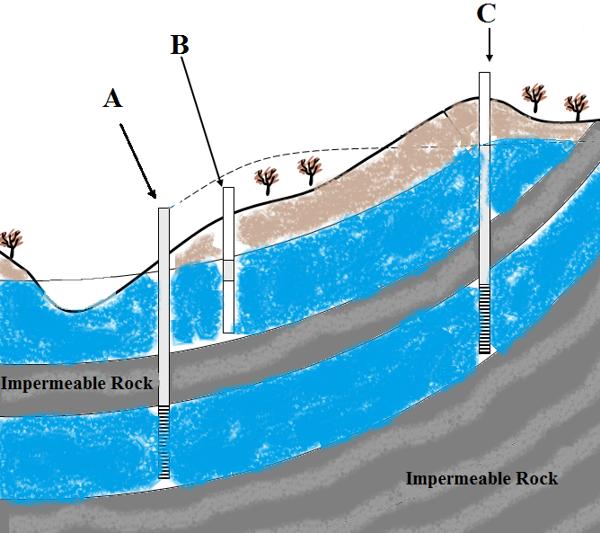
Figure 1
1. What is another proper name for the “impermeable layer”?
a. Deconfining Bed
b. Confining Layer
c. Imporous Rock
d. Solid Rock Layer
2. What feature would occur where the water table intersects the ground surface?
a. An unconfined aquifer
b. A sinkhole
c. Surface water
d. A well
3. Which well or wells in Figure 1 would be an artesian well?
a. A only
b. B only
c. A and C
Figure 2

d. A, B, and C
4. Which well or wells in Figure 1 would be a water table well?
a. A only
b. B only
c. A and C
d. A, B, and C
5. Which well or wells in Figure 1 would be a flowing well?
a. A only
b. B only
c. A and C
d. A, B, and C
6. In Figure 2, which would be the most appropriate term for A?
a. Discharge area
b. Refill area
c. Disposal Area
d. Recharge Area
7. In Figure 2, which would be the most appropriate term for B?
a. Discharge area
b. Refill area
c. Disposal Area
d. Recharge Area
8. Which would pose the highest risk of contamination of the groundwater in Figure 2?
a. Excessive fertilizer placed in zone A
b. Chemical waste dumped upstream in zone B
c. An oil spill downstream in zone B
d. The placement of a well in zone A

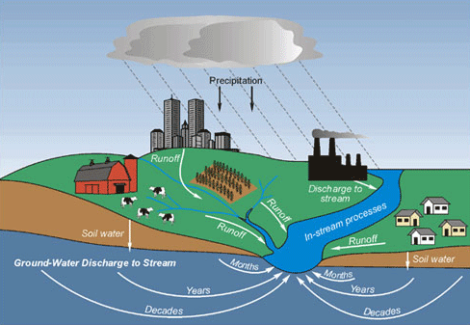
Figure 3

9. In Figure 3, which would be examples of nonpoint source pollution?
a. Excess fertilizer from the farm and smoke produced by the factory
b. Dumping from the factory and acid precipitation
c. A septic tank leak in the residential area and acid precipitation
d. Excessive fertilizer and salt from roads being picked up by runoff
10. Which of the following have no risk of contaminating the stream in Figure 3?
a. Industrial waste being dumped at the factory
b. Overuse of pesticides at the farm that is washed away by precipitation
c. A septic tank leak in the residential area that contaminates the groundwater
d. None of the above
11. How would pollution, such as road salt, travel from the city to the local stream?
a. Infiltration
b. Discharge
c. Runoff
d. Precipitation

12. In Figure 4, what would most likely occur after excessive pumping?
a. The salty groundwater would fall in most areas, except under the well, where it would rise, causing what would resemble an upside down cone of depression.
b. The pumping would not affect the salty groundwater at all.
c. The salty groundwater would rise, especially closest to the well.
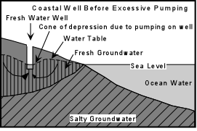

d. The level of salty groundwater would fall, especially near the well, causing what would resemble a cone of depression.
13. What would this process be called?
a. Subsidence
b. Saltwater Intrusion
c. Dissolution
Figure 4

d. Salt leaching
14. If no water was drawn from the well, would the salty groundwater still encroach coastal fresh groundwater aquifers?
a. Yes, the salty ground water would enter the aquifer due to tides and wave
b. No, the density difference would prevent them from mixing
c. Yes, the salt would naturally diffuse into the fresh groundwater
d. No, the seaward motion of ground water would keep the saltwater near the shore and away from the aquifer.
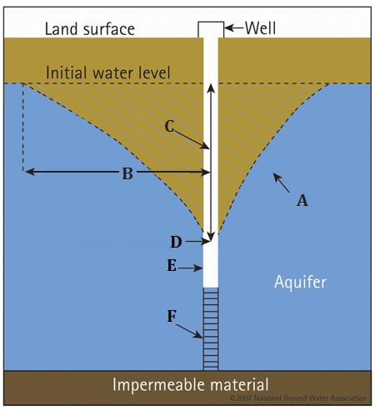
Figure 5

15. In Figure 5, what is the proper term for A, the shape that is created when the water table is lowered with increasing intensity as the well is approached?
a. Cone of Depression b. Cone of Drawdown
c. Sphere of Influence d. Sphere of Leachate
16. In Figure 5, what is the proper term for B, the distance from a well to the point where there is no lowering of the water table?
a. Diameter of Depression b. Length of Drawdown
c. Radius of Influence d. Hydrostatic Drawside
17. In Figure 5, what is the proper term for C, the lowering of the water table due to the pumping of a well?
a. Drawdown b. Water table
c. Attenuation d. Reduction level
18. In Figure 5, what is the proper term for D, the location of the water table at its lowest point at the well when the well is being pumped?
a. Drawdown b. Pumping level
c. Static level d. Reduction level
19. In Figure 5, what is the proper term for E, the part of a well is placed in the borehole to prevent collapse?
a. Well Screen b. Well Casing c. Well Shield d. Well Protector
20. In Figure 5, what is the proper term for F, the part of a well that prevents everything but water, such as sand and other sediment, from getting in?
a. Well Screen b. Well Casing c. Well Shield d. Well Protector
Awesome Aquifer Answer & Score Sheet

School:__________________________________________ Team #: ______________

Station 1: Station 2:
1. _________ 1. _________
2. _________ 2. _________
3. _________ 3. _________
4. _________ 4. _________
5. _________ 5. _________
6. _________ 6. _________
7. _________ 7. _________
8. _________ 8. _________
9. _________ 9. _________
10. ________ 10. ________
11. ________ 11. ________
12. ________ 12. ________
13. ________ 13. ________
14. ________ 14. ________
15. ________ 15. ________
16. ________ 16. ________
17. ________ 17. ________
18. ________ 18. ________
19. 19. ________
20. ________
20.

Point Totals
 | Possible Points | Earned Points
Part 1: Test | 20
Part 2: Test | 20
Station 4: Demonstration | 40
Total Points | 80

Awesome Aquifer Answer Key

Station 1: Station 2:
1. A 1. B
2. D 2. C
3. C 3. C
4. B 4. B
5. D 5. A
6. B 6. D
7. B 7. A
8. A 8. A
9. G 9. D
10. True 10. D
11. False 11. C
12. False 12. C
13. True 13. B
14. False 14. D
15. True 15. A
16. False 16. C
17. A
18. B
19. B
20. A

17. Yes, if the pores are large or numerous, but not interconnected.
18. A borehole is drilled, well casing is placed inside the borehole, usually made of steel or PVC, to prevent collapse. A well screen is place at the bottom to prevent anything but water from entering. The well is capped to prevent contaminants from entering the top.

Station 3: Building Concepts

Using the materials you brought, build a model that can be used to explain and demonstrate the concepts listed below. Concepts can be presented in any order.

CONCEPTS
Define, explain, and demonstrate
Point Source Pollution
Remediation
Confined Aquifer
Movement of a Contaminant within Groundwater
Sustainable Yield
Non-point Source Pollution
Groundwater as Part of the Hydrologic Cycle
Overwithdrawl and Impacts
Contamination Plume
Cone of Depression
Impact a Well has on Surface Water
Comparison of Porosity and Permeability

Station 4: Model Presentation
Judge Worksheet
Team # ______________

School Name: _____________________________

CONCEPTS | Explain/Define | Demo/Point Out | Total
Point Source Pollution | 1 – 2  1 pt. for defining  1 pt. for an example | 1 | 3
Remediation | 1 – 2  1 pt. for defining  1 pt. for describing real technique | 1 – 2  1 pt. demonstrate technique  1 pt. clearly shows the contaminant is gone | 4
Confined Aquifer | 1 | 1 | 2
Movement of a Contaminant within Groundwater | 1 | 1 – 2 | 3
Sustainable Yield | 1 | 1 – 2  Show simultaneous recharge and discharge from aquifer | 3
Non-point Source Pollution | 1 – 2 | 1 | 3
Groundwater as Part of the Hydrologic Cycle | 1 – 2 | 1 – 2 | 4
Overwithdrawal and Impacts | 1 – 2 – 3  1 pt. for defining  1 pt. for each impact (2) | 1 – 2  1 pt. for demonstrating  1 pt. for showing impacts | 5
Contamination Plume | 1 | 1 | 2
Cone of Depression | 1 – 2  1 pt. for defining  1 pt. for explaining how it is cause | 1 | 3
Impact a Well has on Surface Water | 1 | 1 – 2 | 3
Comparison of Porosity and Permeability | 1 – 2 – 3  1 pt. for each definition (2)  1 pt. for comparison | 1 – 2 | 5
Total Points
Notes:

