Anatomy
Answer Key

Station 1: The Heart

1. (10pts) Vena cava, right atrium, tricuspid valve, right ventricle, pulmonary semilunar valve, pulmonary artery, pulmonary veins, left atrium, bicuspid (mitral) valve, left ventricle, aortic semilunar valve, aorta
2. (5pts)
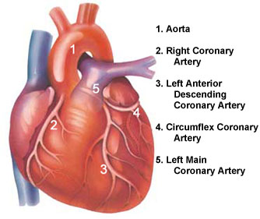
3. (10pts)- 1. systole; 2. diastole; 3. lub-dup; 4. atrioventricular; 5. semilunar; 6. ventricles; 7. atria; 8. atria; 9. ventricles; 10. mumurs

Station 2: Blood

1. (28pts)
Blood Type | Antigens | Antibodies in plasma | Can donate blood to type | Can receive blood from type
Type A | A | Anti-B | A, AB | O, A
Type B | B | Anti-A | B, AB | O, B
Type AB | A and B | None | AB | O, A, B, AB
Type O | none | Anti-A and anti-B | O, A, B, AB | O
2 through 12 are all 2pts apiece
2. a
3. c
4. b
5. d
6. d
7. c
8. a
9. b
10. b
11. true
12. false

Station 3: Name that Bone

- Labeling (20pts)
- Cranium
- Mandible
- Clavicle
- Sternum
- Humerus
- Rib
- Vertebra
- Pelvis
- Radius
- Ulna
- Carpals
- Metacarpals
- Phalanges
- Femur
- Patella
- Tibia
- Fibula
- Tarsals
- Metatarsals
- Phalanges
21. femur (2pts)
22. malleus, incus, and stapes (2pts)
23. mandible (2pts)
24. atlas (2pts)
25. axis (2pts)
26. sternum (2pts)
27. occipital bone (2pts)
28. patella (2pts)

Station 4: Skeletal System

  - Joints (12pts)
    - Movement in all planes
    - Movement in one plane
    - Movement in one plane with some lateral movement
    - Rotation
    - Side to side movement
    - Movement in several planes
  - Classification (7pts)
    - gliding
    - saddle
    - hinge
    - ball and socket
    - condyloid
    - pivot
    - ball and socket
3. Labeling (18pts)
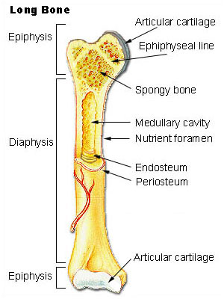
- Some possible answers include: (12pts)
    - Provides a framework that supports the body
    - Provides muscular attachment sites to help move the body
    - Protection of internal organs
    - Contains and protects the red bone marrow
    - Provides a storage site for excess calcium

Station 5: Circulatory System

- lumen (2pts)
- vasoconstriction (2pts)
- vasodilation (2pts)
- veins (2pts)
- arteries (2pts)
- arterioles (2pts)
- venules (2pts)
- Arteries are high-pressure vessels. Veins are low pressure vessels. Blood flows from high to low pressure. The venous valves help to prevent the backflow of blood that might otherwise occur in those low pressure vessels. (6pts)
- 5.6 L/min (3pts)
- 50 mmHg (3pts)
- 83mmHg (3pts)
- Yes, Joe the Plumber has high cholesterol. (3pts)
- Joe Maverick should be hired. Reasons will vary. (8pts)

Station 6: Skeletal System Disorders

- osteoarthritis (2pts)
- scoliosis (2pts)
- herniated disc (2pts)
- osteoporosis (2pts)
- osteoporosis (2pts)
- osteoarthritis (2pts)
- scoliosis (2pts)
- (2pts)
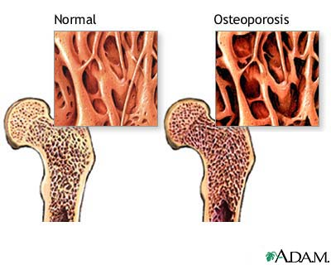
- (2pts)
- 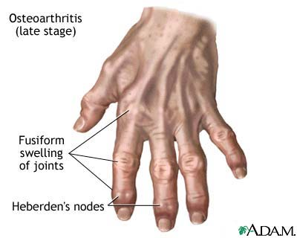
(8pts)

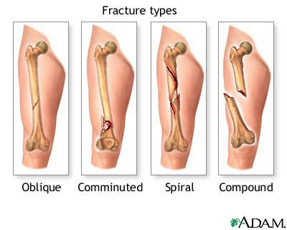
11. Answers will vary. (6pts)

