SCIENCE OLYMPIAD ROCKS AND MINERALS
Practice Test

(.doc version)

Disclaimer/Notice

This practice test was composed using rules from the 2012 season. All items included are listed in either the rules, or the official lists released on the SO website. Credit goes to Nylhvsso for test format and design. Please make sure your study materials are up to date!

Consider the Following:

- Use the corresponding answer sheet (scioly.org).
- The test is timed. For ID questions, you will have 1 minute to identify the rock/mineral and 1 minute and 30 seconds to answer questions.
- For automatic timing, use the PowerPoint version of the test.
- The questions on this test are based on the 2012 National Rocks and Minerals Specimen List
- This test may be very time-consuming. Make sure you have at least 20-40 minutes to complete the test although it may not take the full time given to you.
- There will be 13 ID questions, with questions about each specimen following afterwards.
- Good Luck!

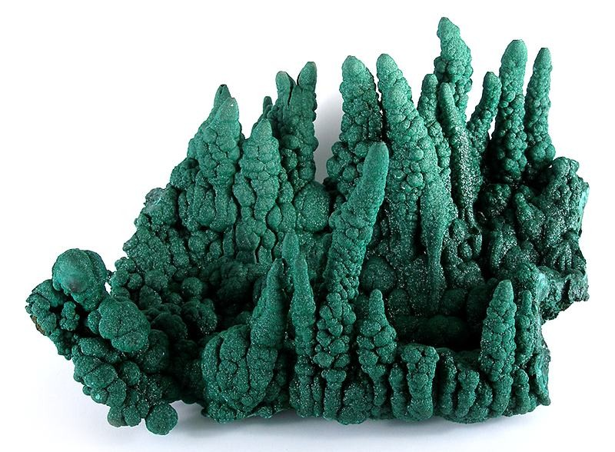

1. Identify this specimen.

2. What is the chemical formula?

3. What is the crystal structure of this mineral?
- Orthorhombic
- Monoclinic
- Tetragonal
- Triclinic

4. Which element gives this mineral its green color?
- Manganese
- Antimony
- Copper
- Tin

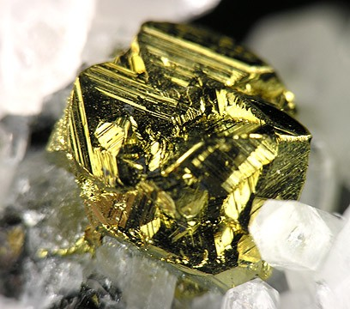

5. Identify this specimen.

6. To what mineral group does this specimen belong to?
- Sulfides
- Halides
- Nitrates
- Phosphates

7. What is the crystal structure of this mineral?
- Monoclinic
- Triclinic
- Tetragonal
- Cubic

8. True or False: When heated, this mineral becomes magnetic.

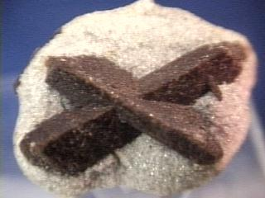

9. Identify this specimen.

10. To what class of minerals does this specimen belong to?
- Silicates
- Sulfates
- Halides
- Sulfides

11. What is the famous nickname for this mineral?
- “Fairy Stone”
- “Fools Gold”
- “November’s Rich”
- “Morning Star”

12. Which of these statements are NOT correct?
- This mineral is the state mineral of Georgia.
- This mineral is used as an index mineral to determine metamorphic conditions
- This mineral was once used to ward off witchcraft and disease.
- This mineral is used as an index mineral to determine crystallization temperature of intrusive igneous rock.

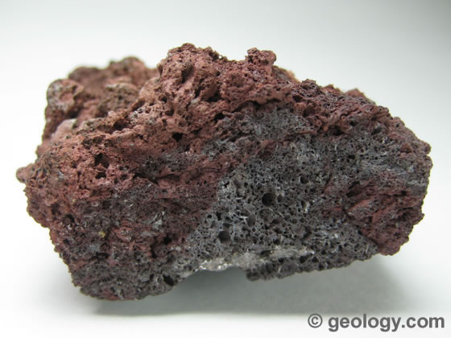

13. Identify this specimen.

14. How is this rock classified?
- Clastic
- Extrusive
- Chemical
- Intrusive

15. True or False: This specimen is strictly andesitic in composition.

16. Which of these statements is correct?
- This specimen has many air pockets, so it floats in water.
- This specimen has air pockets, meaning it cooled underwater at a very fast rate.
- This specimen has air pockets, but since its specific gravity is more than 1, it sinks.
- This specimen has air pockets, but since it was intruded, heavier crystals have formed in its center. Because of this, it sinks.

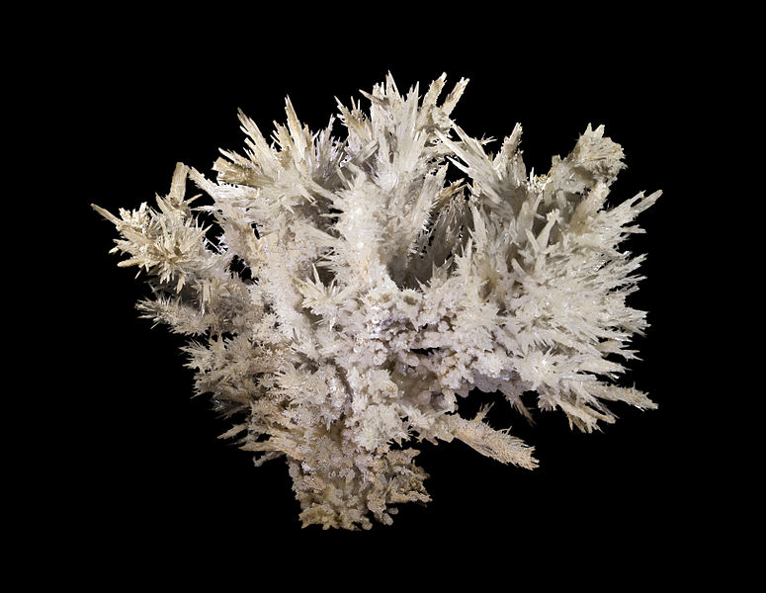

17. Identify this specimen.

18. What is the chemical formula?

19. What other mineral shares this chemical formula?
- Dolomite
- Calcite
- Halite
- Hornblende

20. What kind of crystal structure does this specimen have?
- Triclinic
- Monoclinic
- Orthorhombic
- Tetragonal

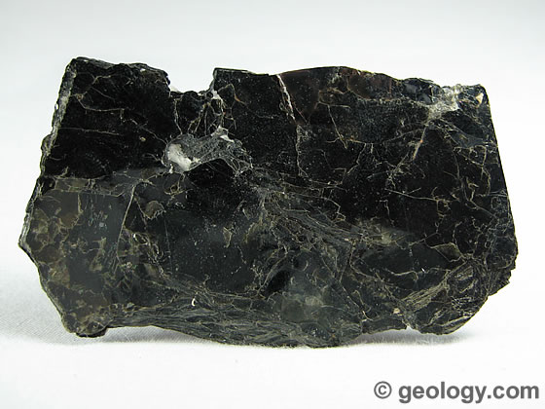
21. Identify this specimen.

22. Which of these best describes this specimen’s cleavage?
- Basal
- Singular
- Primatic
- None of the above

23. What precedes this mineral on Bowen’s Reaction Series?
- Olivine
- Pyroxene
- Orthoclase
- Amphibole

24. What is the hardness of this mineral?
- 1-2
- 2-3
- 3-4
- 4-5

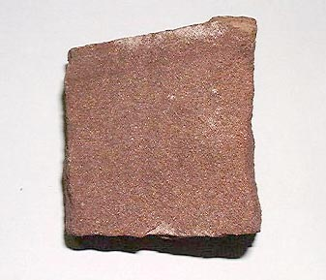
25. Identify the specimen.

26. How is this rock classified?
- Organic
- Inorganic
- Clastic
- Chemical

27. What is the grain size in this rock?
- Gravel
- Sand
- Silt
- Clay

28. True or False: This rock would not make good material for an aquifer, as it is not very porous.

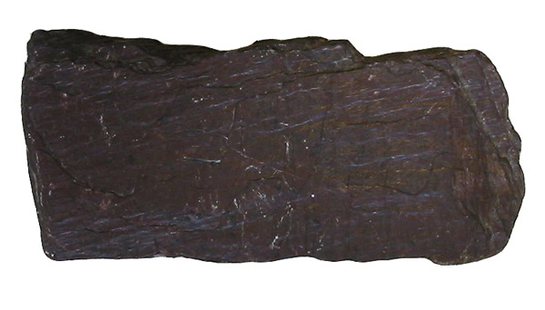
29. Identify the specimen.

30. What degree of metamorphosis does this specimen exhibit?
- Low grade metamorphosis
- Medium grade metamorphosis
- High grade metamorphosis
- No metamorphosis

31. Which of these is the specimen’s parent rock?
- Gneiss
- Slate
- Calcite
- Shale

32. Which of these statements is correct?
- The specimen is foliated, but due to the low grade metamorphosis, it is invisible to the naked eye.
- The specimen is not foliated because the rock is sedimentary. It is clastic.
- The specimen is foliated, but due to very fine grains, foliation is very thin and wavy.
- The specimen is foliated. However, due to high grade metamorphosis, the organic materials have changed the structure of the rock, making foliation hard to see.

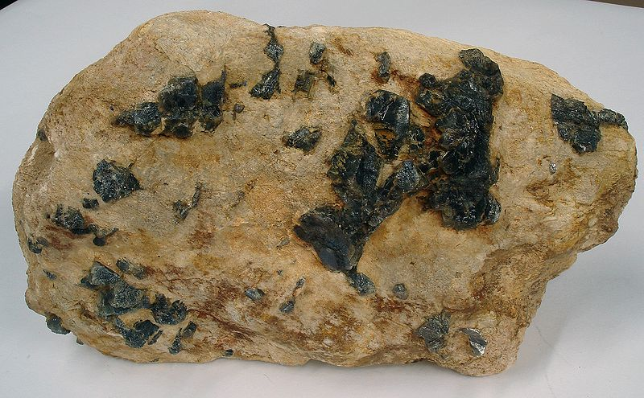

33. Identify the specimen

34. Which of the following statements is false?
- It is hard to define the specimen’s mineralogy, as each sample varies greatly.
- The specimen has a composition very similar to granite.
- Feldspar is a common mineral found in this specimen.
- This specimen has a composition very similar to rhyolite.

35. Which of these describes a rock with large crystals?
- Rhyolitic
- Porphyritic
- Dioritic
- Basaltic

36. What is the classification of this specimen?
- Extrusive
- Intrusive
- Clastic
- Chemical
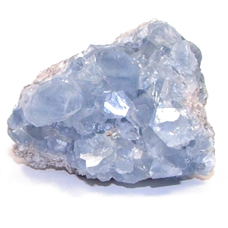
37. Identify this specimen.

38. What is the chemical formula?

39. What group of minerals does this specimen belong to?
- Nesosilicates
- Sulfates
- Halides
- Tectosilicates

40. Which of these best describes the specimen’s fracture?
- Earthy
- Conchoidal
- Splintery.
- Uneven

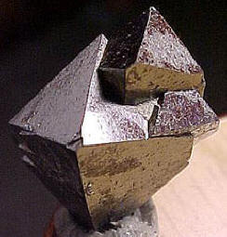

41. Identify this specimen.

42. What is the chemical formula?

43. What is the crystal structure of this specimen?
- Triclinic
- Monoclinic
- Isometric
- Cubic

44. This mineral can be used as a sorbent to remove what harmful element from polluted waters?
- Mercury
- Arsenic
- Antimony
- Lead

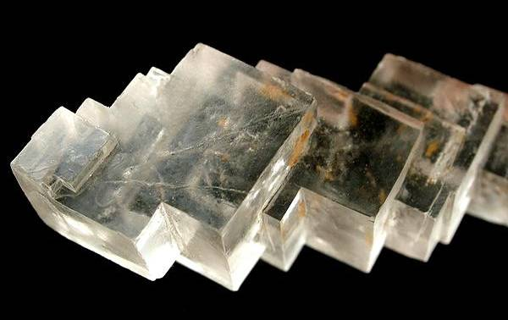

45. Identify this specimen. (Provided Info: HCl has limited effect)
46. What is the chemical formula?

47. What is the crystal structure of this specimen?
- Orthorhombic
- Monoclinic
- Cubic.
- Isometric

48. What is the fracture of this specimen?
- Concoidal
- Uneven
- Earthy
- Splintery

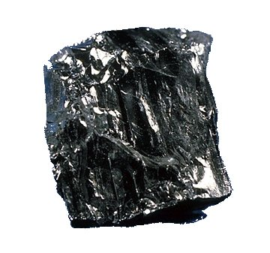
49. Identify this Specimen

50. What is the most prevalent element in this rock, and how much of it is there?
- Magnesium, 50-65%
- Carbon, 50-65%
- Magnesium, 93-98%
- Carbon, 93-98%

51. What is this rock classified as?
- Extrusive
- Chemical
- Organic
- Clastic

52. Which of these terms accurately describes the luster of the rock?
- Vitreous
- Silky
- Submetallic
- Resinous

