Edited Georgia 2007 Test
Name:
Score out of 211:
- What is the approximate diameter of the organism in the picture? (5 pts)

___________
50μ m

- What is the function of the cells in the picture (5 pts)

3-5. A new single celled organism is found and studies show that it contains chloroplasts inside.
- What type of organism has probably been isolated? (10 pts)

- Provide one place from which this organism could have been isolated. (5pts)

- What process occurs in the above cell? (5pts)

#6- 9 Which kind of microscope would you use to do each of the following processes?

- Look for structures such as mitochondria, and endoplasmic reticulum in cells (5 pts)

- Examine bacteria (5pts)

- Examine algae (5pts)

- Examine viruses (5pts)

11. Label microscope parts and indicate their function (12 pts)

12. What part of the light microscope above would you use to bring the image into fine adjustment? (5 pts)

13. Lichens are composed of ___ and ___ cells. (10 pts)

14. Interpret this graph of microbial growth (5 pts)

time | # microbes present
0 | 50
20 min | 100
40 min | 200
60 min | 400
120 min
15. Assuming there is a constant source of nutrients, and unlimited space, what would you expect the population to be after 180 minutes? (10 pts)

16. What is cytoplasm mostly made of? (5 pts)

17. Which of the following groups of organisms represent the main decomposers in the soil? (5 pts)
A. bacteria and viruses C. fungi and viruses
B. bacteria and fungi D. algae and fungi

18. You discover something green and fuzzy on some food that has been in the refrigerator for a long time. This organism is most likely (5 pts)
A. Archaea C. algae
B. bacterium D. fungus

19. A scientist discovers some cells underneath the surface of Antartica. This organism is most likely (5 pts)
A. Archaea C. algae
B. bacterium D. fungus

20-37: Matching. Each statement will have ONLY one answer. Some answers will be used more than once; others answers may not be used at all. USE CAPITAL LETTERS; LOWER CASE LETTERS WILL BE COUNTED WRONG! (1 pts each)

(A. Viruses) (B. Archaea) (C. Bacteria) (D. Algae or plant like protists) (E. Fungi)
(F. Animal protists) (G. Answer not given)

20. Has cell wall, but is not photosynthetic
21. Found in extreme environments
22. Mushrooms are an example
23. Contain only nucleic acids and proteins
24. Photosynthetic
25 Used to make most cheeses
26. Used to make bread
27. Can not grow by themselves
28. Cause of AIDS
29. Cause of athlete’s foot
30. Cause of strep throat
31. Cause of the flu
32. Produce much of world’s oxygen
33. Capable of phagocytosis (engulfing and ingesting of foreign particles or waste matter)
34. Smallest of all forms listed
35. May contain many cilia or may be able to change shape
36. Contain chloroplasts
37. Cause of Mad cow disease.
38. What is the best way to prevent the spread of the agent that causes influenza? (10 pts)
A. Frequent and proper handwashing. C. Frequent use of antibiotics
B. Making sure that all food is thoroughly cooked. D. Avoiding serving bagged lettuce and spinach

42. Write the letter that stores genetic information. (5 pts)
43. Write the letter that is involved in producing much energy for cell. (5 pts)
44. Write the letter that corresponds to endoplasmic reticulum. (5 pts)
45. Write the letter that corresponds to cell membrane. (5 pts)
46: Label the cell and indicate whether you think it’s an animal or plant cell. (5 pts)
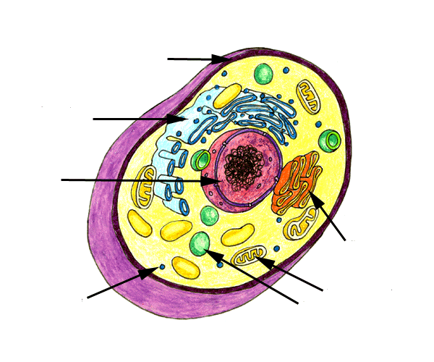
47. The low field diameter of a microscope is 0.5 mm. The low power magnification is 50X.The high power magnification is 100X. How many micrometers is the high field diameter? (15 pts)

48. Name two microbes that are acellular. (10 pts)

49. What are two characteristics of viral diseases? (10 pts)

50. Which two types of microbes typically live alone? (10 pts)

Extra credit: Draw what you’d see if you observed an “e” under a microscope. (+15 pts)

