PAL/MAC Invitational Optics
ANSWER KEY

Team Names : __________________ SCHOOL: ________________

__________________

Part I: ___________/30 pts

Part II: ___________/30 pts

Part III: __________/20 pts ( # mirrors *4) ____________ mirrors

Part IV: _________/20 pts (20-(accuracy in mm)/10) ____________ accur.

TOTAL SCORE: ____________/100 pts

Tie Breaker: _______/2

Part 1: Geometric Optics (30 pts)

(1,2). Light traveling through air reaches a transparent piece of plastic at an angle of incidence of 42º and refracts to an angle of 34º. Calculate the index of refraction for the plastic. (nair = 1.0003)

n=1.2

(3,4) Light enters a a swimming pool (n=1.33) from air at an angle of incidence of 55º. Calculate the angle to which the light is refracted.

ø=38º

(5) When a wave strikes a boundary at an angle from a less dense medium
to a more dense medium the wave is refracted and the wavelength __decreases__________.

(6) _Specular/Regular_________reflection occurs when parallel light rays are reflected parallel by a smooth surface.

(7) The mirror on the passenger side of most cars is what type of mirror ? Convex

Diagram A: Jane, a fabulous physics student is completing a lab with mirrors. She has placed a 20 cm tall object 36 cm from a concave mirror with a focal length of 20 cm.

(8,9) Complete the ray diagram showing at least two correct rays.

(9,10)Calculate the location of the image. 45 cm

(11,12,13) Classify the image as real or virtual

upright or inverted

smaller or larger

Diagram B: Jane, a fabulous physics student is completing a lab with mirrors. She has placed a 20 cm tall object 16 cm from a convex mirror with a focal length of 20 cm.

(14,15) Complete the ray diagram showing at least two correct rays.

(16,17) Calculate the location of the image.

d= -9 cm

(18,19,20) Classify the image as real or virtual

upright or inverted

smaller or larger

Diagram C: Jane, the same fabulous physics student, is shining a red laser (680 nm) into a swimming pool (n=1.33) at an incident angle of 28º.

(21,22) Calculate the angle of refraction.

Ø=20.7º

(23,24) Complete the ray diagram by showing the incident and refracted rays at the air/water interface.

- Calculate the wavelength of the laser in the pool.

512 nm

- Calculate the speed of light in the pool.

V= 2.3 x 10⁸ m/s

(27,28) Calculate the critical angle for laser light traveling from the pool back into air.
Ø=48.75º
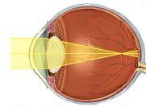
(29,30) The person shown above suffers from (nearsighted/farsighted) vision and needs to wear (divering/converging) glasses.

Part II: Physical Optics (30 pts)

- Calculate the frequency of a red laser with a wavelength of 695 nm.

4.3 x 10¹⁴ Hz

- Red and green light combine to form the secondary color ___yellow______.

- A red apple viewed with green light will appear to be ___black______.

- A yellow shirt in a room with blue light will appear to be __black______.

- In the summer, runners should wear __white_____ hats to maximize reflection.

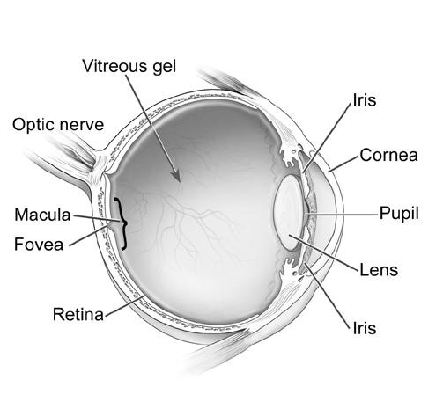
(14,15,16) Light from a star is observed to have a frequency of 5.2 x 10¹⁴ Hz compared to the laboratory value of 5.0 x 10¹⁴ Hz. The star is moving ___towards_______ at a speed of __1.2 x 10⁷_______ m/s.
(6) ___vitreous humor___________
(7) _iris_____________
(8) __cornea____________
(9) _Pupil_____________
(10) __Lens____________
(11) __/Aqueus Humor____________
(12) _Scelera_____________
(Tie B.) _Focula
Macula_____________
(13) ___optic nerve___________

- A hydrogen electron transitions from n=3 to n=1. The electron __emits____ a photon.

- The photon has an energy of ___12.09_____ eV.

- The photon has an energy of __1.9 x 10⁻¹⁸_____ J.

- The frequency of the photon is __2.9 x 10¹⁵________ Hz.

- The wavelength o f the photon is __1.05 x 10⁻⁷______ m.

- The photon (is/is not) visible.

(23,24) Calculate the momentum of a photon of blue light with a wavelength of 425 nm.

P=1.56 x 10⁻²⁷ kg m/s

(25,26) A laser emits a beam of light with a radius of 1.0 mm at a power of 1.2 milliwatts. Calculate the intensity of the beam.

I = 3.82 x 10³ W/m²

(27,28) The average intensity of sunlight at the top of the earth's atmosphere is 1390 W/m². What is the maximum energy that a 25 m x 45 m solar panel can collect in one hour?

E = 5.63 x 10⁹ J

(29,30) The human eye is most sensitive to light having a frequency of 5.5 x 10¹⁴ Hz. How many wavelengths of this light can fit across the width of your thumb, a distance of 2.0 cm.

36700 wavelengths

