Science Olympiad Rocks and Minerals Test
2008 State Exam

- Your Challenge: Without performing scratch tests on the minerals, put them in order of increasing hardness. Use other properties, like cleavage, crystal habit, etc. (Moh’s Hardness scale)

- Identify each mineral specimen and place them in the correct position of the Bowen’s Reaction Series diagram below:
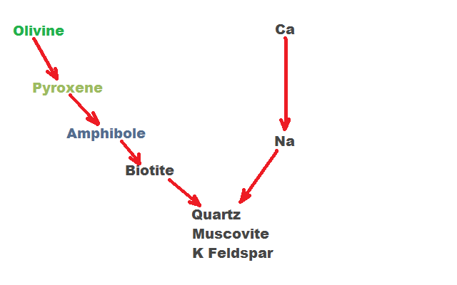
A
B
C
- Identify each mineral specimen, their crystal system and chemical formula.

- Identify the mineral specimen. What do they have in common compositionally?

- Identify the rock. What is its environment of deposition?

- Identify each mineral specimen, its chemical formula and the type of twinning present in the sample.

- Identify the red mineral and name the rock. What type of rock is it (igneous, metamorphic, or sedimentary)?

- Identify the mineral specimens and name its mineral group.

- Identify the mineral specimens. What do they have in common?

- Identify the two minerals. What is the economic importance of the purple mineral?

- Identify the mineral specimens and state their individual economic importance.

- Identify the minerals. What metal is common in all three minerals?

- Identify the minerals.

- Name each rock and place them on the diagram below in the environment in which they were deposited.
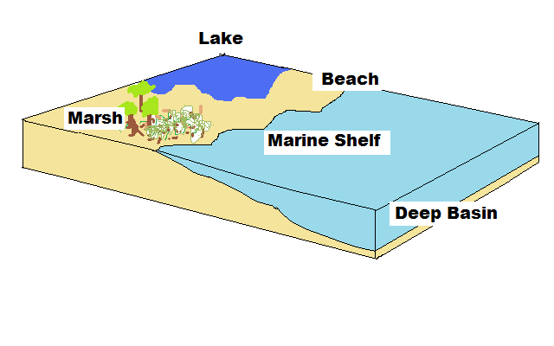
A
B
C
D
E
- Identify the mineral specimens. What is an original use for each mineral?

- Identify the rocks and name their parent rock. (For example, this type of rock was formed from a _________ rock).
 | A | B | C
Sample
Parent Rock

- Identify the green minerals in each rock. What do they all have in common?

- Identify the mineral specimens, their crystal family, and their economic uses.

- Name each rock sample, and place them in the correct environment of formation on the diagram below.

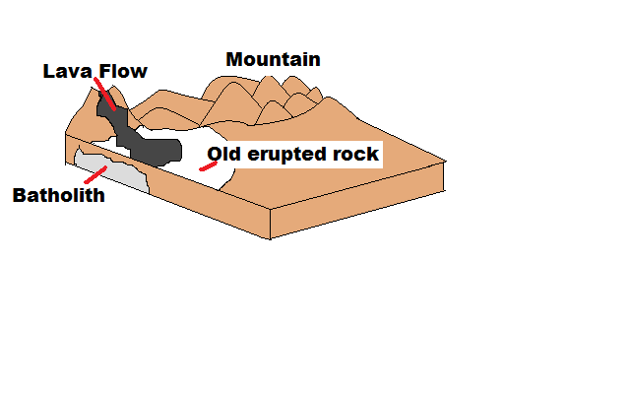
A:

B:

D:

C:

- Name the five characteristics of a mineral (in other words, what is the definition of a mineral?).

