1.
- Altostratus: b. Cumulonimbus:

- Cirrus: d. Nimbostratus

- Stratocumulus f. Cirrocumulus

2.
Cloud coverage: 7/8th Wind spd: 13-17 knots
Wind direction: Coming from the NW Temp: 59 degrees
Weather: Light rain Dewpoint: 57 degrees
Low cloud: Nimbostratus Medium cloud: stratocumulus
High cloud: Cirrocumulus Sea Level Pressure: 1013
3.
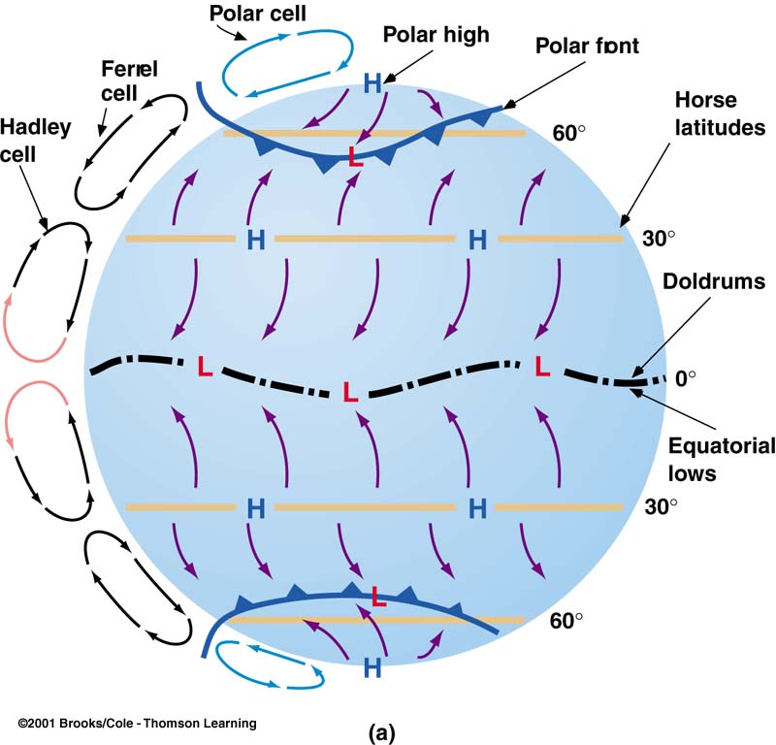(This picture contains more information than you need. Sorry)
Tropic of Cancer
Equator
Tropic of Capricorn
4. A) Nitrogen, 78.1% B) Oxygen, 20.9% C) Argon, .9%
5. 1-E 2-C 3-B 4-A 5-D
6. 32-38 MPH, 28-33 Knots, Beaufort #7, Moderate Gale
7. (BONUS) California
8. 4:00 PM, 2300Z
9. Warm
10. KSFO 28900Z 2003KT 8SM OVC009 57/54 RMK SLP1080

