International Academy Invitational Tournament
Keep the Heat Test 2-4-2012

Team Name ________________

Team Number _____________

Predicted Water Temp ____________________C

Circle the all of the correct answer to the below questions.
One or more of the answers can be correct, if more than on one answer is correct, circle all correct answers.

- Temperature is a measure of ____ of the particles in an object.
  - the difference between the potential and kinetic energy
  - the sum of the potential and kinetic energy
  - the average potential energy
  - the average kinetic energy
- An increase in heat in a system __________.
  - has less kinetic energy
  - increases entropy
  - decreases entropy
  - reduces temperature
- The specific latent heat of melting for lead is 22.4 kJ/kg and that of oxygen is 13.9 kJ/kg. This means:
  - Lead melts at a higher temperature.
  - More energy is needed to heat lead than is needed to heat the same mass of oxygen by the same amount.
  - More energy is needed to melt lead than is needed to melt oxygen.
  - Less energy is needed to heat lead than is needed to heat the same mass of oxygen by the same amount.
  - Lead melts at a lower temperature.
- Convert the temperature of -32 ºC to degrees Rankline
  - -485 ºR
  - -445 ºR
  - 371 ºR
  - 434 ºR
  - 474 ºR
- Convert the temperature of 50 ºC to degrees Rankline
  - -338 ºR
  - -400 ºR
  - 455 ºR
  - 518 ºR
  - 582 ºR
- Convert the temperature of 100 ºF to degrees Celsius
  - 24 ºC
  - 38 ºC
  - 88 ºC
  - 122ºC
  - 148 ºC
- An Object starts at 70 C, energy is added until the temperature increases to 80 C for a total ∆T of 10 C. What is the temperature change as expressed in degrees Kelvin
  - -263 ºK
  - 10 ºK
  - 50 ºK
  - 283 ºK
  - 510 ºK
- An Object starts at 85 C, energy is added until the temperature increases to 100 C for a total ∆T of 15 C. What is the temperature change as expressed in degrees Fahrenheit
  - 8.3 ºF
  - 15 ºF
  - 27 ºF
  - 40 ºF
  - 59 ºF

- The number 1.050 × 10⁹ has how many significant figures?
  - 4
  - 2
  - 13
  - 3
  - 9

- 1.1 Identify which of the following are extensive properties and which are intensive properties: (a) a 10-m3 volume, (b) 30 J of kinetic energy, (c) a pressure of 90 kPa, (d) a stress of 1000 kPa, (e) a mass of 75 kg, and (f) a velocity of 60 m/s. (g) Convert all extensive properties to intensive properties assuming m = 75 kg.

- Which of the following statements about 'heat' is/are Correct?
  - it is the energy transferred due to temperature difference
  - if Object A has a higher temperature than Object B, Object A must have more thermal energy than Object B.
  - it has the same meaning as work
  - it is related to degree of hotness
- The specific heat capacity of a substance is the heat required to warm
  - it by 1 degree Celsius
  - 1 kilogram of water by one degree Celsius
  - 1 kilogram of it by one degree Celsius
  - an equal weight of water by one degree Celsius
- By E = mc∆T and c = 4200 Jkg^{-1o}C⁻¹. Calculate the energy used to heat the water. (Given Mass of water m = 2 kg, Initial temperature T1 = 80 ºC, Final temperature T2 = 100 ºC )
  - 672000J
  - 840000J
  - 168000J
  - 120000J
- A heat engine has a thermal efficiency of 45%. How much power does the engine produce when heat is transferred into it at a rate of 10⁹ kJ/Hr?
  - 50 MW
  - 75 MW
  - 100 MW
  - 125 MW
- What is the thermodynamic efficiency of a heat engine that rejects heat at a rate of 20 MW when heat is supplied to it at a rate of 60 MW is:
  - 33.3%
  - 50%
  - 66.7%
  - 75%
- Which of the following laws of physics becomes the foundation of thermodynamics?
  - Newton’s laws of motion
  - Law of conservation of energy
  - Law of universal gravitation
  - Law of conservation of momentum
- The word thermodynamics stems from two Greek words meaning
  - conservation of heat
  - conversion of heat
  - study of heat
  - movement of heat
- A system does no work even when heat is added to it. Which of the following may happen to the system?
  - The system expands
  - The internal energy of the system increases
  - Both a and b
  - Neither a nor b
- A block of ice at -10ºC is slowly heated and converted to steam at 100ºC. Which of the following curves represents the phenomenon qualitatively
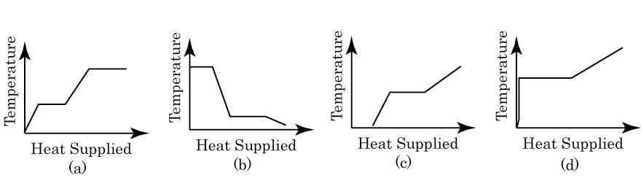
- This person is often called the father of thermodynamics
  - Nicolas Leonard Sadi Carnot
  - George Brayton
  - Anders Celsius
  - Rudolf Diesel
  - Daniel Gabriel Fahrenheit
- This person laid the ground work for the second law of thermodynamics
  - Nicolas Leonard Sadi Carnot
  - George Brayton
  - Anders Celsius
  - Rudolf Diesel
  - Daniel Gabriel Fahrenheit
- Who is most known as the first engineer to prove that fuel can be ignited without a flame or a spark, which he accomplished in the 1890s.
  - Nicolas Leonard Sadi Carnot
  - George Brayton
  - Anders Celsius
  - Rudolf Diesel
  - Daniel Gabriel Fahrenheit
  - James Prescott Joule
  - Nikolaus August Otto
- This person had a thermodynamic property named after him, even though he did not do any work in the invention or discovery of that property.
  - Nicolas Leonard Sadi Carnot – Carnot Engine
  - Anders Celsius – The Celsius Temperature Scale
  - Lord Kelvin – The Kelvin Temperature Scale
  - William John Macquorn Rankine – The Rankine Temperature Scale
  - James Prescott Joule – The Joule measurement for energy
- List the Number of the Law of Thermodynamics that is expressed in the following statements (0th Law,1st Law ,2nd Law,3rd Law or 4th Law). List the best law for each statement.
  - Using logs in a fire place to heat a home
  - Lighting a Candle which gives off heat and light
  - A thermometer is placed in a cup of hot water to measure it’s temperature.
  - Coffee is placed in a coffee mug. The outside of the mug heats up.
  - An oscillating pendulum eventually stops and comes to rest.
  - A heat engine takes that works between two heat reservoirs
- Which of the following systems has the highest Entropy assuming that the dots are molecules of Hydrogen gas?

- B) C) D) E)

- A spontaneous reaction occurs to convert CH₄ + 2O₂ => CO₂ + 2 H₂O what can be stated about the entropy of the resultant components?
  - The change in entropy cannot be determined by the above information
  - There is no change to the entropy
  - The entropy increases
  - The entropy decreases
Place the letter of the term in the box for the definition

Definition Terms
 | 27 | a process during which the pressure P remains constant. |  | A | Absolute pressure
 | 28 | a process during which the specific volume v remains constant. |  | B | Adiabatic process
 | 29 | a process during which the temperature T remains constant. |  | C | Cogeneration
 | 30 | a property and is defined as the sum of the internal energy U and the PV product. |  | D | Convection
 | 31 | an internally reversible and adiabatic process. In such a process the entropy remains constant. |  | E | Critical point
 | 32 | defined as the form of energy that is transferred between two systems (or a system and its surroundings) by virtue of a temperature difference. |  | F | Critical pressure
 | 33 | devices designed for the purpose of converting other forms of energy (usually in the form of heat) to work. |  | G | Cycle
 | 34 | is a condition of a system in which all the relevant types of equilibrium are satisfied. |  | H | Enthalpy
 | 35 | is a process during which there is no heat transfer. |  | I | Exothermic reaction
 | 36 | is a process, or series of processes, that allows a system to undergo state changes and returns the system to the initial state at the end of the process. |  | J | Gage pressure
 | 37 | is a reaction during which chemical energy is released in the form of heat. |  | K | Heat engines
 | 38 | is any change that a system undergoes from one equilibrium state to another. |  | L | Heat
 | 39 | is defined as the point at which the saturated liquid and saturated vapor states are identical. |  | M | Internal energy
 | 40 | is the actual pressure at a given position and it is measured relative to a vacuum. |  | N | Isentropic process
 | 41 | is the amount of energy absorbed or released during a phase-change process. |  | O | Isobaric process
 | 42 | is the difference between the absolute pressure and the local atmospheric pressure. |  | P | Isochoric (or isometric) process
 | 43 | is the process of passing from the solid phase directly into the vapor phase. |  | Q | Isothermal process
 | 44 | is the production of more than one useful form of energy from the same energy source. |  | R | Latent heat
 | 45 | is the transfer of energy due to the emission of electromagnetic waves (or photons). |  | S | Process
 | 46 | the pressure of a substance at the critical point. |  | T | Radiation
 | 47 | the sum of all the microscopic forms of energy. |  | U | Sublimation
 | 48 | the transfer of energy between a solid surface and the adjacent fluid that is in motion, and it involves the combined effects of conduction and fluid motion. |  | V | Thermodynamic equilibrium

- From the picture of the house, White indicates the warmest temperature, followed by red, than yellow, than green and the lowest temperature is blue. What does this picture tell about the heat loss from the house? Describe in as much detail as possible. (This question is worth 1 point and is the First Tie Breaker)
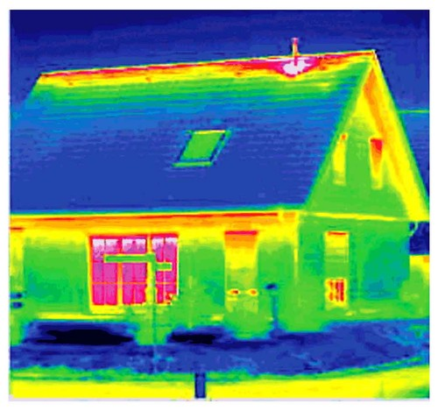

- Thunderstorms are powered by the heat released when water vapor changes to rain drops. How much heat is released when a gallon of rain falls? [1 gal = 1,816 g; specific heat of vaporization of water = 2262 J/g] (This question is worth 2 points and is the Second Tie Breaker)

- A heat engine is operating on a Carnot cycle and has a thermal efficiency of 75%. The waste heat from this engine is rejected to a nearby lake at 15ºC at a rate of 14 kW. Determine the power output of the engine and the temperature of the source, in ºC (This question is worth 3 points and is the Third Tie Breaker)

